PHYSIOLOGY QUIZ 3 2005
- In which PV loop shown below is contractility increased? (The control loop is presented by a solid line, the experimental loop by a dashed line).
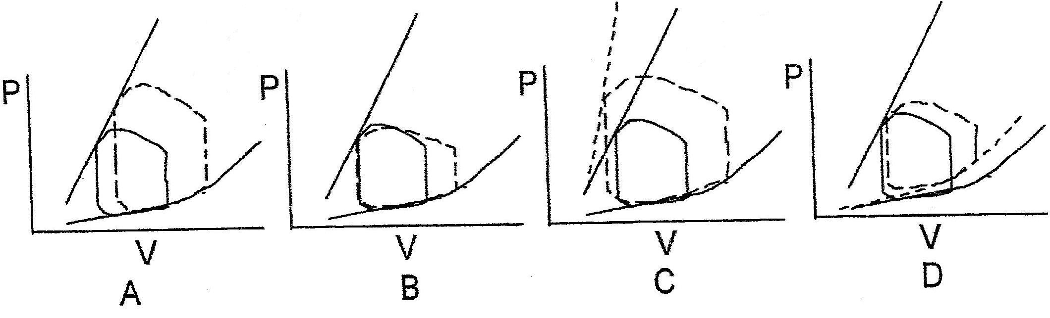
  - Loop A
  - Loop B
  - Loop C
  - Loop D
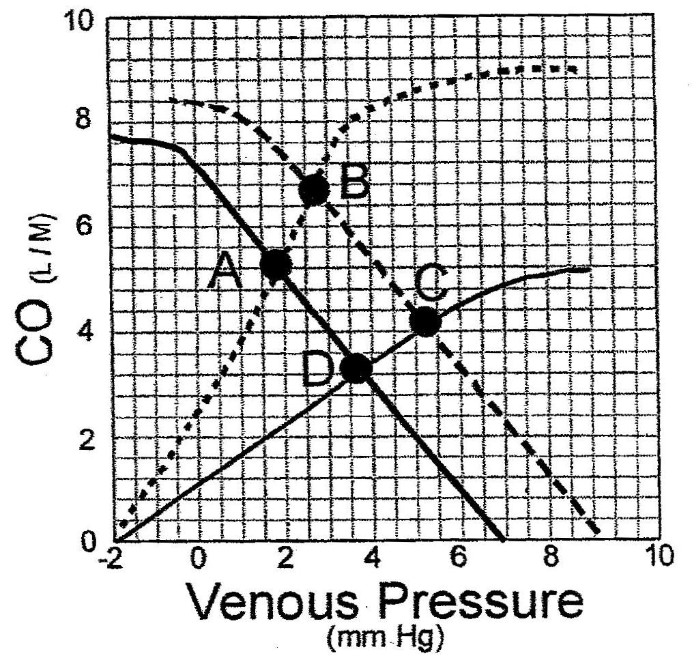
- At which point on the above curves would you measure the cardiac output if both contractility and blood volume have been increased above control values. The control curves are drawn using solid lines and the experimental curves are drawn using dashed lines.
  - Point A
  - Point B
  - Point C
  - Point D
- Which one of the following is the correct definition of the PR interval?
  - It begins at the time the SA node depolarizes and ends with the beginning of the Q wave
  - It begins at the peak of the P wave and ends at the peak of the R wave
  - It begins at the beginning of the P wave and ends at the start of the ST segment
  - It begins at the beginning of the P wave and ends at the start of the QRS complex
- Which one of the following will increase the capillary filtration rate?
  - An increase in the tissue hydrostatic pressure
  - An increase in the capillary hydrostatic pressure
  - An increase in the plasma oncotic pressure
  - A decrease in the tissue osmotic pressure

