PHYSIOLOGY QUIZ 3 2004
- Which one of the following would be increased in a patient with heart failure?
  - Central venous pressure
  - Ventricular systolic wall stress
  - The left ventricular end-diastolic volume
  - All of the Above
- The PR interval:
  - Begins at the peak of the P wave
  - Begins at the beginning of the P wave
  - Ends at the peak of the R wave
  - Ends at the beginning of the T wave
- If the rate (slope) of diastolic depolarization (phase 4) is increased, then the:
  - Heart rate will increase
  - Duration of the diastolic depolarization will increase
  - Threshold for the action potential will be more positive
  - SA node membrane potential will become more positive
- Mean circulatory pressure will increase when:
  - Total peripheral resistance is increased
  - Venous compliance is increased
  - Cardiac output is increased
  - Blood volume is increased
- Which one of the following, when increased, will increase blood flow through a vascular bed?
  - The pressure gradient across the vascular bed
  - The arteriolar resistance of the vascular bed
  - The blood viscosity
  - The length of the blood vessels within the vascular bed
- During which phase of the cardiac cycle would the murmur of mitral stenosis occur?
  - Ventricular ejection
  - Isovolumic contraction
  - Left ventricular filling
  - Isovolumic relaxation
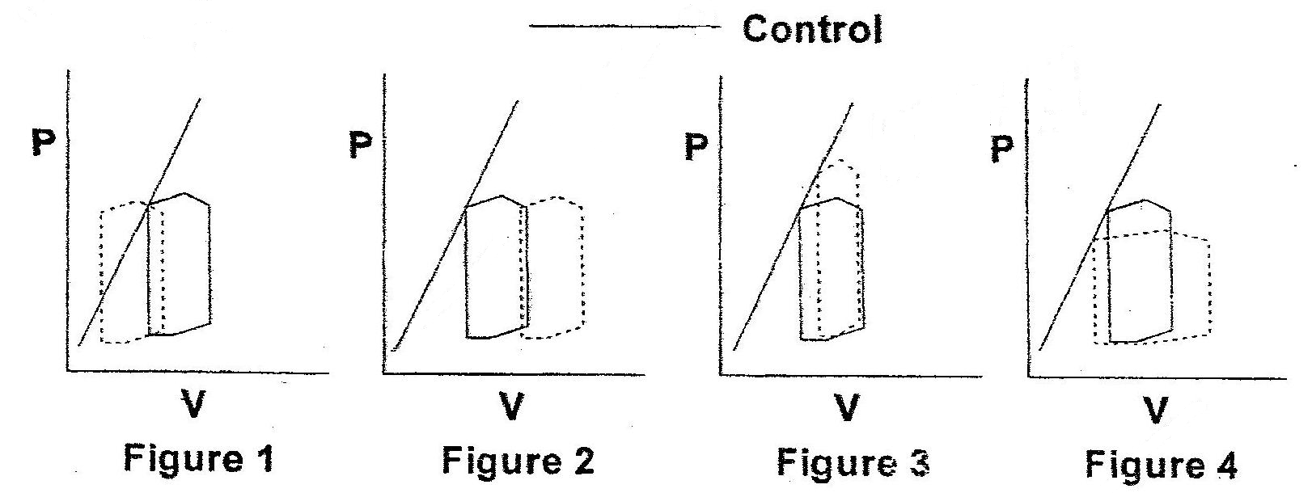
- Which one of the four figures showing pressure volume loops demonstrates an increase in preload and a decrease in contractility?
  - Figure 1
  - Figure 2
  - Figure 3
  - Figure 4
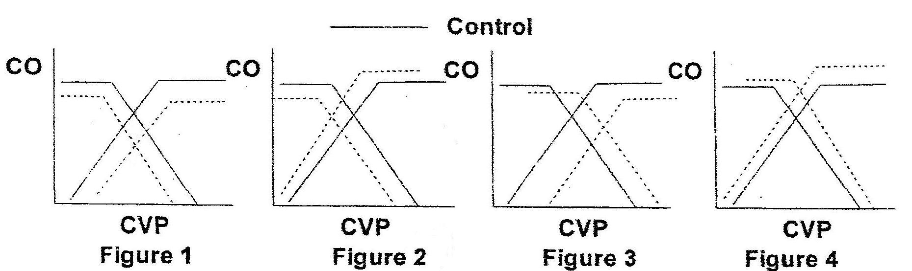
- Which figure shows the effect of a decrease in blood volume and a decrease in contractility?
  - Figure 1
  - Figure 2
  - Figure 3
  - Figure 4
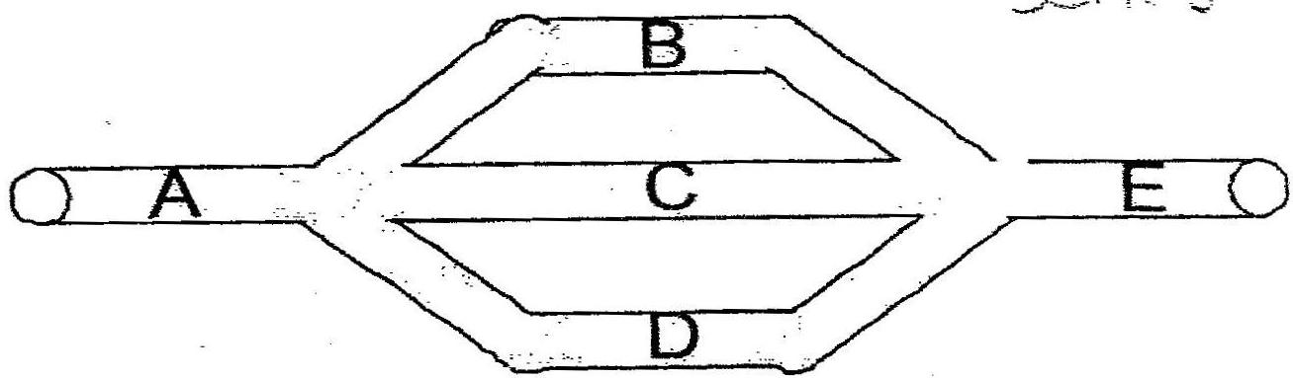
- Analysis of the above schematic drawing of a vascular bed shows that:
  - Vessels A and E have equal blood flows
  - Vessels B, C and D do not necessarily have equal resistances
  - Vessels B, C and D do not necessarily have equal blood flows
  - All of the above

