Neuroanatomy Final Exam

April 15, 2011
8:30 a.m.

Name________________________________________________________

There are 50 questions for this examination. Each is worth 2 points. These questions will be graded by computer and must be answered on the accompanying computer answer sheet. On the computer answer sheet, your name should be printed in the boxes indicated and the appropriate circles below each letter filled in. Also fill in your Student ID number and the appropriate circles below each number.

Write Marino in the space provided for instructor.

On the back of the computer sheet there is a place for your signature and the date. Please fill these out.

Record your answer for each multiple choice question on the computer sheet. Mark each correct response with a #2 pencil on the answer sheet using numbers 1 – 100. If you erase be sure to erase completely.

There is only once correct answer for each question.
- A myelinated axon in the central nervous system is surrounded by:
  - Schwann cells
  - Oligodentrocytes **
  - Astrocytes
  - Fibroblasts.

- What type of neuron is found in the trigeminal ganglion?
  - Multipolar
  - Autonomic
  - Pseudounipolar **
  - Interneuron

- You would expect to find synapses in all of the following EXCEPT:
  - White matter of the spinal cord. ****
  - Periaortic ganglia
  - Ciliary ganglion
  - Sympathetic chain ganglia

- Cerebrospinal fluid would NOT be found:
  - In the central canal of the spinal cord.
  - In the 3rd ventricle
  - Between the dura mater and the arachnoid ****
  - Between the arachnoid and the pia mater

- In comparing axons to dendrites; axons:
  - Transport impulses to its own nerve cell body
  - Can be meters long ****
  - Are only found in the CNS
  - Are only found in the PNS

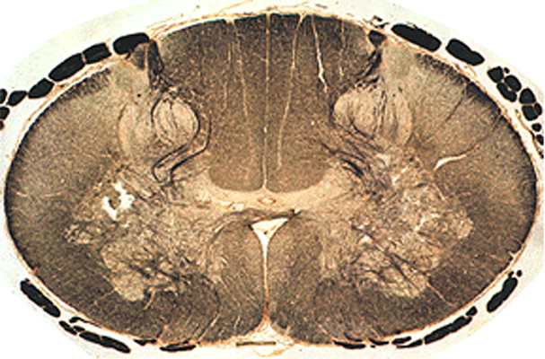
1
2
3
4

- This is a section from what region of the spinal cord.
  - Low cervical ****
  - Mid thoracic
  - Low thoracic
  - L1

- In the image above the fasciculus gracilis is found at:
  - 1 ***
  - 2
  - 3
  - 4

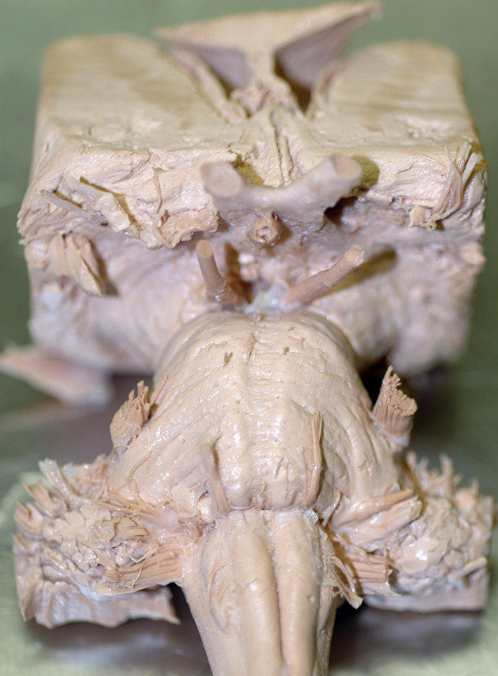
8
9
10
- The white arrow labeled 8 points to cranial nerve.
  - 3
  - 5 ***
  - 7
  - 9

- The white arrow labeled 9 points to the:
  - Middle cerebellar peduncle
  - Inferior cerebellar peduncle
  - Pyramid **
  - Olive

- The white arrow labeled 10 points to the:
  - Interpeduncular fossa
  - Infundibulum **
  - Midbrain
  - Trochlear nerve

- Which pathway is most involved is regulation of muscles of mastication?
  - Corticobulbars **
  - Corticospinals
  - Reticulospinals
  - Tectospinals

- Neurons in which pathway originate in the midbrain?
  - Corticobulbars.
  - Reticulospinals
  - Vestibulospinals
  - Tectospinals **

- Extrafusal muscle fibers receive motor innervation from:
  - Alpha motor neurons **
  - Gamma motor neurons
  - Corticomotor neurons
  - Upper motor neurons.

- Which of the following would be found in an upper motor neuron lesion?
  - Rapid atrophy.
  - Loss of tone
  - Flaccid paralysis
  - Hyperreflexia **

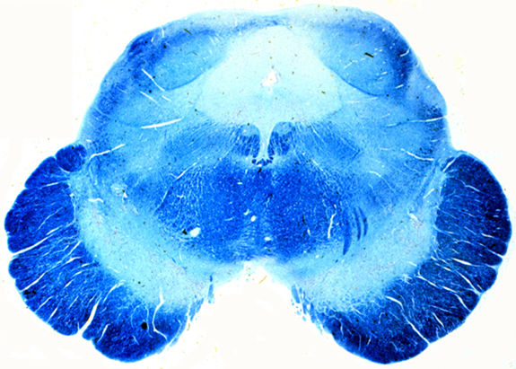

- The arrow points to the:
  - Tectum
  - Superior cerebellar peduncle
  - Crus cerebri
  - Substantia nigra ****

- A characteristic of lateral cerebellar disease is:
  - Tremor at rest (“pill-rolling”).
  - An intention tremor. ****
  - Flaccid paralysis.
  - A Babinski sign.

- An output nucleus of the basal ganglia is the:
  - Caudate
  - Nucleus accumbens
  - Putamen
  - Subthalamic nucleus. ***

- Which of the following can be found in a basal ganglia lesion?
  - Asynergia: loss of coordination of motor movement.
  - Dysmetria: the inability to judge distance and when to stop.
  - A(dis)diadochokinesia: the inability to perform rapid alternating movements.
  - Athetosis: writhing of hands. ***

- Which of the following would act directly on lower motor neurons?
  - Output nuclei from the basal ganglia
  - Deep cerebellar nuclei
  - Neurons in the reticular formation ***
  - Substantia nigra neurons

- A characteristic of Parkinson’s disease is:
  - Rigidity ****
  - Chorea
  - Ballistic movements
  - Athetosis

- The receptor for vibrations is a:
  - Pacinian corpuscle. ***
  - Meisner’s corpuscle.
  - Free nerve ending.
  - Merkel’s discs

- The largest axons which conduct the fastest would convey:
  - Limb position ****
  - Tactile sense
  - Pressure
  - Vibration

- Position sense from the right toes to the cortex crosses in the:
  - Pons
  - Medulla ***
  - At the spinal cord

- Where would you find a second order sensory neuron for proprioception?
  - Gray matter of the spinal cord.
  - Dorsal root ganglion
  - Spinal nucleus of V
  - Nucleus cuneatus ****

- Pain from the premolar on the left upper jaw would be conveyed to the cortex via:
  - Left mandibular division of the trigeminal nerve
  - Left principal nucleus of the trigeminal nerve
  - Right ventral tegmental tract ***
  - Right VPL nucleus of the thalamus.

- First order neurons for smell synapse on the:
  - Cells in the solitary nucleus
  - VPM nucleus of the thalamus
  - Cells of the olfactory bulb ***
  - Olfactory Cortex

- The cells in the spiral ganglion synapse in the:
  - Vestibular nuclei
  - Inferior colliculus
  - Superior colliculus
  - Cochlear nucleus. ****

- Which of the following cranial nerves contain neurons that innervate a muscle that moves the tongue?
  - Mandibular division of V
  - Maxillary division of V
  - Facial
  - Vagus ***

- You are enjoying the taste of your morning coffee and appreciate that the sensation in conveyed to CNS via all the following nerves EXCEPT:
  - Glossopharyngeal
  - Vagus
  - Accessory ***
  - Facial

- What sensory modality does NOT travel in the nerves located at the cerebellarpontine angle?
  - Taste from the posterior 1/3rd of the tongue. ***
  - Taste from the anterior 2/3rds of the tongue.
  - Balance
  - Auditory

- The left lower visual field projects to the:
  - Left lower temporal retina
  - Left upper temporal retina
  - Right lower temporal retina
  - Right upper temporal retina ***

- The movement recognition pathway for vision goes to the:
  - Parietal lobe ****
  - Temporal lobe
  - Frontal lobe
  - Uncus

- Autonomic preganglionic nerve cell bodies that cause the pupil to dilate are found in the:
  - Ciliary ganglion
  - Superior cervical ganglion
  - C8 – T1 spinal cord ***
  - Edinger-Westphal nucleus

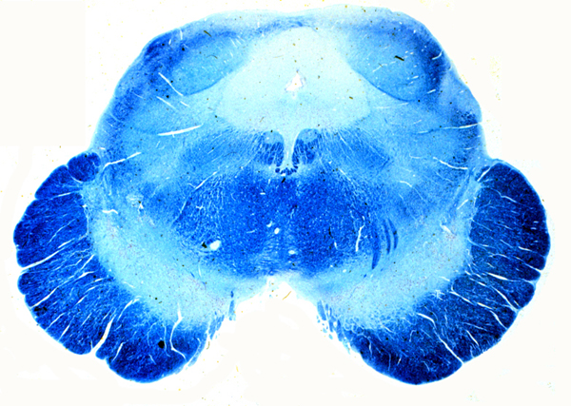
- The nerves at the tip of the pointer are:
  - Oculomotor ****
  - Trochlear
  - Trigeminal
  - Abducens

- What two nuclei are involved in lateral gaze?
  - Motor nucleus of V and oculomotor
  - Oculomotor and trochlear
  - Trochlear and abducens
  - Abducens and occulomotor. ****

- Language comprehension is located in:
  - Broca’s area
  - Wernicke’s area ***
  - Precentral gyrus
  - Prefrontal cortex.

- The lateral prefrontal cortex is most involved in:
  - Object identification.
  - Motor planning
  - Language comprehension
  - Motivation, planning and judgment ****

- The orbitofrontal cortex is most involved in:
  - Spatial attention
  - Language
  - Comportment ****
  - Object recognition

- You have just given a very emotional speech. You know the part of the cortex involved in being emotional as you speak is located in:
  - Broca’s area on the right ****
  - Broca’s area on the left
  - Wernicke’s area on the right
  - Wernicke’s area on the left

- You are just about to pick up your dental drill you know that it is a dental drill because you are able to recognize objects and that ability reside in the:
  - Lateral prefrontal cortex
  - Occipital cortex
  - Orbitofrontal cortex
  - Temporal cortex ***

- What type of memory is associated most closely with the hippocampus?
  - Working memory
  - Procedural memory
  - Declarative memory ****
  - Emotional memory

- Short term or working memory is located in the:
  - Prefrontal cortex ***
  - Temporal cortex
  - Parietal cortex
  - Occipital cortex

- Just before you took this exam you felt nervous and were fearful you would not pass. The structure that is most involved in this is the:
  - Insula
  - Midbrain tegmentum
  - Amygdala ****
  - Putamen

- A negative primary reinforce is:
  - A sound of a siren
  - A flashing light
  - A punch in the nose ***
  - A caress on the cheek

- The saying the best way to a man's heart is through his stomach, applies to our female counterparts as well. You know this is true because food is a:
  - Primary positive reinforcer ***
  - Primary negative reinforcer
  - Secondary positive reinforcer
  - Secondary negative reinforcer

- The most posterior part of the hypothalamus is located at the level of the:
  - Optic chiasm
  - Optic nerves
  - Mammillary bodies ***
  - Anterior commissure

- Neurons in the supraoptic and paraventricular nuclei secrete:
  - LH
  - FSH
  - Prolactin
  - Oxytocin ***

- Preganglionic nerve cell bodies that innervate the small intestine are located in the:
  - Superior cervical ganglion
  - Thoracic spinal cord ***
  - Sympathetic chain ganglia
  - Periaortic ganglia.

- Parasympathetic preganglionic nerve cell bodies would be found in the:
  - Edinger-Westphal nucleus ***
  - Occulomotor nucleus
  - Hypoglossal nucleus
  - Vestibulocochlear nucleus

- As you finish this exam you are grateful that you have such good.
  - Procedural memory
  - Emotional memory
  - Working memory
  - Declarative memory ***

