**The Cell:**

1. Recall the structure and function of the plasma membrane.

* The plasma membrane determines the external limit of a cell.
* It has recognition and regulatory functions - modulates everything going into and out of cell
* Acts as a selective barrier for controlling the exchange of materials between the extracellular matrix and cell’s interior – maintains ion content of cytoplasm
* Structure: Phospholipid bilayer (hydrophilic heads on exterior, hydrophobic tails on interior) with embedded cholesterol molecules, glycolipids, and proteins.
  + Cholesterol molecules: modulate fluidity and movement of membrane
  + Glycolipids – oligosaccharide chains that extend outward and contribute to membrane asymmetry
  + Proteins – integrated by hydrophobic interactions between lipids and nonpolar amino acids; integral/peripheral

2. Know the structure and function of mitochondria.

* Structure: circular to rod-shaped organelle with an inner and outer membrane
  + Outer membrane: porin – acts to let substances into the intermembrane space
  + Inner membrane: contains cristae (increased surface area) – enzymes located here for respiration: enzymes for the Citric Acid (Krebs) Cycle and fatty acid beta-oxidation; cytochromes a, b, c, Coenzyme Q, and cytochrome oxidase for electron transport system
    - In steroid-secreting cells, conversion of cholesterol to pregnenolone takes place here.
* Function:
  + Steroid secretion
  + transformation of metabolites into energy for cell (stored as high energy phosphate bonds -- ATP)
* Mitochondria have DNA, rRNA, mRNA, and tRNA to make proteins
* arise from other pre-existing mitochondria

3. Compare and contrast the production of intracellular and extracellular proteins.

-All protein synthesis begins on free polyribosomes (those not attached to rough ER)

* Intracellular proteins: Proteins that are to remain freely soluble within the cytoplasm are synthesized on free polyribosomes

(Extracellular proteins on net page)

* Extracellular proteins: Proteins that are to be incorporated into membranes, secreted from the cell, or sequestered into lysosomes are made on polysomes attached to the membranes of endoplasmic reticulum.
  + 1. mRNA for proteins to be segregated in the ER (to be secreted) contain a sequence of bases at the 5’ end to code for amino acids making up the ER signal sequence.
  + 2. The signal sequence interacts with a complex of polypeptides bound to a small RNA molecule, which is the signal recognition particle (SRP).
  + 3. The signal recognition particle inhibits further elongation of the polypeptide until the SRP-polyribosome complex binds to receptors in the ER membrane.
  + 4. When bound, the SRP is then released from the polyribosomes, and translation continues inside the lumen of the RER.

4. Compare and contrast lysosomes, peroxisomes.

* Lysosomes: Small single membrane bound organelles for intracytoplasmic digestion
  + contain hydrolytic enzymes – acid hydrolases
  + site of intracellular digestion and turnover of cell components (destruction of nonfunctional organelles)
  + Break down most macromolecules:
    - Lysosome joins endosome 🡪 Endolysosome 🡪 Secondary Lysosome 🡪 Residual body with lipofucin granules
  + Acidic pH (unlike cell’s cytoplasm)
* Peroxisomes: Small membrane bound vesicles
  + contain catalase and oxidative enzymes
  + Oxidase: break down of fatty acids – lipid metabolism
  + Catalase: breakdown hydrogen peroxide to water and oxygen
  + Degrade alcohol (in liver)
  + Detoxify blood-borne toxic molecules

5. Compare and contrast microtubules, thin filaments, and intermediate filaments.

-All make up the cytoskeleton, which plays roles in support and strength, cell movement, phagocytosis, cytokinesis, cell-cell/matrix adhesion, and cell shape changes

* **Microtubules**: fine tubular structures made of alpha- and beta-tubulin; subunits polymerize to form microtubule structure
  + Found in cilia and flagella (for cell movement)
  + Maintenance of cell shape and size
  + Involved in chromosome movement during mitosis
    - centrioles – short, highly organized microtubules; duplicate and move to opposite poles of cell during cell division
  + Cell mobility
  + Movement of materials (organelles and vesicles) within a cell
* **Thin Filaments:** Actin filaments
  + Organized as a double-stranded helix
  + found in all cells
  + Interact with myosin (thick filaments) for movement – shorten muscle cells
  + G-actin and F-actin
    - G-actin: globular form
    - F-actin: filamentous form
  + form a meshwork at cell periphery – terminal web
  + Abundant in microvilli
  + may play role in intracellular movement
  + Involved with cleavage during cell division
* **Intermediate Filaments**: six different types (with 50 different proteins)
  + type of filament is specialized to cell type – varying protein subunit structure in different cell types
  + intermediate in size to thin filaments and microtubules
  + provide mechanical strength and stability to cells
  + 6 types:
    - Type I and II: cytokeratins – in epithelia
    - Type III:
      * Vimentin – in cells of mesodermal origin
      * Desmin – at Z discs in skeletal and cardiac muscle
      * Glial fibrillary protein – in astrocytes
    - Type IV:
      * Neurofilaments – in neurons
      * alpha-internexin – CNS: spinal cord, optic nerve
    - Type V: Nuclear lamins – inner membrane of nuclear envelope
    - Type VI: Nesin – stem cells of nervous system

**The Nucleus:**

**Epithelium:**

1. *Recall the different types of the epi and how the cells are arranged to form them.*
   1. Simple epi: consists of one layer of epi, basement membrane, lamina propria
      1. Simple squamous epi:
      2. Simple cuboidal epi
      3. Simple ciliated columnar epi
   2. Stratified epi: more than one layer or epi, basement membrane, lamina propria
      1. Stratified squamous
      2. Transitional epi
      3. Ciliated pseudostratified epi: appear to have more than one layer of epi, but has only one layer.
   3. Cells may be keratinized: have flattened irregular shape on the surface due to accumulation of keratin and will lack a nuclei.
      1. Helps protect against water loss.
2. *Explain how the organization of the epi cells contributes to their fxn to form a barrier btw the outside world and the rest of the body.*
   1. Cell domains:
      1. Apical: the top surface
      2. Basolateral
   2. Polarity:
      1. Apical: closest to the lumen with differentiations (cilia, microvilli, or stereocilia).
         1. Microvilli: short projections at the apex to increase surface area/ absorption
         2. Stereocilia: morphologically like microvilli but longer. Contain actin. Found in epididymis and the sensory hair cells of the ear.
         3. Cilia: beat and move fluid across epithelial cell surfaces. Also can propel cells. They extend from the cell surface.
            1. Cilia and flagella: form 9 + 2 pattern = axoneme.
      2. Basolateral: closest to the basement membrane.
   3. Barrier: The epi cells act as a barrier by joining the with adjacent epi cells.
      1. Cell Adhesion molecules: Cadherins
      2. Three types of Junctions:
         1. Tight: found at the apex, regulate what can go inbtw cells. Formed by two adjacent plasma membranes coming into close proximity. Separates the luminal space and the interstitial space.
            1. Contains: Claudin, occluding, JAM
         2. Anchoring
            1. Zonula adherens: sort of make a belt around the cell.

Contain: Cadherin, nectin, catenin, and actin.

* + - * 1. Desmosome: sort of like a spot-weld.

Contain: desmocollin, desmoglein, plakoglobin, plakophilin, intermediate filaments.

* + - 1. Gap: membrane channels btw adjacent cells used for cell communication.
         1. Channels formed by proteins called connexins.

Six connexin molecules together = connexon.

* + - 1. Basement membrane: region btw the epi cell and underlying connective tissue. 2 layers.
         1. Two layers :

Basal lamina: has two subgroups

lamina lucida and lamina densa.

Reticular lamina

1. *Compare and contrast how epi cells are organized to carry out their fxns such as absorption, transcytosis, and secretion.*
   1. Organized:
      1. Most epi rest on connective tissue called lamina propria.
      2. The area of contact btw epi and lamina propria is increased via small invaginations called papillae.
      3. There is a polarity with organelles and membrane proteins unevenly distributed, with the region towards connective tissue called basal pole and the opposite end called apical pole. The neighboring side is called the lateral surface.
   2. Secretion:
      1. Types:
         1. Mucus
         2. Serous
      2. Cell type Mechanisms:
         1. Merocrine: the secretory vesicle which take the product apically fuses with the plasma membrane to release its contents. The fused plasma membrane can be taken back into the cell via endosytosis and recycled.
         2. Apocrine: some of the apical cytoplasm gets pinched off with the contained secretions.
         3. Holocrine: the cell produces and accumulates the secretory product in the cytoplasm and then disintegrates to release the secretory material.
   3. Transcytosis: a mechanism for cellular transport in which the cell encloses extracellular material in an invagination of the cell membrane to form a vesicle, then moves the vesicle across the cell to eject the material through the opposite cell membrane by the reverse process. This helps get material to the underlying connective tissue.
   4. Absorption:
      1. pinocytosis
      2. Diffusion of ions
      3. Lateral membrane interdigestion.
2. *Distinguish how different types of epithelial cells renew themselves and compare that to other tissues.*
   1. Proliferation of cells and their down growth into sub adjacent connective tissue (cartoon on slide 41 of epithelium lecture):
      1. the epithelium proliferates downward into the connective tissue and divides in one of three ways.
         1. Exocrine gland formation: with a duct and secretory portion.
         2. Cords of cells forming endocrine gland: has a disappearance of duct cells, capillaries, and a secretory portion.
         3. Follicular endocrine gland formation: has capillaries and secretory portion.
   2. Renewal:
      1. epi cells are renewed continuously via mitotic activity. The rate is variable (fast in intestinal epi or slow as in large glands).
      2. In stratified squamous epi mitosis only occurs in the basal layer in contact with the basal lamina.

1. *Explain how epithelia interface with other tissue and the role of basement membranes.*
   1. Basement membrane: region btw the epi cell and underlying connective tissue. 2 layers.
      * + 1. Two layers:

Basal lamina: has two subgroups

lamina lucida and lamina densa.

The macromolecule components are:

Laminin: large glycoprotein molecules

Type IV collagen

Entactin

Functions

Simple structural and filtering, influence cell polarity, regulate proliferation and differentiation, influence cell metabolism, influence cell-to-cell interactions, pathway for cell migration.

Reticular lamina

**CT:**

***Competencies***

* **Recall the structure and function of the different types of cells found in connective tissue.**
* **Compare and contrast the different cells found in the connective tissue.**
* **Compare and contrast the fibers found in the different types of connective tissue.**
* **Understand the structure and function of the ground substance in which cells and fibers are located.**
* **Have a general knowledge about how the cells, fibers and ground substance molecules attach to each other.**

**Fibroblasts**- most common cell type found in connective tissue

* stellate cell
* a single, ovoid nucleus, prominent Golgi apparatus, profiles of rough endoplasmic reticulum, fat droplets and mitochondria

Fibroblasts produce:

* + Procollagen , Elastic fibers, Reticular fibers , Extracellular matrix components
* **Collagen**
* Collagen fiber is organized into bundles, bundles are bundles of fibrils, fibril is composed tropocollagen molecules
* Strength of the collagen fibril comes from the lateral binding between collagen molecules
* At least 27 types of Collagen- Type I Collagen is main type
* Fibril forming – tensile strength
  + - I, II, and III
  + Microfibril forming – cell to matrix
  + Transmembrane – cell to matrix
  + Multiplexin – stabilizes skeletal muscle, devel.
  + Fibril-Associated – fibril interactions
  + Meshwork-forming – basal lamina
  + Anchoring-fibril – epithelial/ct strength
* **Elastic fibers**
* Elastic fibers are composed of :
  + Elastin
  + Microfibril-associated glycoprotein.
* Fibrillin 1 and 2
* **Macrophages**- rounded cell with numerous short processes
* filled with:
  + a small indented or kidney shaped nucleus and lysosomes (both primary and secondary), residual bodies
* Function of macrophages is:
  + phagocytosis - removal of :
    - * foreign substances and cell debris from dying cells
  + Also be involved in the immune response-presentation of antigens
  + Production of Cytokines (IL-1) and Tumor necrosis factor - a
* Mononuclear Phagocytic  
   System
* cells that are derived from monocytes
* Cells include- Macrophages, Kupfer cells, Splenocytes , Alveolar macrophages (Dust Cells), Langerhans cell, Dendritic cell, Mast Cells
* **Mast Cells**
* Large, round cells , Small ovoid nucleus, Filled with large granules
* Secretory granules contain:
  + heparin - an anticoagulant
  + histamine - binds to blood vessel endothelial cell receptors and causes the endothelium to become permeable
  + slow-reacting substance of anaphylaxis (SRS-A) - acts like histamine
  + eosinophilic chemotatic factor of anaphylaxis (ECF-A) - allows for eosinophils to migrate toward the mast cells and begin to repair the tissue
* **Plasma Cells-** produce antibodies
* Large, ovoid cells, Strong basophilic appearance
* Nucleus eccentrically placed- Majority is heterochromatin
* Other Cells- Lymphocytes, Eosinophils , Monocytes , Basophils , Neutrophils
* Ground Substance – produced by fibroblasts
* can be rather viscous- loose irregular connective tissue
* can be rather gel-like matrix- cartilage
* functions of Ground Substance:
  + RETENTION OF WATER
  + DIFFUSION OF OXYGEN
  + DIFFUSION OF NUTRIENTS
  + CONTROL OF PATHOGENS
* Proteoglycans: core protein binding many
* glycosaminoglycans (GAGS)- GAGS long-chained polysaccharides (Negatively charged)
* Abundance of hydroxyl, carboxyl and sulfate groups
* Ground Substance- Proteoglycans interact with fibers, cells, and structural glycoproteins.

-Cell Attachment Proteins

* **Integrins** - attach cells to adhesion proteins

**Fibronectin -** Has 3 domains- 1 domain binds collagen, 1 domain binds heparin, 1 domain binds cell surface receptors

**Laminin -** found in basal lamina & binds to:

* + Type IV collagen, Heparin sulfate, Entactin , laminin receptors in epithelial cells

**Entactin -** Adds strength to connective tissue by binding:laminin and Type IV Collagen

**Muscle:**

* **Recall the connective tissue components of the skeletal muscle**

The epimysium surrounds the entire muscle and is composed of dense, irregular CT. the Perimysium surrounds a single muscle fascicle. The endomysium surrounds single muscle fibers and is made up of a basal lamina and reticular fibers.

* **Define the role of different organelles in the skeletal muscle cell.**

Sarcoplasmic reticulum is the smoother ER of skeletal muscle cells. It stores calcium and is located adjacent to T tubules. Its calcium channels are opened by a depolarization wave carried by the T tubules causing muscle contraction. Mitochondria are abundant in skeletal muscle as they produce ATP needed for muscle contraction.

* **Define the sarcomere and its components**

The sacromere is the basic unit of contraction in a muscle cell.

* + H zone contains only thick (myosin) filaments
  + I zone contains only thin (actin) filaments
  + A zone contains both thick and thin filaments
* **Recall how the components of the sarcomere bring about contraction**

1. Impulse generate along the sarcolemma (plasma membrane)
2. Impulse goes into T tubules to the sarcoplasmic reticulum
3. Calcium is released into cell from SR and binds to troponin C
4. Change in conformation of the troponin complex removes tropomyosin from blocking the actin binding site
5. ATP on S1 fragment of myosin is hydrolyzed
6. ADP + Pi bond to actin
7. Pi released and S1 fragment is altered
8. ADP released and thin filament is moved towards the M line
9. ATP binds to S1 and actin releases from myosin

* **Understand the sources of energy used by muscle cells**

1. ATP and phosphocreatine have high energy bonds and provide energy for 9 seconds
2. Anerobic metabolism of glycogen provided another 1 ½ minutes for maximal muscle activity
3. Aerobic energy can support activity indefinitely but not at a maximal level

* **Recall the steps involved in skeletal, cardiac and smooth muscle cell contraction**

In skeletal muscle the impulse for contraction arrives via nerves at the myoneural junction. One neuron innervates one or more muscle fibers. This is called a motor unit. The axon at the motor end plate is where Ach is released, causing a depolarization in the sarcolemma.

For Cardiac muscle, action potentials travel through gap junctions in the myocardium. The heart generates the impuse from the SA node. Cardiac muscles get calcium for contraction from SR, T tubules, and slow sodium channels. Increases or decreases in heart rate are regulated by the autonomic nervous system.

Smooth muscle cells do not have striations but still rely on actin-myosin interactions for contraction. Actin in smooth muscle lacks troponin. The filaments attach to each other via gap junctions. Contraction can occur over an extended period of time. It is not an all or none phenomena.

* **Define the myoneural junction and the role of nerves in muscle contraction**

This is where the impulse for contraction arrives via the nerves. It is also referred to as the neuromuscular junction. The motor end plate is where axons meet muscle cells.

* **Define the components of the muscle spindle and how they contribute to the function of this sensory receptor**

The muscle spindles have small intrafusal muscle fibers encapsulated by a connective tissue sheath. They are aligned parallel to extrafusal muscle fibers. [Primary](http://en.wikipedia.org/wiki/Type_Ia_sensory_fiber) and [secondary](http://en.wikipedia.org/wiki/Type_II_sensory_fiber) sensory nerve fibers spiral around and terminate on the central portions of the intrafusal muscle fibers, providing the sensory component of the structure via stretch-sensitive [ion-channels](http://en.wikipedia.org/wiki/Ion-channels) of the axons.

* **Compare and contrast cardiac, smooth, and skeletal muscle**

|  |  |  |  |
| --- | --- | --- | --- |
|  | **Skeletal Muscle** | **Cardiac Muscle** | **Smooth Muscle** |
| **Nuclei** | Multiple | One or two | One |
| **Sarcomeres** | Yes | Yes | No |
| **T tubules** | Yes with triads | Yes with dyads | No |
| **Cell Junctions** | No | Intercalated discs | Gap junctions |
| **Regeneration** | Satellite cells | No (?) | Yes |
| **Mitosis** | No | NO (?) | Yes |
| **Innervation** | Somatic motor | Autonomic | Autonomic |

* **Define the components of the intercalated disc**

Cardiac muscle cells (myocytes) connect end to end via intercalated discs. They have gap junctions for cell-cell communication, fascia adherens for attachment of actin filaments, and desmosomes for attaching one cell to the next.

**Blood and Blood Development:**

Blood and Blood Development

1. Know the different cells and constituent components of blood.

***Blood***

**Cells and Platelets Plasma (5 – 6 L) 54% blood volume**

**46% blood volume water (90%)**

**RBCs 45% WBCs 1% proteins (7%)**

**electrolytes, waste products(1% )**

**nutrients, hormones (2%)**

* **Formed Elements of Blood:**
  + **Red Blood Cells = Hematocrit**
  + **White Blood cells**
    - * **Agranular Leukocytes**
        + **Monocytes**
        + **Lymphocytes**
      * **Granular Leukocytes**
        + **Eosinophils**
        + **Neutropils**
        + **Basophils**
  + **Platelets**

1. Recognize the differences between cells in blood based upon their morphology.

RBCs- Red biconcave discs without nuclei

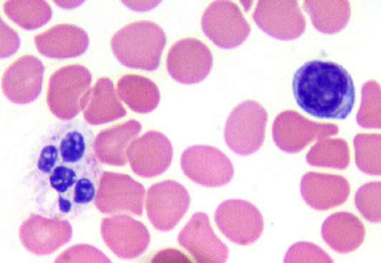

Neutrophils – One multilobated nucleus (as much as 5 lobes)

Eosinophils – Has coarse red granules, a nucleus that may contain 2 or 3 lobes

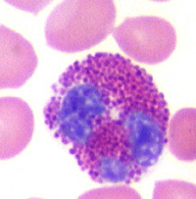

Basophil – multilobed nucleus with dark blue granules

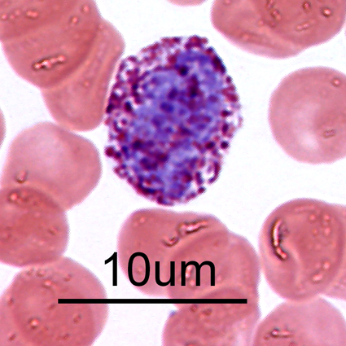

Lymphocyte – small, round, blue staining, heterochromatic nucleus is round, dark staining, and nearly fills the cell.



Monocytes - Nucleus usually is kidney-shaped or indented; cytoplasm is described as light blue or bluish-gray.

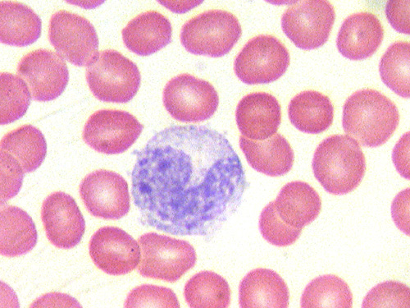

Platelets- are cell fragments that are formed by segmentation of **megakaryocytes** in bone marrow.

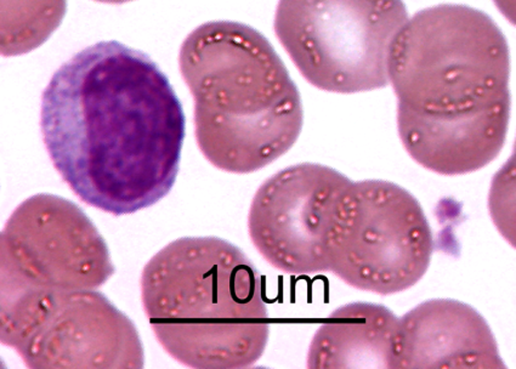

Megakaryocytes

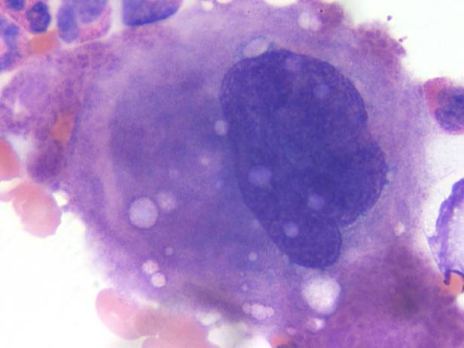

1. Understand how the structural differences in the cells results in the different functions these cells carry out.

Neutrophils

* Involved in phagocytosis and destruction of bacteria .
* First, secondary or specific granules fuse with the phagosomes and release enzymes into it.
* Then, primary or azurophilic granules will actively complete the digestion of the particles.
* An increase in neutrophils in the blood indicates an infection.

Eosinophils

* Granules have a crystalline core that contains major basic protein and eosinophilic cationic protein, which are involved in the destruction of bacteria and parasites.
* The rest of the granule contains a number of enzymes that participate in the digestion of bacteria, protozoa, and parasites.
* These enzymes also are involved in the inactivation of histamine and leukotrienes .
* remain in the blood for approximately 8 – 12 hours
* The azurophilic granules are lysosomes with hydrolytic enzymes.
* These cells can trigger bronchial asthma

Basophils

* granules contain enzymes that are involved in the allergic reaction
* enzymes are histamine, heparin, eosinophilic chemotactic factor, leukotrienes and peroxidase
* Histamine causes vasodilation.
* Leukotrienes cause slow and more prolonged vasodilation.
* Promote migration of white blood cells into the connective tissue.
* Involved in bronchial asthma and allergic skin reactions.

Monocytes

* contain lysosomes in the cytoplasm
* function is phagocytosis

Lymphocytes

* Go on to produce either T or B lymphocytes

Platelets

* Primary aggregation – formation of platelet plug
* Secondary aggregation – increase plug size
* Blood coagulation – formation of blood clot or thrombus
* Clot retraction –
* Clot removal – vessel wall restored.

Megakaryocyte

* Gives rise to thousands of platelets during the cell’s lifetime

1. Use this information above to determine how the cells would function to provide a defense against unwanted pathogens.

Answers is above in each cell description

1. Know how each of the cells develops including the origin of the cell and its lineage.

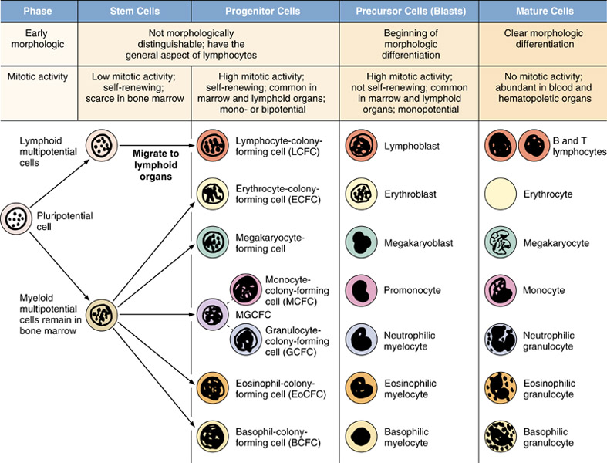

**Circulatory:**

Circulatory System

* 1. To remember how the blood flows through the circulatory system including the portal systems.
  2. To recall the propagation of impulses through the cardiac conduction system of the heart.
  3. Remember the structure of the myocardium
  4. Remember the differences between the different types of arteries and veins and how that reflects on the function they have.
  5. Recall the differences between the different types of capillaries.

**1)**

1. Systemic blood enters the right atrium

2. Goes through the tricuspid valve.

3. Enters the right ventricle.

4. Leaves through the pulmonary artery.

5. Goes to the lungs

6. Blood returns from the lungs via the pulmonary veins.

7. Goes to the left atrium

8. Goes through the mitral valve.

9. Enters the left ventricle

10. Leaves to the systemic circulation via the aorta

**2)** Impulses begin in the sinoatrial node with an intrinsic rhythm of 70 bpm. From here the impulses travel across the atrial musculature to the base of the interatrial septum where they reach the AV node and slow down. Next the impulses reach the AV bundle (only place where atrial musculature connects with ventricular musculature). From here they travel to the crest of the interventricular septum where they are divided into left and right bundle branches. Lastly, from the bundle branches the impulses travel to the Purkinje cells from where they reach working myocardial cells.

**3)** The myocardium is an involuntary striated muscle in the middle layer of the heart. It consists of connective tissue, blood vessels, nerves, and working myocardial cells. **4)**

|  |  |  |  |  |
| --- | --- | --- | --- | --- |
| Vessel | Role | Adventitia | Media | Intima |
| Large Artery | Conveys blood | CT with blood vessels | Elastic laminae & smooth muscle cells | Endothelium and underlying CT |
| Muscular Artery | Supplies oxygenated blood | CT with blood vessels, nerves | 10 – 40 smooth muscle cells | Endothelium and underlying CT |
| Arteriole | Controls blood pressure | scant | 1 – 3 smooth muscle cells | endothelium |
| Capillary | Exchange with tissue | None | None | Endothelium and pericytes |
| Venule | Receives blood from capillaries | Slight CT | 1 –2 layers smooth muscle | Endothelium and pericytes |
| Medium Vein | Blood to the heart | Thick with collagen and elastic fibers | Smooth muscle and collagen | Endothelium and valves |
| Large vein | Blood to the heart | Thick with smooth muscle, vasa vasorum | Smooth muscle cells | Endothelium and CT |

**5)** 3 Types: Continuous, Fenestrated, and Sinusoidal

Continuous – Found in muscle, nerve, and connective tissue

* Responsible for transporting small molecules through diffusion and vesicle transcytosis

Fenestrated – Found in pancreas, intestine, endocrine glands, and kidney (no diaphragms)

* Have pores covered by diaphragms and continuous basal lamina

Sinusoidal – Found in liver, spleen, endocrine glands, and lymphatic organs

* Discontinuous basal lamina, large openings, and no diaphragms.

**Lymphatic System:**

1. **Understand the different mechanisms the body uses to fight off pathogens**.
2. Innate immune response: non specific
3. Physical barrier
4. Epithelia: ex keratinized stratified squamous epi
   * 1. Junctions
     2. Cilia: take mucus and move away from the lungs
5. Chemical barrier
   * + - 1. Mucus
         2. Acids in skin and GI tract
         3. Lysozyme in tears and saliva
         4. Complement-made in the liver
6. Phagocytic cells:

Neutrophils

Macrophages: destroy bacteria, cell debris, foreign substances. Secrete cytokines—regulate lymphocytes (# and differentiation), and persent antigens for reaction by lymphocytes.

1. Eosinophils: extracellular killing-parasites
2. Natural killer cells: non-specific lymphocytes. Kill cells that are coated with antibodies=antibody-dependent cell mediated cytotoxicity. Release: perforins (form a pore in the cell membrane) and granzymes (induce apoptosis)
3. Adaptive immune response:
4. Humoral
5. Cellular
   * + 1. **Compare and contrast the different cell types found and their functions. You should know the structure and function of B cells and the different types of T cells**.
6. Lymphocytes:

B cells: develop immunocompetence in bone marrow. Have membrane-bound antibodies (B-cell receptors or surface immunoglobulins) recognize an antigen. Produce antibodies, develop in bone marrow, antigen-induced maturation occurs in peripheral lymphoid tissues (germinal centers of tonsils, spleen, lymph nodes).

T cells: leave bone marrow into blood as CD4- and CD8- and go to the thymus to become immunocompetent CD4+ and 8+. Have t cell receptors (TCR)—recognize antigen. Are MHC-restricted meaning only react against antigen presented by self-MHC. Can not react against self antigens bound to self-MHC (self tolerance). For T cells to function must recognize self-MHC. MHC1 presents antigen as short protein made by the cell. MHCII presents the antigen as a fragment of exogenous protein taken up by phagocytosis.

Helper: (Th) are CD3 and CD4. TCR and CD4. Th2=parasitic response. Th1=viral, bacterial and single cell parasite response.

Cytotoxic: (Tc) are CD8 and CD3. TCR and CD8

1. Accessory cells:

1. Macrophages: destroy bacteria, cell debris, foreign substances. Secrete cytokines—regulate lymphocytes (# and differentiation), and persent antigens for reaction by lymphocytes.

2. Dentritic cells

3. Follicular dentritic cell

* + - 1. **Have general knowledge of how the lymphatic system fights off disease. This means that you should appreciate how the different cells in the lymphatic respond to foreign agents be they bacteria, antigens, parasites, or other foreign substances**.

5 classes of antibodies: bind different cells and carry out different functions:

IgA: significant in the oral cavity

1. secreted into tears, saliva and mucus
2. complexes to viruses, bacteria and other antigens
3. secreted into milk for passive immunity of the neonate
4. assists eosinophils in killing parasites

IgG:

1.Opsonizes antigens for phagocytosis

2. Crosses the placenta

3. Secreted in milk

4. Fixes complement cascade

5. antibody-dependent cell-mediated cytotoxicity with natural killer cells

IgM: exposure to Rh+ if Rh- mother—initial exposure=IgM production. IgM doesn’t cross the placenta. Second exposure=IgG response and IgG does cross the placenta

Complement: 20 plasma proteins, produced by the liver, activated by bacteria or antibodies, and facilitates lysis of bacteria, opsonization, and bringing phagocytes to the site of reaction.

|  |  |  |
| --- | --- | --- |
|  | Binds to | Function |
| IgM | B cells | Activates complement |
| IgD | B-cell membrane | Activates B cell differentiation into plasma cells |
| IgA | Epithelial cells | Protects mucosae |
| IgE | Mast cells and basophils | Causes granule release from basophils and mast cells |
| IgG | Macrophages and neutrophils | Activates phagocytosis |

* + - 1. **Compare and contrast the morphology of the lymphatic organs. In learning how the lymphatic system is organized you should be able to identify where the different cells are located and how they function within that location**.

Primary=immunocompetent cells develop.

i.Fetal liver

ii. bone marrow

iii.thymus

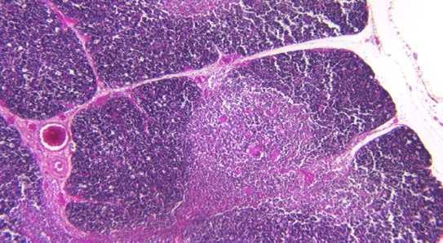

Secondary=cells interact with each other and antigens.

i.Lymph nodes: lymph enters via afferent lymphatic, enters subcapuslar sinus through paratrabecular sinuses, passes between medullary cords and exist via lymphatic vessels.

ii.spleen

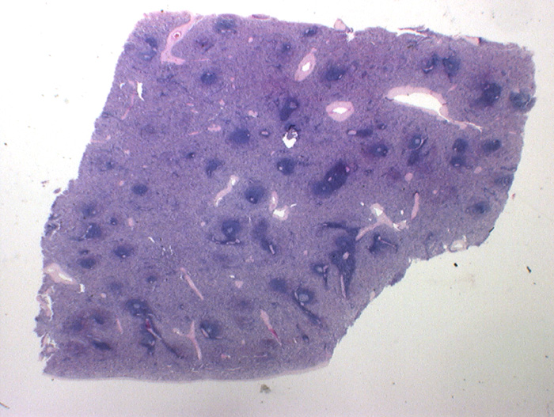

Blood enters splenic artery to trabecular arteries and branches leave and become surrounded with lymphocytes. Artery=central artery. Periarteriolar lymphatic sheat (PALS)

iii.mucosa-associated lymphoid tissues (GALT, MALT)

iv.bone marrow.

**Liver, Pancreas and Gall Bladder:**

1.Remember the structure of the liver and how it is organized to carry out these functions:

2.Compare and contrast the endocrine and exocrine functions of the liver.

3.Understand how the liver is able to take noxious elements and render them harmless.

4.Recall how the gall bladder is organized to store, concentrate, and secrete bile.

5.Remember the structure of the pancreas and how it is organized.

6.Compare and contrast the endocrine and exocrine function of the pancreas.

7.Have a general knowledge of how the pancreas is involved in diabetes.

1. The structure of the Liver
   1. Receives blood from two sources:
      1. Hepatic artery – a branch of the aorta
      2. 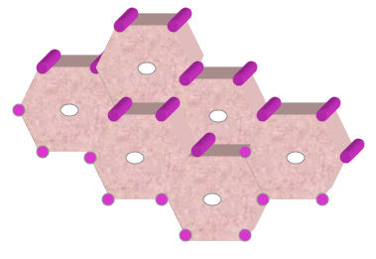Portal vein – drains blood from spleen and GI tract
   2. Liver arranged as lobules.
      1. 6 portal triads
      2. 1 central vein

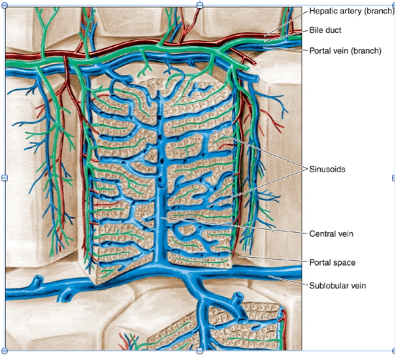

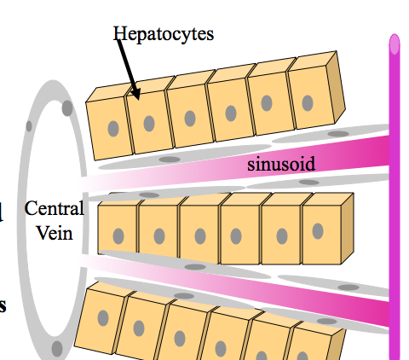•Hepatocytes arranged in plates.

•Sinusoids between plates of hepatocytes.

•Sinusoids lined by endothelial cells.

–**Discontinuous**

•Functions of the liver.

–Secretion of bile acids

–Secretion of bilirubin

–Lipid metabolism

–Carbohydrate metabolism

–Protein metabolism

–Vitamin storage (Vitamin A in Ito cells, vitamins D and B12, and Folic Acid)

–Degradation of hormones, drugs and toxins

–Immune function

Bile absorbs fats, eliminates cholesterol, eliminates bilirubin, transports IgA to intestine, and excretes drugs and heavy metals

In lipid metabolism; cholymicrons absorbed by lacteals in intestine, taken up by hepatoytes, and are degraded into fatty acids, acetyl coenzyme A, and used to make cholesterol or phospholipids.

For Carbohydrate metabolism; the liver maintains blood glucose levels, stores glucose as glycogen when there is too much glucose in the blood, and metabolizes glycogen and secrete glucose when there is too little glucose in the blood.

1. Endocine and Exocrine Functions of the Liver
   1. Exocrine functions include the production of bile from metabolic conversions of substrates from the digestive tract, pancreas and spleen. Secretion occurs via bile ductules draining into the hepatic duct, the gallbladder, the cystic duct, the common bile duct and, finally, into the duodenum.
   2. Endocrine functions include the release of substances produced by liver cells into blood, including albumin, lipoprotein, globulins, liver glycogen, and T3 (thyroid hormone).
2. Degradation of hormones, drugs and toxins
   1. Remove ammonia from the blood
      1. From hepatocyte breakdown of amino acids
      2. From bacteria
   2. Hepatocytes breakdown ammonia to urea
   3. Barbituates and antibiotics inactivated.
      1. Occurs in SER by methylation
      2. Also in peroxisomes
   4. Tolerance
      1. Increased efficiency of hepatocytes to detoxify
      2. Therefore more drug needed for the effect.
      3. Decreases effectiveness of drug.
3. Gall Bladder
   1. 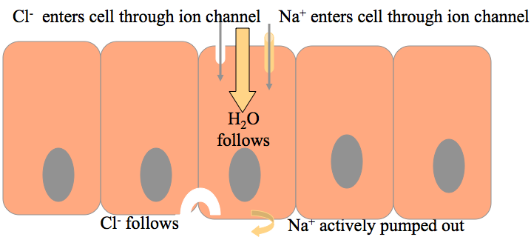Contains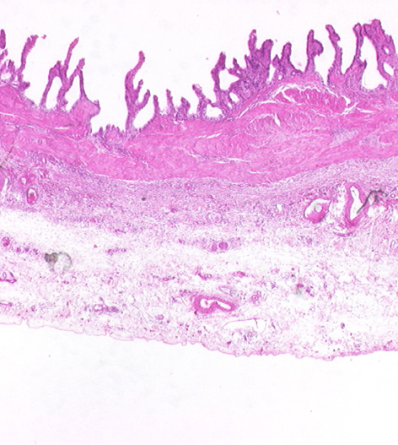 a mucosa, muscular layer (smooth muscle), perimuscular connective tissue, and a serosa.
   2. Stores concentrates and releases bile.
   3. Cholecystokinin is released from cells of duodenum in response to fats.
      1. Causes contraction of smooth muscle of gall bladder
      2. Causes relaxation of the sphincter of Oddi so bile enters the duodenum
4. Pancreas Structure

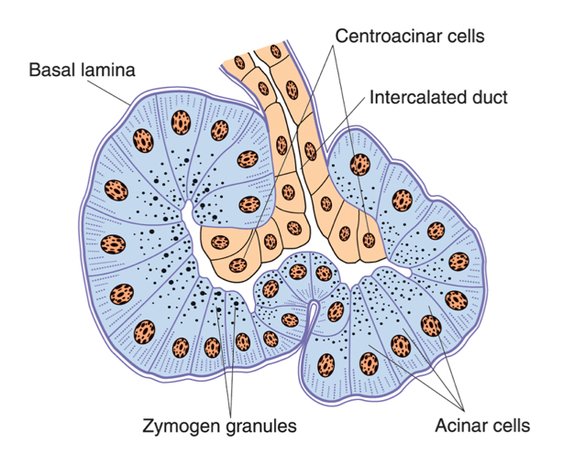

1. The exocrine enzymes are digestive enzymes and the endocrine enzymes are hormones.
   1. Exocrine
      1. Acinar cells make pancreatic amylase, pancreatic lipase, ribonuclease, deoxyribonuclease, trypsinogen, chymotrypsinogen, procarboxypeptidase, elastase and trypsin inhibitor
      2. Digestive enzymes released in response to cholecystokinin
      3. Centroacinar cells and intercalated duct cells make serous bicarbonate-rich alkaline fluid and is released in response to secretin.

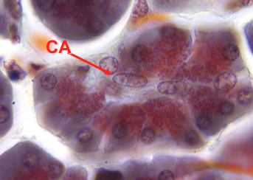

* 1. Endocrine
     1. 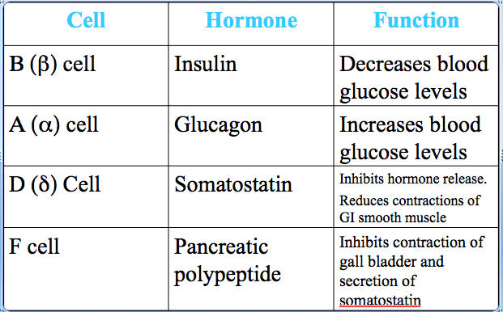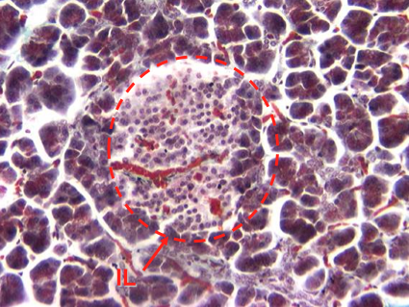Islets of Langerhans

1. Pancreas and Diabetes
   1. The Pancreas is where insulin is produced which deals directly with diabetes.
   2. Diabetes mellitus occurs when the body cannot produce enough insulin or when the insulin that the body makes does not work properly.
   3. Type 1 Diabetes is the type that is almost always found in children and adolescents and occurs because the pancreas loses the ability to make insulin. People with type 1 diabetes need insulin treatment to stay alive.
   4. Type 2 Diabetes usually affects older people and is often associated with being overweight. These people make some insulin but the insulin does not work well. Type 2 diabetes can often be controlled by changes to diet and weight control- but may need tablets or sometimes insulin injections.

**Urinary System:**

**Kidney**

Covered by a strong CT capsule. Contains an outer cortex and an inner medulla. The major functional unit of the kidney is the uriniferous tubule; a nephron + the collecting duct it empties into. Proximal Convoluted Tubule accounts for 70% of water resorption. 10% is removed in the descending thin limb.

**Renal Corpuscle**s are round or ovoid structures located in the cortex. They contain the Glomerulus and Bowman’s Capsule

Bowman’s capsule

1. Parietal layer
   1. Simple squamousep.
2. Visceral layer
   1. Made up of podocytes that completely surround the capillaries
   2. Capillaries are fenestrated without diaphragms

Juxtaglomerular Apparatus

Cells in the macula densa of the juxtaglomerular apparatus detect changes in NaCl levels as well as blood pressure. Under the conditions of decreased blood pressure and low Na+, the juxtaglomerular apparatus is stimulated to secrete rennin.

**Renin** enters the blood and converts **Angiotensinogen to Angiotensin I**.

It is then converted to **Angiotensin II in the lungs**.

**Angiotensin II**

-tells the adrenal gland to **secrete aldosterone**. This increases resorption of Na+ and water into the blood.

-tells the Proximal Convoluted Tubule to resorb more Na+

-tells cells in the hypothalamus to **make ADH**

causes**vasoconstriction**.

**ADH** is made in the hypothalamus and secreted from the pars nervosa of the pituitary in response to decreased blood volume. The **vasarecta absorbs water** and urine becomes more concentrated.

The **Ureter and Bladder**have a transitional epithelium. Has a “cobblestone appearance”. Allows for distention and contraction of the bladder.

The ureter conducts the urine to the bladder. It consists of

* 1. **Mucosa**
     1. transitional epithelium
     2. laminapropria
  2. **Muscularis**
  3. inner longitudinal muscle
  4. outer circular muscle
     1. (This muscle arrangement is the opposite of that found in the gut)
  5. **Adventitia**

Fibroelastic connective tissue.

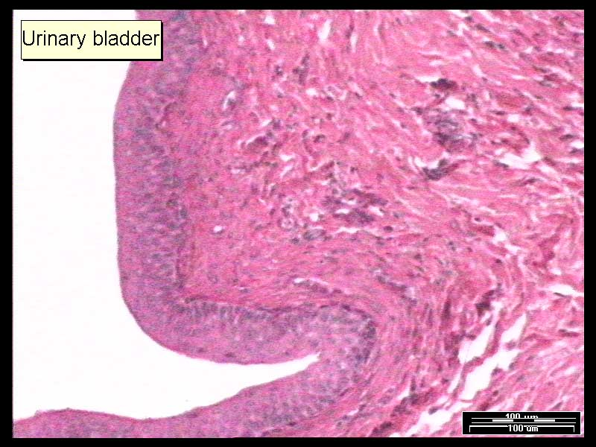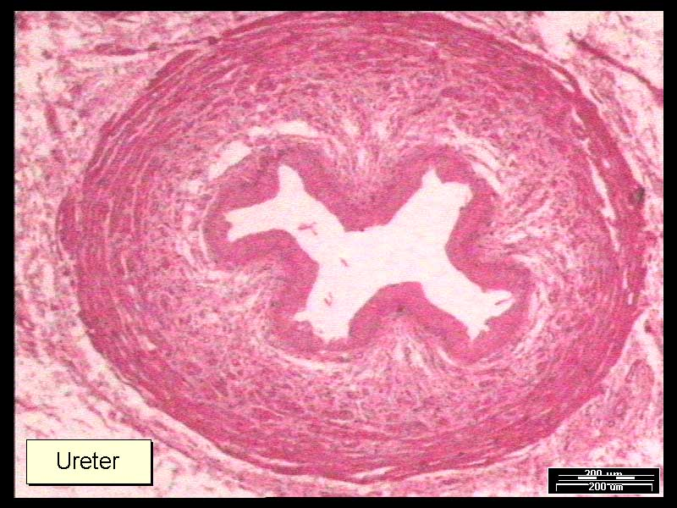

**URETHRA**

The urethra is the urinary tube leading from the bladder to the external orifice

**Male Reproductive System:**Competencies were not listed in lecture.

* Consists of 2 testes, a genital duct system, glands, and penis
* Spermatogenesis – produce sperm
* Spermatocytogenesis – spermatogonia into spermocytes
* Spermiogenesis – spermatids into sperm
* Sertoli cells – tall columnar cells, large pale nucleus, lateral cell junctions, subdivides the seminiferous epithelium into the basal and adluminal compartment
  + Support germ cells
  + Forms blood testis – barrier
  + Makes androgen binding protein, anti-mullerian hormone, inhibin, testicular transferring
  + Involved in phagocytosis
* Androgen binding protein – involved in the increase in testosterone in the seminiferous tubule
  + After binding testosterone it keeps testosterone from leaving the tubule
* Anti-mullerin hormone – acts in embryo and results in the elimination of the paramesonphric duct
  + Paramesonphric duct gives rise to the uterine tubes, uterus and part of vagina
* Inhibin – prevents the release of FSH from pituitary
* Testicular transferrin – takes iron and transfer it to spermatoctyes and spermatids
* Humans produce 200 million sperm/day
  + Produced in seminiferous tubules
  + 500 tubules per testes so about 500 meters of tubules
* Spermatogonia – cells in the basal compartment
* Type B cells give rise to primary spermatocytes
  + These go between sertoli cells and form junctions with them, then begin meiosis
* Two divisions following a single replication of DNA
  + Gives you 4 haploid cells
  + Crossing over produces recombinant DNA (variability)
  + First meiotic division is 22 days, second one is very short
* Spermatids – all spermatids from one spermatogonium are connected to one another via cytoplasmic bridges
  + Contains one chromatid per spermatid
* Spermiogensis – the transformation of 1 spermatid into a sperm
  + Four Sages: Golgi phase, cap phase, acrosomal phase, maturation phase
* Testosterone is secreted by endocrine cells, Leydig cells
  + It is formed from cholesterol
  + Pregnenolone is a precursor
  + LH is made by the basophils in the pituitary, LH binds to receptors on Leydig cells to activate testosterone synthesis
  + These basophils that makes LH are under the influence of GNRH from hypothalamus as well as feedback from the Leydig cells
* Sperm produced in the testis moves to the tubuli recti then to the rete testis
  + Rete Testis – simple cuboidal epithelium, single flagellum
* From the Rete testis the sperm move to the efferent ductules
  + Efferent ductules – ciliated columnar cells and nonciliated cuboidal epithelial cells
    - Function – transmit sperm and remove fluid
* Epididymis – pseudostratified columnar epithelium with stereocilia
  + Basal cells and principal cells which secrete glycerophosphocholine (inhibits capacitation)
  + Function to remove fluid and mature sperm
  + Sperm develop motility in the epididymis
  + Sperm that traverse the epididymis in one week gain capacity
  + Sperm must travel through the female genital ducts to gain the ability to fertilize the ovum (called capacitation)
* Sperm then moves to the vas deferens
  + Epithelium similar to the epididymis
  + Transmits sperm
* Glands – seminal vesicles, prostate gland, and bulbourethral glands
  + Prostate – series of tubuloalveolar glands embedded in CT and smooth muscle
    - Surrounding the prostate are 3 glands (inward to outward): mucosal, submucosal, and main glands
    - Prostate produces a serous secretion (lipids, proteolytic enzymes, acid phosphatase, fibrinoysin, and citric acid).
    - Secretions under the regulation of dihydrotestosterone converted from testosterone in the prostate
    - Benign prostatic hypertrophy – occurs in 40% of men over 50 and 95% of men over 80
    - Prostatic carcinoma – affects 30% of men over 75, occurs in the main glands
  + Seminal vesicle – paired highly coiled glands, produce fructose-rich seminal fluid (energy source for the sperm)
* Penis contains: 2 corpora cavernosa, a corpus spongiosum, and erectile tissue

**Early Embryology:**   
1. Recall the events that occur during the first three weeks of development including:

1. Cleavage,

* **Day2:** The fertilized egg begins to divide during the second day. The first division is called cleavage. Until the 8-cell stage, each individual cell is capable of forming a complete embryo. Identical twins develop when cells in the embryo separate and develop into individual, genetically identical embryos. Twins can develop any time up to day twelve of gestation.

1. Cell division

* **Day 2-5**: The fertilized egg continues to divide in a series of divisions in which the daughter cells all are smaller than the cells from which they arose. The cells undergoing division will also undergo compaction. This occurs as tight junctions hold the cells of together. At this point the embryo is called a morula.
* **Day 5:** The morula continues down the uterine tube and a cavity, called the **blastocyst cavity**, begins to form. Surrounding this cavity, there is an outer layer of cells, the **trophoblast** which will develop into the placenta and other supporting tissues. Inside of the trophoblast is a cluster of cells that communicate by gap junctions called the **inner cell mass**. The inner cell mass will go on to form virtually all of the tissues found in the human body. However, alone the inner cell mass cannot form an organism because the placenta and supporting tissues needed for development come from the trophoblast.

1. Formation of the blastocyst.

* forms during first week
* Bilaminar disc – forms during second week
* consists of an **inner cell ,** a **trophoblast** (becomes part of the placenta), and the **primary yolk sac** (at this point also called the blastocyst cavity).

1. Gastrulation

* starts during the third week
* Trilaminar disc – exists during the third week
* Lateral body folding
* Head and tail folding
* **Gastrulation** is the process that establishes three germ layers or a **trilaminar** embryo. Gastrulation begins around day 14 of gestation or 28 days after the beginning of the women’s last menstrual cycle.
* The first sign of gastrulation is the formation of the **primitive streak** in the epiblast. The primitive streak consists of the primitive groove, primitive node and the primitive pit.
* Epiblast cells migrate towards the midline and invaginate into the space between the epiblast and hypoblast. Some of the migrating epiblasts cells replace the cells that were in the hypoblast. At this point a trilaminar disc is formed with the epiblast, giving rise to three germ layers, the:
* 1. epiblast that remains becomes the **ectoderm**,
* 2. cells that replace the hypoblast become the **endoderm**
* 3. cells in between become the **mesoderm** and the **notochordal process**.
* The **notochordal process** lies in the midline between the endoderm and the ectoderm,. The cells continue forward until they reach the **prechordal plate**. The prechordal plate is the region between the notochordal process and the oral plate and it is composed of endodermal cells. The migrating cells forming the **notochordal (head) process** will fuse with the endoderm for a short time and will be called the **notochordal plate**. The notochordal plate will then round up and become the **notochord**.

1. Neurulation

* **Neurulation** is the formation of the neural tube which will give rise to the central nervous system.
* The notochord induces the overlying ectoderm to thicken and differentiate. These cells are called the **neural plate**.
* The neural plate begins to fold in on itself. The elevated edges on either side of the neural plate form the **neural folds** and the central region is called the **neural groove**.
* The neural folds begin to meet in the midline, forming a **neural tube**. Fusion of the neural folds first occurs in the cervical region where the future neck will form. The neural tube then continues to develop in both cephalic and caudal directions.
* The narrow caudal end of the tube represents the future spinal cord while the larger more dilated cephalic end will become the brain.

1. Formation of the vertebrate body plan.

* The lateral body folding also plays an important role in the formation of the gut. With the continued growth of the mesoderm in the lateral directions the flat embryonic disc folds ventrally and then toward the midline to form the ventral abdominal wall.
* During the formation of the neural tube, the rest of the ectodermal cells that form the surface ectoderm, are arranged as a flattened disk. These ectoderm cells lie on the lateral mesoderm cells which lie on the endoderm cells. .
* As development proceeds, the lateral edges of the ectoderm, mesoderm, and endoderm begin to fold under the embryo.
* In addition, the lateral plate mesoderm develops a cavity so that it forms two layers:
* Somatic mesoderm
* Splanchnic mesoderm
* Over the course of the next two days the embryo undergoes lateral body folding so that the lateral edges of the ectoderm will meet in what will become the anterior midline.
* The lateral body folding also plays an important role in the formation of the gut. With the continued growth of the mesoderm in the lateral directions the flat embryonic disc folds ventrally and then toward the midline to form the ventral abdominal wall.
* Only in the region of the midgut does a communication persist with the yolk sac. This is called the **vitelline duct**.
* As development continues, the allantois becomes partially incorporated into the embryo and forms the **cloaca**.
* The rest of the allantois, in the connecting stalk, and the vitelline duct in the yolk stalk fuse establishing the **umbilical cord**.
* During the third week of development the mesoderm on either side of the notochord thickens and is called the **paraxial mesoderm**. The paraxial mesoderm gives rise to **somites**.
* Laterally, the mesoderm is thin and is called the **lateral plate mesoderm**. A cavity develops in the lateral plate mesoderm that is continuous with the extraembryonic coelom, called the **intraembryonic coelomic cavity**. This cavity divides the lateral mesoderm into two layers.
* The mesoderm that lies dorsal to the intraembryonic coelomic cavity is called the **somatic (parietal) mesoderm**. The ectoderm and somatic mesoderm is called the **somatopleure**.
* That mesoderm found ventral to the intraembryonic coelomic cavity is called the **splanchnic (visceral) mesoderm**. The splanchnic mesoderm and the endoderm is called the **splanchnopleure**.
* The mesoderm between the paraxial and lateral plated mesoderm is called the **intermediate mesoderm**.

2. Correlate the timing of events during early pregnancy to the woman’s menstrual cycle. These events include:

1. Implantation
2. Gastrulation
3. Beginning of embryogenesis

Embryology/

Gestational Age Clinical Age

|  |  |  |  |
| --- | --- | --- | --- |
|  | Beginning of last menstrual period | Ovarian follicle matures | Day 0 |
| Day 0 | Proliferative phase of menstrual cycle | Ovulation | Day 14 |
| Day 1 | Secretory phase of menstrual cycle. | Fertilization | Day 15 |
| Day 6 - 7 | Implantation | Blastocyst | Day 20 - 21 |
| Day 14 | Primary villi in the placenta | Bilaminar disk | Day 28 |
| Day 15 | First menstrual period missed | Gastrulation Begins | Day 29 |

3. Follow the formation of the embryo from the bilaminar to the trilaminar stage and then thru the formation of the vertebrate body plan.

* Epiblast cells migrate towards the midline and invaginate into the space between the epiblast and hypoblast. Some of the migrating epiblasts cells replace the cells that were in the hypoblast. At this point a trilaminar disc is formed with the epiblast, giving rise to three germ layers, the:

1. epiblast that remains becomes the **ectoderm**,

2. cells that replace the hypoblast become the **endoderm**

3. cells in between become the **mesoderm** and the **notochordal process**.

* The lateral body folding also plays an important role in the formation of the gut. With the continued growth of the mesoderm in the lateral directions the flat embryonic disc folds ventrally and then toward the midline to form the ventral abdominal wall.
* During the formation of the neural tube, the rest of the ectodermal cells that form the surface ectoderm, are arranged as a flattened disk. These ectoderm cells lie on the lateral mesoderm cells which lie on the endoderm cells. .
* As development proceeds, the lateral edges of the ectoderm, mesoderm, and endoderm begin to fold under the embryo.
* In addition, the lateral plate mesoderm develops a cavity so that it forms two layers:
* Somatic mesoderm
* Splanchnic mesoderm
* Over the course of the next two days the embryo undergoes lateral body folding so that the lateral edges of the ectoderm will meet in what will become the anterior midline.
* The lateral body folding also plays an important role in the formation of the gut. With the continued growth of the mesoderm in the lateral directions the flat embryonic disc folds ventrally and then toward the midline to form the ventral abdominal wall.
* Only in the region of the midgut does a communication persist with the yolk sac. This is called the **vitelline duct**.
* As development continues, the allantois becomes partially incorporated into the embryo and forms the **cloaca**.
* The rest of the allantois, in the connecting stalk, and the vitelline duct in the yolk stalk fuse establishing the **umbilical cord**.
* During the third week of development the mesoderm on either side of the notochord thickens and is called the **paraxial mesoderm**. The paraxial mesoderm gives rise to **somites**.
* Laterally, the mesoderm is thin and is called the **lateral plate mesoderm**. A cavity develops in the lateral plate mesoderm that is continuous with the extraembryonic coelom, called the **intraembryonic coelomic cavity**. This cavity divides the lateral mesoderm into two layers.
* The mesoderm that lies dorsal to the intraembryonic coelomic cavity is called the **somatic (parietal) mesoderm**. The ectoderm and somatic mesoderm is called the **somatopleure**.
* That mesoderm found ventral to the intraembryonic coelomic cavity is called the **splanchnic (visceral) mesoderm**. The splanchnic mesoderm and the endoderm is called the **splanchnopleure**.
* The mesoderm between the paraxial and lateral plated mesoderm is called the **intermediate mesoderm**.

4. Understand the different types of stem cells and be able to correlate the type of stem cell with its origin.

Surface Ectoderm

* epidermis, hair, nails, cutaneous and mammary glands, anterior pituitary gland, enamel of teeth, inner ear, and lens

Neural Crest:

* cranial and sensory ganglia and nerves,medulla of adrenal gland,pigment cells, branchial arch cartilages, head mesenchyme

Neural Tube

* central nervous system, retina, pineal body, posterior pituitary

5. Recall the effect of age on the ability of a couple to have a child.

**Chances of Conception\***

**In one month**

**In six months**

**In one year**

**Early 20's**

25%

75%

94%

**Late20's/early30's**

15%

38-47%

70-85%

**Late30's**

10%

22-24%

65-70%

**Average Time to Conception**

**No. of months**

**Early 20's**

4-5

**Late 20's**

5-7

**Early 30's**

7-10

**Late 30's**

10-12

6. Remember the basis of pregnancy testing.

* Human Chorionic Gonadotropin (hCG) produced by the syncytiotrophoblast cells.
* hCG maintains the corpus leuteum for production of progesterone
* hCG can be detected by day 14 of pregnancy or 28 days LMP
* As soon as lacunae are formed and communicate with maternal blood hCG is detected.

**Head and Neck Development**

Recall the embryonic precursors that give rise to the adult structures of the head and neck.

A. Pharyngeal arches - appear at 4-5 weeks

- play important role in formation of the face and neck structures

each arch has its own blood supply (aortic arches)

each arch has an external ectoderm, internal endoderm, and a mesenchymal core and consists of cartiage, aortic arch, cranial nerve, and mesenchyme

each arch is separated by a pharyngeal cleft on the outside, and a pharyngeal pouch on the inside

Head Mesenchyme

Paraxial mesoderm - forms the floor of the brain case, some of the occipital region, the voluntary muscles of the craniosfacial region, dermis and connective tissue in dorsal head, meninges

Lateral Plate Mesoderm - forms the larygeal cartilage from 4th and 6th arch, connective tissue in larynx region

-Neural Crest Cells - migrate into pharyngeal arches to form forebrain, midbrain, hindbrain, pharyngeal arch skeletal structures, bones of the face and skull, hyoid caritlage (from the 2nd arch), cartilage, bone, dentin, tendon, dermis, meninges, sensory neurons, and glandular stroma

neural crest cells in the head region arise from rhomomeres

R1 and R2 to arch 1, R4 to arch 2, R6 and R7 to arch 3, R8 to arch 4

Hox genes are important to the development of arches 2-4

Describe how these precursors, especially the pharyngeal arches, form the different structures in the head and neck.

Compare and contrast the development of the different pharyngeal pouches, clefts, arches, mesoderm, nerves, and connective tissues. 1st arch develops into 4 prominences - two maxillary and to mandibular along with first pharyngeal cleft which gives rise to the external auditory meatus

1st and 2nd arches give rise to the external ear

Cervical sinus - the region between the 2nd arch and the 3rd,4th, and 6th arches

Parafollicular cells of the thyroid are the C cells that produce calcitonin and they develop from the 4th (5th) pouch

First arch is innervated by the 5th cranial nerve.

Second arch is innervated by the 7th cranial nerve.

Third arch is innervated by the 9th cranial nerve.

Fourth arch is innervated by the 10th cranial nerve.

Development of the Face - by week 5 the face has 2 facial prominences plus 2 nasal placodes which are ectoderm induced by ventral forebrain

during week 5 the nasal placodes invaginate and form nasal pits and two new prominences appear: the lateral nasal prominence and the medial nasal prominance

Over the next two weeks the maxillary processes increase and grow to the midline and the medial nasal prominences grow to midline where they fuse together then the maxillary processes fuse with medial nasal processes

the maxillary and lateral nasal prominences are separated by the nasolacrimal groove which invaginates to form the nasolacrimal duct. The upper end becomes the lacrimal sac

Development of the lower lip - mandibular prominences merge in the midline

Cheeks develop from the maxillary prominences

The nose is formed from the frontal prominence bridge, the medial nasal prominences: crest and tip, and the lateral nasal prominences

Development of the tongue - from lingual swellings and tuberculum impar develop from the first arch. The hypobranchial eminence of copula develops at the level of the 2,3, and 4 arches. Epiglottic swellings develop at the level of the 4th arch. Lateral lingual swellings from the 1st arch give rise to mucosa of anterior 2/3 of the tongue. Hypobranchial eminence mostly from the 3rd arch gives rise to the posterior 1/3 of the tongue. The epiglottis and the most posterior part of the tongue are derived form the 4th arch

Myoblasts from occipital somites give rise to most of the tongue muscles and are innervated by the hypoglossal nerve

Development of the nasal cavities - as nasal pits invaginate, the nasal cavity is separated from the oral cavity by oronasal membrane

Development of the pituitary - Ranthke’s Pouch- invagination of ectoderm - pars intermedia, pars distalis and pars tuberalis

Infundibulum - diverticulum from forebrain - infundibular stalk and the pars nervosa

3. Determine how the congenital abnormalities cleft lip, cleft palate, oblique facial cleft, thyroglossal duct cysts, and cervical fistulas would occur.

Cleft lip - no fusion of the palatine shelves and the intermaxillary segment aka premaxilla

Cleft palate - lack of fusion of the palatine shelves

oblique facial cleft - the lateral nasal process failing to fuse with the maxillary process. It can occur along with a cleft lip.

thyroglossal duct cysts - arises from the foramen caecum at the junction of the anterior two-thirds and posterior one-third of the tongue

cervical fistulas -

5. Use this information to figure out the cause of other congenital defects that you might see clinically.