TEMPLE KORNBERG SCHOOL OF DENTISTRY
DEPARTMENT RESTORATIVE DENTISTRY

TREATMENT PLANNING D421
EXAM #11

- Of the phases of treatment, in the Maintenance Phase:
  - The patient’s response to treatment is not assessed.
  - We can determine any new treatment needs.
  - It is seldom used to develop future treatments.
  - Aims for the long term rehabilitation of the patient’s oral health.
  - Goes beyond the treatment of active disease.

- In the sequencing of a treatment plan:
  - Esthetic issues are always treated first.
  - Not all active disease control areas need to be addressed.
  - Determine if the masticatory system is “physiologic” or “pathologic”.
  - All major irreversible procedures are done early.
  - Initial Periodontal treatment is usually postponed.

- Within the Masticatory System, the main reason we need posterior teeth is:
  - They maintain the Vertical Dimension of Occlusion.
  - They maintain the Anterior Guidance constant.
  - They maintain the Curve of Spee.
  - To avoid pathologic occlusion when they are lost.
  - They prevent cross-tooth interferences.

- A treatment plan is generally accomplished using:
  - A treatment-oriented model.
  - A problem-oriented model.
  - The disease is treated in the priority of importance given by the dentist.
  - Patient’s problems are sequenced from easy to hard.

- When establishing a treatment plan for a patient, the data is usually organized and sequenced based on:
  - The individual needs of the patient.
  - The individual needs and abilities of the treating dentist.
  - The individual needs of the student-dentist.
  - What type of treatment the patient can afford.
  - Strict rules that cover all aspects of the case.

- When presenting a treatment plan to a patient:
  - The dentist takes into account the financial status of the patient.
  - The dentist acts as an advisor and educator for the patient.
  - The dentist does not take into account the patient wishes.
  - The dentist knows what is better for the patient, so he/she directs the treatment.

- The phrase “Never treat a stranger” means:
  - You should know your patient personally.
  - You must ensure the record you have belongs to the patient in the chair.
  - You need a thorough health history.
  - You need to know as much as you can about your patient before you start treatment.

- Among the benefits of creating Problem Lists and Diagnoses are:
  - Problems and Diagnoses can be organized more easily.
  - Helps in the development of Professional Competence.
  - Creates a convenient form to share information with the patient.
  - Avoids the appearance of treating the patient without a reason.
  - Helps the patient decide on the treatment plan.

- When preparing to treat a patient with complex needs:
  - The dentist may want to break the plan on easy appointments.
  - The dentist may want to establish the final treatment plan as a guide.
  - The dentist may want to do as much treatment as possible per appointment.
  - The dentist may want to break the treatment into phases or segments.
  - The dentist may approach all the patients the same way as this improves the overall prognosis of the case.

- When analyzing the examination data, major considerations for keeping a tooth include:
- What is the functional requirement of the final restoration.
- The health of the attachment apparatus.
- The endodontic status of the tooth.
- The anticipated resistance and retention of the proposed restoration.
- The possibility of coronal/root fractures.

  - 1 and 2 only.
  - 2,3 and 4 only
  - 1,3 and 4 only.
  - 3, 4 and 5 only.
  - 2, 3, 4 and 5. (Best answer as it includes the majority)

- Extractions, initial endodontic therapy, initial periodontal therapy, and caries control usually occurs:
  - Acute phase of treatment.
  - Disease control phase.
  - Definitive phase of treatment.
  - Maintenance phase of treatment.
  - Can occur anytime during treatment.

- Among the objectives of comprehensive care for the patient are:
- Restoration of majority of the masticatory system functions.
- Maintenance of the masticatory system functions.
- Maximize the prognosis of the case.
- Elimination of pain and discomfort.
- Make treatment affordable for the patient.

  - 1, 2 and 3.
  - 2, 3 and 4
  - 1, 4 and 5.
  - 2, 4 and 5.
  - 1, 2 and 5.

- During a routine examination of your patient masticatory system, which muscle of mastication can you usually palpate?
  - Internal Pterogoid
  - Lateral Pterigoid
  - Masseter
  - Buccinator

- A facebow transfer will give you:
- A position versus an estimated hinge axis.
- a position versus an accurate hinge axis.
- An angulation versus a reference plane.
- An angulation as a reference plane.

  - 1, 2
  - 1, 4
  - 1, 3
  - 2, 3
  - 3, 4

- An “ideal” treatment plan will offer the following EXCEPT:
  - Maximum function.
  - Most complex and expensive.
  - No pain and discomfort.
  - Excellent long-term prognosis
  - Maximize all preventive aspects of care.
- After an initial examination is obvious that your patient has extensive dental problems. Your treatment approach for this patient is:
  - You develop a disease control phase plan only because your patient has demonstrated no interest in his oral health.
  - You develop a tentative plan with possible end points but still retain the flexibility of change as necessary.
  - You develop a comprehensive treatment that incorporates a disease control and a definitive phase of treatment only.
  - You develop a comprehensive treatment plan that involves the complete rehabilitation of the patient’s mouth.

- Which of the following are usually characteristics of “alternative” treatment plans?
  - They are less comprehensive than emergency treatment plans.
  - They include only Phase One treatment objectives and procedures.
  - They involve patient choice between risk and benefit considerations.
  - They do not include esthetic considerations.
  - They are more difficult to accomplish from a technical perspective.

- The facebow transfer procedure captures which of the following determinants of the masticatory system?
  - Anterior guidance.
  - Condylar guidance.
  - Freeway space.
  - Vertical dimension of occlusion.
  - Estimated arc of closure of the mandible.

- A Disease Control Phase can be valuable when:
  - The dentist is uncertain about the disease severity.
  - The dentist is uncertain about treatment options.
  - The dentist is uncertain about the patient commitment to treatment.
  - A and c only
  - All of the above.

- When making an informed consent for treatment, the dentist must describe in general terms the case diagnosis and treatment options to the patient.
  - Statement is True.
  - Statement is False.

- For a patient with complex needs, it may be advantageous to break the treatment into phases because:
  - Allows the patient to afford the treatment.
  - Allows the dentist to prepare for each appointment.
  - Has no bearing in the prognosis of the case.
  - Will help with the organization of the case.
  - No advantage at all as it will confuse the patient.

- With the establishment of a proper Diagnosis for your treatment:
  - Golden Rule: You can not treat until you have a diagnosis.
  - Success of the overall treatment may hinge in the proper diagnosis.
  - Has no bearing in the success or failure of a treatment.
  - A and B only.
  - A and C only.

- The following constitute parts of a Disease Control Phase EXCEPT:
  - Caries Risk Assessment.
  - Basic Caries Intervention Protocol.
  - Focus Diagnosis.
  - Supplemental protocol for caries active patients.
  - A Maintenance/Reevaluation Phase.

- On a routine examination of a patient, he/she states that they get headaches more often. What other symptoms will make you suspicious of TMJ problems?
- Bite feels “off”.
- Swelling of the face. “All can be symptoms of suspected TMD”
- Ringing/pain of the ear
- “Can’t chew my food”

  - 1, 2 and 3.
  - 2, 3 and 4
  - 2, 3 and 4
  - 1 and 3 only
  - 2 and 4 only.

- The following are conservative treatments for a patient with “TMJ” problems EXCEPT:
  - Eat soft foods.
  - Apply ice packs
  - Exercise the jaw.
  - Pain medications
  - Stabilization splints.

26. The following X-Ray shows a fractured anterior tooth:
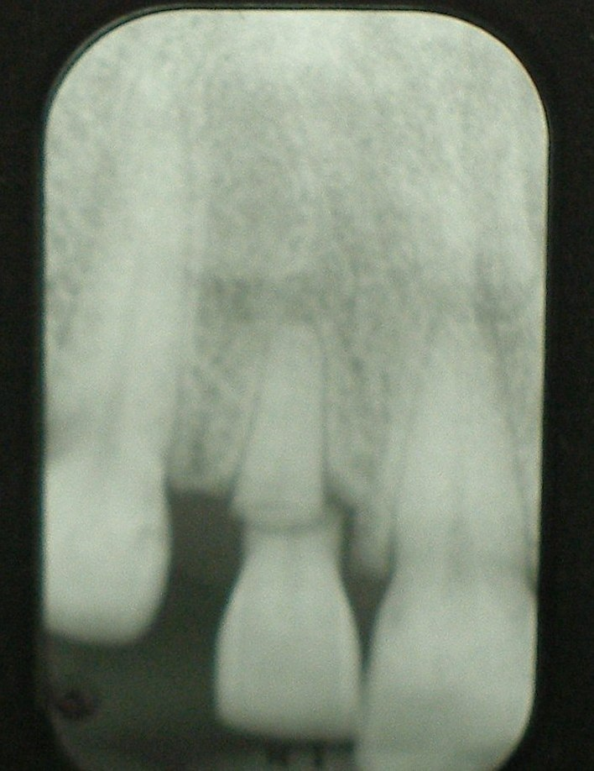

Based on Dr. Boston’s lecture this tooth is non- restorable because:
- Integrity attachment apparatus is compromised
- Root/Restoration Ratio is compromised.
- Endodontic status and treatability.
- Insufficient structure for designing retention.

  - 1, 2 and 3. “Just because you can do an endo doesn’t means tooth
  - 2, 3 and 4. is restorable”
  - 1, 3 and 4
  - 1, 2, 3 and 4.
  - 1, 2 and 4.

- Treatments available so this tooth can be saved include:
  - Root Canal Treatment.
  - Root Canal Treatment followed by a Crown.
  - Root Canal treatment followed by Crown Lengthening and a Crown.
  - Root Canal Treatment, Crown Lengthening, Post/Core, and a Crown.
  - Can not be saved due to fracture position and remaining tooth structure.

- The patient’s general health must be considered when planning dental treatment EXCEPT:
  - To limit or modify dental treatment based on the systemic findings.
  - To prevent emergencies in the dental office.
  - To recognize signs and symptoms of undiagnosed systemic disease.
  - To know when is appropriate to make a consultation with the patient’s primary care provider.
  - To know when to the patient is a good historian of their health.

- The following picture shows a restored Cervical lesion Tooth #6.
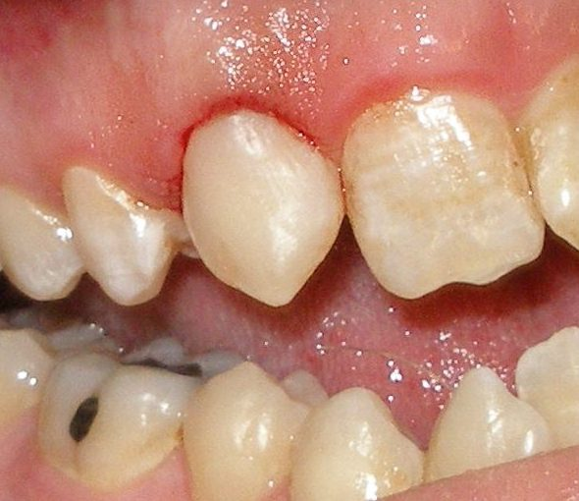
Based on what you learned from Dr. Jefferies lecture, to restore this lesion:
  - Composite Resin is the “Ideal” restorative material.
  - Resin Modified Glass Ionomer is the “ideal’ material.
  - If esthetics were not a problem, Amalgam is the “ideal” material.
  - Moisture control is not a problem with any of the materials.
  - Moisture will cause the Composite to “creep” from the preparation.

- For this lesion, the choice of the restorative material will be influenced by the following EXCEPT:
  - Location of the gingival margin.
  - Moisture control.
  - Occlusion
  - Presence or absence of enamel in the cavosurface margin.
  - Access to the gingival margin.

- Awareness of the patient’s health status should be the first priority for every health care provider.
  - That’s why it is recommended to review the patient’s health history every 6 months.
  - That’s why it is recommended to review the patient’s health history annually.
  - That’s why it is recommended to review the patient’s health history when you see them for the first time.
  - That’s why it is recommended to review the patient’s health history every time you see them.
  - That’s why it is recommended to review the patient’s health history every time you re-register the patient.

.

