PERIODONTOLOGY II EXAM 1 2007
- Phase I periodontal therapy involves which of the following?
    - periodontal scaling and root planning
    - periodontal surgery
    - fixed prosthodontics
    - acquisition of medical consultations
  - all of the above
  - # 1 & 4 only
  - #1 only
  - #1, 2 & 4 only
- In presenting a periodontal treatment plan to a patient, it is important to:
  - Keep language simple in “layman’s terms”.
  - Start the discussions with a clear statement on which teeth need extraction.
  - Obtain informed patient consent for the periodontal examination procedures.
  - Avoid discussion of alternative, non-recommended treatments.
- Phase III therapy includes all except which one of the following?
  - placement of permanent restorations
  - orthodontic therapy
  - dental implant surgical placement
  - endodontic therapy
- Removal of plaque-retentive overhanging dental restorations is carried out at which time point in a periodontal treatment plan?
  - Phase I
  - Phase II
  - Phase III
  - Phase IV
- Emergency dental care is performed at which time point in a periodontal treatment plan?
  - Phase I
  - Phase II
  - Prior to formulation of the treatment plan
  - Only after formulation of the treatment plan
- Determination of a tooth-by-tooth prognosis is carried out only after a periodontal treatment plan in formulated. A patient’s expectations and wishes are considered only after Phase I periodontal therapy is completed.
  - Both statements are true
  - The first statement is true and the second statement is false
  - The first statement is false and the second statement is true
  - Both statements are false
- Generalized advanced periodontitis of equal extent and severity is found in a young patient 22 years old and an older patient 75 years old. How does the age of the patients influence their periodontal prognosis?
  - The prognosis for the older patient is worse since decreased healing capability exists in older patients.
  - The prognosis for the older patient is worse since their remaining life span is shorter.
  - The prognosis for the younger patient is worse since they potentially have a longer life span during which additional progressive periodontal breakdown can occur.
  - The prognosis for the younger and the older patients are the same since the same extent and severity of disease is found in both of them.
- The prognosis for gingivitis cases diagnosed in systemically healthy persons is:
  - good
  - questionable
  - excellent
  - outstanding
- The prognosis for teeth with Grade III mobility is usually:
  - questionable
  - poor
  - hopeless
  - fair
- Grade II and III furcation involvements have a poorer prognosis that non-furcated teeth because they are more difficult to successfully instrument free of microbial plaque and calculus, and have inaccessible areas for patient plaque control procedures. Increasing severity of periodontal attachment loss reduces the periodontal prognosis.
  - Both statements are true
  - The first statement is true and the second statement is false
  - The first statement is false and the second statement is true
  - Both statements are false

- Which of the following does not worsen the periodontal prognosis on a tooth?
    - Patient is a smoker.
    - Short, tapered roots are present.
    - Overhanging dental restorations are present.
    - Crestal alveolar bone loss is negligible.
  - all of the above
  - #4 only
  - #2 only
  - #3 & 4 only
- Prognosis in periodontics is:
  - a blueprint of therapy to be carried out on a patient.
  - a prediction about a disease and its response to proposed therapeutic measures.
  - determined only after a treatment is formulated.
  - unrelated to long-term tooth mortality.
- Margination of neutrophils refers to:
  - chemotactic movement of neutrophils in tissues towards antigens.
  - neutrophil adhesion to blood vessel endothelium.
  - secretion of lysosomal enzymes by neutrophils.
  - neutrophil migration through blood vessel walls.
- Acute inflammation in gingival tissues in response to bacterial penetration is an example of a:
  - non-specific defense mechanism.
  - specific defense mechanism.
  - microbial barrier.
  - none of the above
- The subgingival microbiota in periodontal health as compared to that in periodontitis is:
  - prominently more gram-negative than gram-positive organisms.
  - is dominated more by anaerobic bacteria.
  - is dominated more by gram-positive bacteria.
  - none of the above
- The notion that all dental plaque microorganisms are equally capable of causing periodontal pathology if present in high enough numbers is the basis for which of the following?
  - The specific plaque hypothesis
  - The non-specific plaque hypothesis
  - The ecological plaque hypothesis
  - The red complex species hypothesis
- When dental plaque is visible with the naked eye along the gingival margin of a tooth without filling the interdental space, what is the Plaque Index score for the tooth?
  - 3
  - 2
  - 1
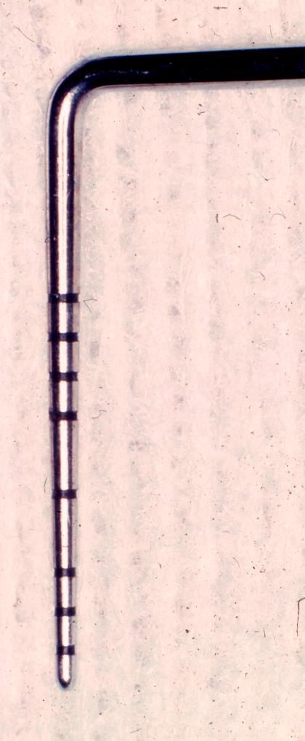
  - +
- The criteria for generalized, severe periodontal attachment loss is:
  - ≥ 50% of sites have ≥ 4 mm of attachment loss
  - ≥ 50% of sites have ≥ 6 mm of attachment loss
  - > 25% of sites have ≥ 6 mm of attachment loss
  - > 30% of sites have ≥ 5 mm of attachment loss
- What instrument is depicted?
  - #11/12 extended explorer
  - World Health Organization (WHO) probe
  - Michigan-O probe with Williams markings
  - Nabers probe
- A PSR score of 3 represents:
  - The presence of spontaneous gingival bleeding without provocation.
  - The presence of at least one site in a dentition sextant with a probing depth between 3.5 to 5.5 mm.
  - The presence of at least one site in a dentition sextant with a probing depth > 5.5 mm.
  - The presence of calculus or an overhanging margin of a dental restoration in a dentition sextant
  - having all probing depths < 3.5 mm.
- Spot bleeding on probing only is seen with:
  - Papillary Bleeding Index = 2
  - Gingival Index = 1
  - Papillary Bleeding Index = 1
  - Plaque Index = 1

- When a dentist places the ball of his/her index finger along the lateral aspect of the marginal gingival of a tooth, applies pressure in a rolling motion toward the crown of the tooth, and then visually observes the orifice of the periodontal pocket, what is being evaluated?
  - Presence of fremitus
  - Presence of occlusal trauma
  - Presence of suppuration
  - Presence of subgingival dental plaque
- Cytomegalovirus is thought to enter periodontal tissues via transport in:
  - neutrophils
  - monocytes and macrophages
  - B-lymphocytes
  - T-lymphocytes
- Subgingival colonization of shallow periodontal pockets by red and orange complex microbial species is enhanced by which of the following?
  - IL-1β positive genotype
  - smoking
  - black (African-American) racial identification
  - both A and B
- Which of the red complex microbial species is motile?
  - Porphyromonas gingivalis
  - Tannerella forsythensis
  - Treponema denticola
  - none of them
- Initiation of localized aggressive periodontitis is most closely associated with which of the following?
  - Aggregatibacter (Actinobacillus) actinomycetemcomitans
  - Selenomonas noxia
  - Campylobacter rectus
  - all of the above
- Supragingival calculus appears what color when it is dried by an air blast during an oral exam?
  - brown-black
  - light green
  - white
  - all of the above
- A moderate periodontal probing depth is:
  - 3-4 mm as measured from the CEJ
  - more than 6 mm
  - always accompanied by at least 1 mm of gingival recession as measured from the CEJ
  - 4-6 mm
- When 6.0 millimeters in length is measured between the radiographic CEJ to the most coronal level of intact supporting bone, what is the actual loss of alveolar bone on the site?
  - 4.0 to 4.5 mm
  - 6 to 6.5 millimeters
  - 7.5 to 8.0 mm
  - cannot be determined from the data provided
- A five millimeter distance is measured from the CEJ of a tooth to the apical extent of penetration with light pressure of a periodontal probe into the gingival sulcus. What is being measured?
  - A moderate periodontal probing depth
  - moderate periodontal attachment loss
  - severe periodontal attachment loss
  - cannot determine from the data provided
- Mutation of the cathepsin C gene on chromosome 11 is associated with which of the following?
  - Increased pro-inflammatory cytokine secretion by macrophages and plasma cells.
  - Severe localized aggressive periodontitis associated with Ehlers-Danlos syndrome.
  - Severe generalized aggressive periodontitis associated with Papillion-Lefevre syndrome.
  - Functional polymorphisms in Fc receptor sites on IgG immunoglobulins.
- Which of the following represent shortcomings in current genetic testing for IL-1 polymorphisms as adiagnostic indicator of human periodontitis risk?
    - Other significant genetic polymorphisms associated with periodontitis are not evaluated.
    - IL-1 polymorphisms may have clinical value in only certain select population groups of northern European origin.
    - Lack of prospective study data demonstrating that predetermination of a positive IL-1 genotype in fact leads to a higher risk of subsequent periodontitis disease development.
    - Lack of conclusive study data showing that IL-1 genotype analysis gives the treating clinician the ability to better modify the course of or prevent periodontitis.
  - all of the above
  - #3 only
  - #1, 2 & 3 only
  - #3 & 4 only
- Which of the following are associated with complex gene disorders?
    - Consistent clinical disease phenotype (appearance) is found.
    - Adult onset, with chronic disease state.
    - Environmental factors, as well as genetic factors, are significant and important in disease etiology.
    - Gene polymorphisms cause only slight change in function of gene product (functional polymorphism).
  - all of the above
  - #1, 2 & 4 only
  - #2, 3 & 4 only
  - #3 only
- Persons who are genotype-negative for the CD14-260T/T genotype polymorphism may be more susceptible to developing periodontal infections with plaque bacteria that otherwise exhibit low pathogenicity.
  - The statement is true.
  - The statement is false.

