ORTHODONTICS I EXAM 200?
- An infant’s head is typified by the following ratio of cranium to face:
  - Large cranium to large face
  - Small cranium to large face
  - Small cranium to small face
  - Large cranium to small face
- The largest yearly increments in facial growth after birth occur
  - During the pubertal growth spurt
  - At late childhood, just prior to the pubertal growth spurt
  - During the first two years of life
  - Around age 5-6 years
- The chronological age of a growing individual is always well correlated with his:
  - Dental age
  - Skeletal age
  - Height
  - None of the above
- The largest yearly increments in facial growth after birth occur:
  - During the pubertal growth spurt
  - At late childhood, just prior to the pubertal spurt
  - During the first two years of life
  - Around age 5-6 years
- The chronological age of a growing individual is always well correlated with his:
  - Dental age
  - Skeletal age
  - Height
  - None of the above
- Menarche always occurs
  - One year before the onset of the pubertal growth spurt
  - Exactly at the onset of the pubertal growth spurt
  - At the peak of the pubertal growth spurt
  - At the deceleration phase or the pubertal growth spurt
- The chin in modern man develops by:
  - Endochondral ossification at menton
  - Excessive bone apposition at the pogonion and gonion
  - Exdochondral ossification in the mandibular condyle and ramus
  - Apposition of bone at pogonion and periosteal resorption of the alveolar bone above it
- This profile is:
  - Straight
  - Concave
  - Convex
  - None of the above
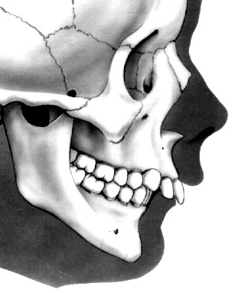
- This malocclusion shows:
  - Class I malocclusion
  - Class II malocclusion
  - Class III malocclusion
  - Class I normal occlusion
- Muscle bone relationship in craniofacial growth and development may be defined as follows:
  - Both tissues grow independently
  - Bone growth determines the extent of muscle development
  - Muscle development determines the ultimate size and shape of adjacent bony elements
  - The shape of the facial soft tissues can be constructed from skeletal remains

- Cartilage is replaced by bone in the following craniofacial regions:
  - The cranial base and cranial vault
  - The cranial base and the nasal septum
  - The mandible and the maxilla
  - The cranial base and the secondary palate
- The response of cartilage and bone to mechanical stress (pressure and/or tension) is as follows:
  - Both tissues resorb at tension sites
  - Both tissues respond to pressure by apposition of new tissues
  - Pressure causes cartilage resorption, but bones do not respond to pressure
  - Bone responds to pressure by resorption while cartilage does not respond to pressure
- A suture may be defined as a
  - Growth site
  - Growth center
  - Growth determinant
  - Growth inhibitor
- The size of the cranium is determined by:
  - Bone growth at suture sites
  - Bone growth around synchondroses
  - The expanding brain
  - Growth of the face
- The cranial base in embryonic life does not respond to pressure from growing neural mass because at that time its main tissue constituent:
  - Fibrous connective tissue
  - Bone
  - Muscle
  - Cartilage
- Room for the development and eruption of the maxillary molars is produced by:
  - Resorption of the pterygoid plates
  - Mesial migration of all primary teeth and deposition along the anterior part of the bony maxillary arch
  - Anterior displacement of the maxilla and deposition at the tuberosity
  - Vertical growth of the nasomaxillary complex
- During the course of mandibular growth the lower incisors become:
  - Crowded
  - Spaced
  - Rotated
  - Impacted
- The eruptive path of the mandibular incisors is usually:
  - Straight upward
  - Straight labially
  - Upward and labially
  - Upward and lingually
A patient’s cephalometric analysis is as follows:
SNA = 92°
SNB = 80°
ANB = 12°
Ī NA = 22°, 4mm
I NB = 25°, 4mm
I – Ī = 131°
- This problem is best summarized as being:
  - Skeletal only
  - Dental only
  - Combination skeletal and dental
  - None of the above
- The problem is best stated as:
  - Maxillary hyperplasia
  - Maxillary hypoplasia
  - Mandibular hypoplasia
  - Mandibular hyperplasia
- The growth curve of lymphoid tissues, according to scammon reaches mature size following:
  - Rapid proliferation and growth during puberty
  - Moderate growth in childhood to about 50% of adult size, followed by additional growth at puberty
  - Rapid growth at childhood to about twice the adult size then gradual reduction around puberty
  - None of the above
- The anterior surface of the maxilla is mainly sites of bone apposition:
  - True
  - False
- The mandible of the young child appears small and under developed relative to upper jaw and the face in general
  - True
  - False
- S-N plane can be used in superimpositioning in cephalometric analysis.
  - True
  - False
- The term growth refers to an increase in size (quantitatively) while development is growth toward maturity.
  - True
  - False
- Which one of the following statements is correct:
  - Drift means apposition – resorption and displacement is backward growth, forward movement
  - Displacement means apposition – resorption and drift is backward and forward growth
  - Drift and displacement can be used interchangeably
  - None of the above
- The direction of condylar growth is:
  - Upwards
  - Upward and backward
  - Backwards
  - Forwards
- According to Moss, the mandibular growth Vector can be described by a:
  - Circle
  - Triangle
  - Logarithmic curve
  - Straight line
- Secondary displacement of the mandible occurs as a result of
  - Condylar growth
  - Bone apposition at the posterior border of the ramus
  - Alveolar bone resorption at the labial surface of the mandibular incisors
  - Periosteal apposition at the temporal bone, opposite the condyle
- The descent of the nasal floor is effected by:
  - Resorption of the nasal floor
  - Resorption of the top of the cranial vault
  - Vertical growth of the maxillary dento-alveolar process
  - Mandibular condylar growth
- In an individual whose mandible is growing forward more than it should (skeletal Class III) the mandibular incisors will probably incline
  - Forward (labially)
  - Backward (lingually)
  - Normally
  - None of the above, there is no relationship between mandibular growth and incisor inclination
- Measurement of body weight at a given moment:
  - Depends on the degree of hydration of the tissue
  - Does not depend on the degree of tissue hydration
  - Will be changed by the water retaining effect of estrogens
  - Both A and C are correct
- The dental age of an individual is assessed by:
  - The stage of crown or root formation as determined by panorex X-ray
  - The degree of crown mineralization as determined radiographically
  - The size of crowns of the primary teeth
  - The size of crowns of the permanent teeth
- In evaluating the state of Dental development of a given child, it is important to consider that
  - Height and weight have a definite relationship to the degree of tooth development
  - The rate of tooth development in boys is considerably more advanced than in girls
  - Individual variables exist because of discrepancies between chronological and dental age
  - None of the above
- A tooth is responsible for the alveolar bone that supports it. If the tooth is extracted, the alveolar bone will disappear. This statements is most closely related to:
  - The Scott’s Theory of Craniofacial Growth
  - The Sicher’s Theory of Craniofacial
  - The Moss Theory of Functional Matrix
  - The Baum Theory of Growth Center

- Enlarged tonsil in a 6 year old child are at age 12, most likely to be:
  - Larger
  - Smaller
  - The same size
  - Purulent
  - Hyperemic
- The cranial vault increases rapidly in size the first few years postnatally and complete approximately 90% of its growth by six years of age. This is typical of which of the following types of tissues?
  - Neural
  - Dental
  - Genital
  - Lymphoid
  - General (somatic)
- The Lee Way Space results from the disparity in size between the posterior primary teeth and their successors.
  - True
  - False
- In a lateral cephalogram, (cephalometric analysis) the angel ANB relates:
  - The maxilla to the anterior cranial base
  - The mandible to the anterior cranial base
  - The maxilla to the mandible
  - The maxillary to mandibular incisor
- The malocclusion above is:
  - Class I malocclusion
  - Class II, Division I malocclusion
  - Class II, Division II malocclusion
  - Class III malocclusion
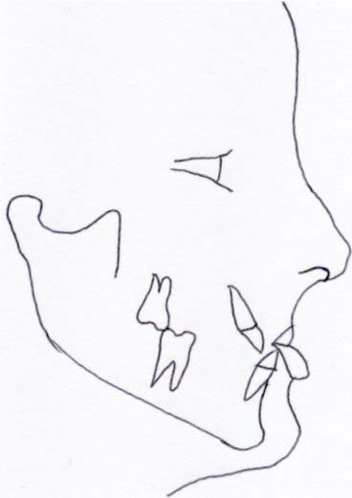
- The above profile is:
  - Straight
  - Concave
  - Convex
  - None of the above
- The above facial type is:
  - Brachycephalic
  - Dolichocephalic
  - Mesocephalic
  - None of the above
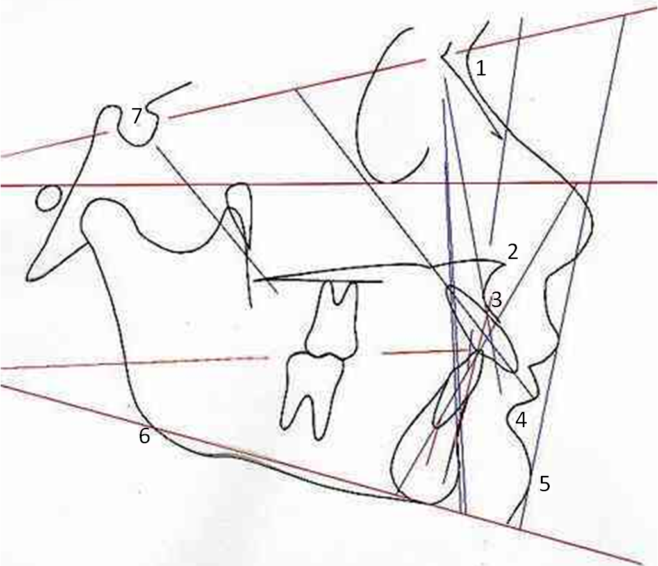
- The malocclusion in the above illustration is
  - Class II Division I
  - Class II Division II
  - Class I Normal occlusion
  - Class I Malocclusion
- This malocclusion shows:
  - Deep overbit
  - Open bite
  - Normal bite
  - None of the above
- The profile is:
  - Concave
  - Convex
  - Straight
  - None of the above
- Which number identifies cephalometric point A:
  - 2
  - 4
  - 5
  - 3
- Which number identifies cephalometric point B:
  - 5
  - 4
  - 3
  - 2
- Which number identifies Nasion (cephalometric point N):
  - 7
  - 2
  - 1
  - None of the above
A patient’s cephalometric analysis is as follows:
SNA = 82°
SNB = 75°
ANB = 7°
Ī NA = 22°, 4mm
I NB = 25°, 4mm
I – Ī = 131°
- This problem is best summarized as being
  - Skeletal only
  - Dental only
  - Combination skeletal and dental
  - None of the above
- The problem is best stated as:
  - Maxillary hyperplasia
  - Maxillary hypoplasia
  - Mandibular hypoplasia
  - Manidbular hyperplasia

- The anterior surface of the maxilla is mainly sites of:
  - Bone resorption
  - Bone apposition
  - Endochrondral ossification
  - Connective tissue proliferation
- Displacement is caused by apposition and resorption; while drift is backward growth and forward movement.
  - True
  - False
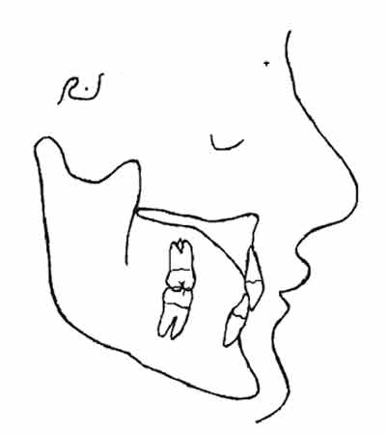
- The malocclusion in the above illustration is:
  - Class I malocclusion
  - Class II Division I malocclusion
  - Class II Division II malocclusion
  - Class III Malocclusion
- At birth, the position of the maxilla in relation to the mandible is:
  - Retrusive (backward)
  - Protrusive (forward)
  - Same antero-posterior position (straight profile)
  - None of the above
- The V-principle asserts that a growing V-shaped bony element display resorption:
  - At the periosteal surface
  - At the endosteal surface
  - Only near the reversal line
  - Only after growth by apposition is complete
- A 7 year old child presents to the clinic with an anterior open bite malocclusion. Cephalometric radiograph and analysis would be helpful for the following reasons:
  - To discern whether this is a skeletal or a dental problem
  - To serve as baseline data in studying the growth of this patient
  - To help develop specific treatment goals for the patient
  - All of the above
  - None of the above
- The downward and forward direction of facial growth results from:
  - Upward and backward growth of the maxillary structures and the mandibular condyles
  - Vertical eruption and mesial drift of the dentitions
  - Interstitial growth in the maxilla and the mandible
  - Epithelial induction oat the growth centers
- The Lee Way Space, results from the disparity in size between the posterior primary teeth and their successors
  - True
  - False
- A suture may be defined as:
  - Growth Site
  - Growth center
  - Growth determinant
  - Growth inhibitor
- Mandibular growth usually ends:
  - At the same time as the maxilla
  - 2 years after the maxilla
  - Two years before the maxilla
  - None of the above

- In cephalometrics, the Frankfort horizontal plane passes:
  - Vertically from orbitale through the maxillary canine
  - Vertically from chin point through nasion
  - Horizontally from infraorbitale to the superior aspect of external auditory meatus
  - Horizontally from nasion through superior aspect of external auditory meatus
- Cephalometrics is used in orthodontics to:
  - Treat malocclusion
  - Study growth changes
  - Aid in diagnosis and case analysis
  - B and C
- The head of the condyle shows unique arrangement of tissue and cells:
  - True
  - False
- The cranial vault increases rapidly in size the first few years postnatally an d completes approximately 90 percent of its growth by 5 years of age. This is typical of which of the following types of tissues?
  - Neural
  - Genital
  - Lymphoid
  - General
- The direction of mandibular growth is best observed with the following:
  - The Y axis (the intersection of the Frankfort horizontal plane and a line drawn from Sella to Gnathion)
  - Inclination of lower incisors to mandibular plane
  - Inclination of lower incisors to upper incisors
  - Angle SNB
- Which of the following factors can control growth and maturation
  - Heredity
  - Hormones
  - Nutrition
  - All of the above
- Bone is not a static tissue
  - True
  - False
- The term growth refers to an increase in size (quantitatively) while development is a growth toward maturity.
  - True
  - False
- In clinical cephalometrics the anterior cranial base is measure from Sella to nasion.
  - True
  - False
- The anterior cranial base completes its growth several years before the posterior cranial base.
  - True
  - False
- From a lateral perspective, the brain grows as if it were a wedge from a circle. The portion closest to the center of the circle grows least, where as the farthest portion grows the most.
  - True
  - False
- The mandible is NOT an example of posterior growth – anterior displacement.
  - True
  - False
- The principal growth cartilage of the cranial base during childhood is:
  - The spheno-ethmoidal synchondrosis
  - The spheno-occipital synchondrosis
  - The spheno-presphenoidal synchondrosis
  - The inter-ethmoidal synchondrosis
- Soft tissue analysis (in cephalometrics) considers the position of:
  - Nose
  - Chin
  - Lips
  - All of the above
- The best means to assess the Skeletal Age of a growing child is from measurements of:
  - Standing height
  - Body weight
  - The size of the mandible in a Cephalometric X-ray
  - Radiograph of the hand and wrist

- According to Moss:
  - The functional matrix is subordinate to and supportive of skeletal unit
  - The skeletal unit is subordinate to and supportive of the functional matrix
  - The skeletal unit and functional matrix are not related at all
  - None of the above
- The vertical lengthening of the nasomaxillary complex is brought about by
  - The vertical growth of the mandible
  - The downward growth of the ethmoid bone
  - Resorption of the nasal side of the palate and apposition on the oral side
  - Resorption of the oral side of the palate and apposition on the nasal side
- Room for the development and eruption of the maxillary molars is produced by:
  - Resorption of the pterygoid plates
  - Mesial migration of all primary teeth and deposition along the anterior part of the maxillary arch
  - Anterior displacement of the maxilla and deposition at the Tuberosity
  - Vertical growth of nasomaxillary complex
- The chronological age of a growing individual is always well correlated with his dental age
  - True
  - False
- Which one of the following statement is/are correct?
  - Brachyfacial pattern usually have a long facial pattern
  - Dolichofacial pattern usually have a broad facial pattern
  - Both A and B
  - None of the above
- Which of the following conditions is usually present in Class II Division II malocclusions?
  - Open bite
  - Retrusion of the maxillary lateral incisors
  - Retrustion of the maxillary central incisors
  - None of the above
- At birth, the overall growth of the cranium is about:
  - 90% complete
  - 5-10% complete
  - 60-65% complete
  - Totally complete
- Enlarged adenoids in a 4 year old boy may cause the development of a
  - Thumb sucking habit
  - Mouth breathing habit
  - Both A and B
  - Neither A or B
- Part(s) of the bone that is/are operative in bone transformation:
  - Compact bone
  - Spongy bone
  - Both A and B
  - Neither A or B
- A reversal line means
  - The growth rate after the peak of the pubertal growth spurt
  - The outline of the suture on the ectocranial side of the cranial vault
  - The border between cartilage and bone
  - The boundary between adjacent surfaces of bone apposition and resorption
- Frankfort horizontal is a reference plane constructed by joining which of the following landmarks?
  - Nasion and sella
  - Porion and sella
  - Porion and masiona
  - Porion and orbitale
  - Basion and orbitale
- Which of the following tissue grows to 200 percent of its normal adult mass during ages 6-12?
  - Neural
  - Genital
  - Lymphoid
  - General (skeletal, muscular)
- In cephalometric analysis of children with malocclusions the angel ANB is frequently used, in patients with severe Class II malocclusion, this angle
  - Greater than the norm
  - Less than the norm
  - Normal
  - Unrelated
- During bodily movements of a tooth toward the lingual, which of the following are found on the root surface of the lingual alveolar wall?
  - Osteoblasts
  - Osteoclasts
  - Ameloblasts
  - Cementoclasts
  - Plasma cells
- Females will generally mature how many years ahead of males?
  - 1 years
  - 2 years
  - 3 years
  - 4 years
- The malocclusion in the above picture is:
  - Class II, Division I
  - Class II, Division II
  - Class I, normal occlusion
  - Class III malocclusion
- The malocclusion shows:
  - Deep overbite
  - Open bite
  - Normal bite
  - None of the above
- The profile is
  - Concave
  - Convex
  - Straight
  - None of the above

MISC PRECLINICAL ORTHODONTIC QUESTIONS
- Which of the following is the LEAST common?
- Class I malocclusion
- Class II malocclusion
- Class III malocclusion
- Normal occlusion
- Which of the following CANNOT be reliably assessed from a set of orthodontic study casts?
  - Amount of overjet
  - Arch crowding
  - Location of unerupted teeth
  - Location of crossbites
  - Molar relation
- Which malocclusion is described by the following two statements? 1) The distobuccal cusp of the upper first permanent molar (bilaterally) is located, when in occlusion, in the buccal groove of the lower first permanent molar. 2) Increased overjet of the maxillary incisor teeth.
  - Class I malocclusion
  - Class II, division 1 malocclusion
  - Class II, division 2 malocclusion
  - Class III malocclusion
- Which one of the following is associated with edge-to-edge incisors?
  - Class I malocclusion
  - Class II, division 1 malocclusion
  - Class II, division 2 malocclusion
  - Class III malocclusion

- Transverse dysplasias can occur in all Angle types of malocclusion. Vertical problems occur only in Angle Class III malocclusion.
  - The first statement is true; the second is false.
  - The first statement is false; the second is true.
  - Both statements are true.
  - Both statements are false.
- Which of the following statements is true for the Angle classification?
  - Describes sagittal relationships
  - Describes spacing and crowding
  - Identifies transverse discrepancies
  - Localizes the skeletal discrepancy
- Which malocclusion is described by the following two statements? 1) The disto-buccal cusp of the upper first permanent molar (bilaterally) is located, when in occlusion, in the buccal groove of the lower first permanent molar. 2) There is a deep overbite of the incisor teeth.
  - Class I malocclusion.
  - Class II, division 1 malocclusion
  - Class II, division 2 malocclusion
  - Class III malocclusion
- Which profile is characterized by a curve from the bridge of the nose to the chin with the maxillary structures appearing relatively posterior to the chin?
  - Concave
  - Convex
  - Oblique
  - Straight
- What is the facial type when the mandible is forward in relation to the rest of the profile?
  - Mesognathic
  - Orthognathic
  - Prognathic
  - Retrognathic
- Angle Class I occlusion can be called
  - mesioclusion.
  - metaclusion.
  - neutroclusion.
  - orthoclusion.
- The definitive diagnosis of lateral functional shift due to transverse maxillary deficiency is based on
  - a panoramic radiograph.
  - clinical examination.
  - measurement of maxillary intermolar width.
  - plaster study casts.
- What is the correct Angle classification for a patient having right side first permanent molars in neutroclusion and left side permanent molars in distoclusion?
  - Class I, subdivision left malocclusion
  - Class I, subdivision right malocclusion
  - Class II, division 1 or 2, subdivision left malocclusion
  - Class II, division 1 or 2, subdivision right malocclusion
- Growth of the living human skull
  - involves a uniform increase in size.
  - is easily measured with calipers.
  - is not important in planning orthodontic treatment.
  - varies from year to year in rate, direction and amount.
- The orthodontic problem list includes only abnormalities that can be treated. Diagnosis of malocclusion is completed before preparing a treatment plan.
  - The first statement is true; the second is false.
  - The first statement is false; the second is true.
  - Both statements are true.
  - Both statements are false.
- In planning orthodontic treatment for a patient who appears to have a discrepancy between the amount of tooth material and the size of the dental arches, which of the following is likely to provide diagnostic information that is directly pertinent to this issue?
  - Dental history
  - Facial photographs
  - Panoramic radiograph
  - Study casts

- Imagine a typical Angle Class II division 2 malocclusion. Now, properly align all the maxillary teeth, but do NOT change the molar relation. What would be the resulting overjet of the maxillary incisors?
  - Excessive
  - Minimal
  - Normal
  - Reverse
- A force was applied to a tooth by an orthodontic appliance, and a hyalinized zone developed in the periodontal ligament. As long as the hyalinized zone is present, the rate of movement of the tooth will be approximately
  - 100 microns per day.
  - 50 microns per day.
  - 25 microns per day.
  - 0 microns per day.
- When a tooth undergoes controlled tipping, how many pressure zones would you expect to find in the PDL?
  - None
  - One
  - Two
  - Gazillions
- After orthodontic treatment, what would you expect careful examination of the tooth roots to reveal?
  - Decreased root length
  - Increased root length
  - Increased thickness of cementum
  - No change in any aspect of the tooth roots
- Basion is a midline point on the anterior border of foramen magnum. PNS is part of the palatine bone.
  - The first statement is true; the second is false.
  - The first statement is false; the second is true.
  - Both statements are true.
  - Both statements are false.
- Porion is a part of the
  - ethmoid bone.
  - frontal bone.
  - occipital bone.
  - sphenoid bone.
  - temporal bone.
- Which of the following cephalometric landmarks is a midline, i.e. an unpaired, structure?
  - Gonion
  - Orbitale
  - Porion
  - Pterygomaxillary fissure
  - Sella
- On a cephalometric radiograph the images of structures on the right side of the head usually appear further forward than those on the left side BECAUSE the divergent rays of the X-ray beam project bilateral structures onto different locations.
  - Both the statement and the reason are correct and related.
  - Both the statement and the reason are correct but NOT related.
  - The statement is correct but the reason is NOT.
  - The statement is NOT correct but the reason is accurate.
  - NEITHER the statement NOR the reason is correct.
- The standard cephalometric radiographs are lateral (profile) and postero-anterior (P-A, the X-ray source located behind head and X-ray film located in front of the face). Both of these cephalometric radiographs are standardized with mid-sagittal plane of the head perpendicular to the floor and head in natural head position.
  - The first statement is true; the second is false.
  - The first statement is false; the second is true.
  - Both statements are true.
  - Both statements are false.
- What is needed so that soft tissues are clearly visible on a lateral cephalometric radiograph?
  - Adjustment in kilovoltage
  - Adjustment in millamperage
  - A soft tissue shield
  - A hard tissue shield
  - Nothing must be done to make soft tissues visible
- The ANB angle describes which of the following?
  - Flexure of the cranial base
  - Growth direction of the mandible
  - Position of the chin
  - Relation of the maxillary and mandibular denture bases

- Which of the following is NOT necessarily found in Angle Class II division 1 skeletal malocclusions?
  - Class II molar relationship
  - Deep overbite
  - Excessive overjet
  - Large ANB angle
- One way to increase magnification of the image in cephalometric radiographs is to decrease the anode-to-film distance. One way to increase magnification of the image in cephalometric radiographs is to increase the subject-to-film distance.
  - The first statement is true; the second is false.
  - The first statement is false; the second is true.
  - Both statements are true.
  - Both statements are false.
- A child has a prognathic mandible when his teeth are in occlusion but a straight profile when his teeth are slightly apart. What is the most likely diagnosis?
  - Anterior crossbite
  - Anterior functional shift
  - Class III malocclusion
  - Facial pain
- Premature loss of an upper or lower primary second molar almost always results in the loss of space for the unerupted bicuspid. A space maintainer is indicated whenever there has been premature loss of an upper or lower primary second molar.
  - The first statement is true; the second is false.
  - The first statement is false; the second is true.
  - Both statements are true.
  - Both statements are false.
- In a growing child, an ankylosed tooth appears to "submerge" as adjacent, unaffected teeth continue their normal pattern of eruption. An ankylosed tooth cannot be moved orthodontically.
  - The first statement is true; the second is false.
  - The first statement is false; the second is true.
  - Both statements are true.
  - Both statements are false.
- A malocclusion characterized by a basal bone disharmony is said to be skeletal in nature. A malocclusion characterized by crowded teeth is said to be dental in nature.
  - The first statement is true; the second is false.
  - The first statement is false; the second is true.
  - Both statements are true.
  - Both statements are false.
- Which of the following is the most effective clasp for use on removable acrylic and wire appliances?
  - Adams clasp
  - Arrowhead clasp
  - Ball clasp
  - 'C' clasp
- Which of the following wires would be MOST suitable for a finger spring on a removable appliance where gentle force was desired?
  - 0.016 inch diameter stainless steel wire
  - 0.016 x 0.022 inch stainless steel wire
  - 0.028 inch diameter stainless steel wire
  - 0.036 inch diameter stainless steel wire
- An active finger spring of a removable appliance usually touches the tooth with a point contact. What is the most likely type of tooth movement produced in this situation?
  - Extrusion
  - Intrusion
  - Tipping
  - Translation
- An orthodontic bracket is positioned farther toward the gingival on tooth #7 than comparable brackets on the adjacent teeth. What will be the resulting tooth movement when an archwire is placed?
  - Tooth #7 will extrude.
  - Tooth #7 will intrude.
  - Tooth #7 will rotate.
  - Tooth #7 will translate.
- After brackets are bonded on the maxillary anterior teeth an archwire is placed. The wire fits into all of the brackets except for the one on tooth #10. The long axis of the bracket slot on this tooth crosses the archwire at an angle of five degrees. When the wire is placed in the bracket slot on tooth #10 the resulting tooth movement is best described as
  - extrusion.
  - intrusion.
  - tipping.
  - translation.

- Which malocclusion is most commonly associated with traumatic injury to maxillary incisors?
  - Class I
  - Class II, division 1
  - Class II, division 2
  - Class III
- What is the effect of incorporating a helix in a finger spring, as compared to a similar spring without a helix?
  - Both springs are the same stiffness.
  - The spring with a helix is less stiff.
  - The spring with a helix is more stiff.
- Which of the following is NOT an appropriate appliance to treat Class II maloclusion?
  - Functional Regulator II
  - Functional Regulator III
  - Herbst appliance
  - Twin Block appliance
- In developing a comprehensive multi-disciplinary treatment plan, the primary care dentist must communicate with the orthodontic specialist. A patient receiving comprehensive orthodontic treatment from a specialist must return for regular recall appointments.
  - The first statement is true; the second is false.
  - The first statement is false; the second is true.
  - Both statements are true.
  - Both statements are false.
- Informed consent is important for orthodontic patients BECAUSE many adverse outcomes are possible.
  - Both the statement and the reason are correct and related.
  - Both the statement and the reason are correct but NOT related.
  - The statement is correct but the reason is NOT.
  - The statement is NOT correct but the reason is accurate.
  - NEITHER the statement NOR the reason is correct.
- Bending a piece of stainless steel wire into a 'z' spring occurs in a region of the stress-strain curve that is
  - below the proportional limit.
  - beyond the failure point.
  - within the area of formability.
  - within the area of resilience.

