D-277 Dental Physiology Quiz 3. Tuesday, May 18, 2010
__________________________________
Name Student Number
(0.5 pts. for each correct answer)
Instructions: Select the best answer.

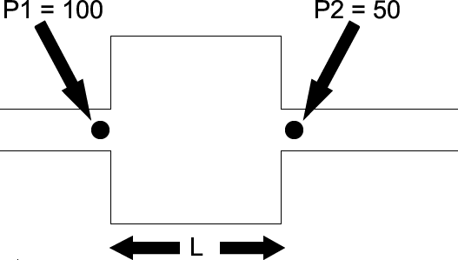
- Doubling which one of the following will double the blood flow through the vessel shown above?
  - Pressure 1 (P1)
  - Pressure 2 (P2)
  - **The difference between Pressure 1 and Pressure 2 (P1 – P2)
  - The length of the vessel (L)

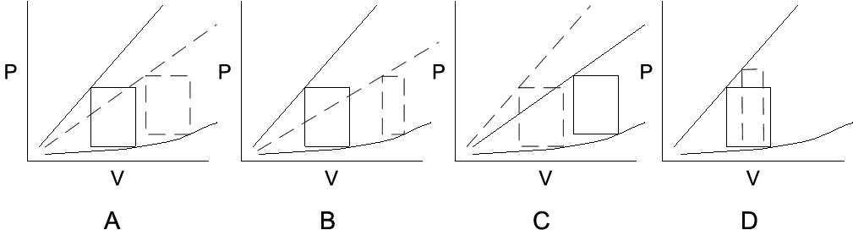
- Which figure (dashed line) shows a pressure volume loop which demonstrates all of the following: 1) a decrease in contractility, 2) an increase in preload, and 3) no change in stroke volume?
  - **Figure A
  - Figure B
  - Figure C
  - Figure D

- Cutting both carotid sinus nerves would result in which of the following?
  - An increase in heart rate
  - An increase in sympathetic nervous system activity
  - A decrease in parasympathetic nervous system activity
  - **All of the above

- Which one of the following will decrease the heart rate?
  - Increasing the slope of phase 4 depolarization of the SA node
  - Making the threshold of the SA node more negative
  - **Making the most negative membrane potential reached during phase 4 of the SA node potential more negative
  - Cutting the parasympathetic nerves which innervate the SA node

