PHYSIOLOGY EXAM 3 2006
- In which vessel shown below, will the blood velocity be the greatest? This schematic is reproduced from the tutorial on hemodynamics.
  - Vessel A
  - Vessel B
  - Vessel C
  - The blood velocities will be equal in all vessels
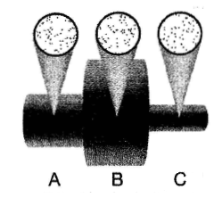
- What is the total blood flow through the circuit shown above? This schematic is reproduced from the tutorial on hemodynamics.
  - 3
  - 10
  - 30
  - 90
- Doubling which of the following will have the greatest effect on blood flow through a vessel:
  - The length of the vessel
  - The pressure difference between the proximal and distal ends of the vessel
  - The radius of the vessel
  - The viscosity of the blood
- Which of the following is most likely greater than normal in a carotid artery in which plaque build-up has caused a bruit (an abnormal sound)?
  - Blood flow
  - Blood velocity
  - Cross sectional area
  - Blood pressure
- The phosphorylation of which protein decreases the time required for cardiac relaxation?
  - L type calcium channel
  - Phospholamban
  - Troponin
  - B and C are correct
- Which of the following will increase the force of cardiac muscle contraction?
  - An increase in sarcomere length from 1.8 to 2.0 microns
  - Phosphorylation of the L type calcium channel
  - An increase in the intracellular calcium concentration
  - All of the above
- During which phase of the cardiac cycle are both the mitral and aortic valves closed and the left ventricular pressure is decreasing?
  - Isovolumic contraction
  - Ejection
  - Isovolumic relaxation
  - Filling

- If the end-diastolic volume is held constant and the ejection fraction is increased:
  - The stroke volume will be decreased
  - The end-systolic volume will be increased
  - The cardiac output will be increased
  - The heart rate will be increased
- If the refractory period of the atrioventricular nod is increased significantly as a result of medication given to a patient who has atrial fibrillation:
  - The frequency at which the SA node produces action potentials will be increased
  - The ventricular rate (frequency of ventricular contraction) will be decreased
  - The time available for filling of the ventricles will be decreased
  - Cardiac output will be decreased
- Which of the following will increase the heart rate?
  - An increase in the slope of phase 4 depolarization
  - A shift in the threshold to a more positive (less negative) value
  - An increase in the duration of phase 4 of the SA node action potential
  - A shift in the most negative portion of phase 4 of the SA node action potential to a more negative potential
- Which of the following statements about the P-R interval is true?
  - It begins with depolarization of the SA node
  - Increasing its duration will increase the heart rate
  - Its duration can be increased by decreasing the speed of propagation of the action potential through the AV node
  - Normally lasts less than 0.1 seconds
- The T wave:
  - Represents atrial repolarization
  - Occurs before the ST segment
  - Is upright (above the baseline) in all leads
  - Represents repolarization of both the right and left ventricles
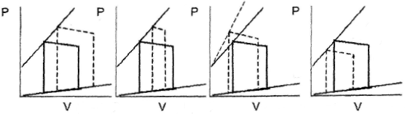
A B C D
- Which pressure loop above demonstrates an increased contractility and a decreased preload, compared to control? The control loops are constructed using solid lines:
  - Loop A
  - Loop B
  - Loop C
  - Loop D
- If total peripheral resistance is increased with no change in contractility, heart rate or end-diastolic volume then: (hints: MBP = CO*TPR and drawing a PV loop will be helpful)
  - Peak ventricular pressure will be increased
  - Stroke volume will be decreased
  - End-systolic volume will be increased
  - All of the above
- When compared to normal people, which of the following will be found in most patients in heart failure?
  - Decreased contractility
  - Increased ejection fraction
  - Decreased wall stress
  - Decreased preload
- Which is the best measure of ventricular preload?
  - Aortic pressure
  - End-diastolic left ventricular pressure
  - Pulse pressure
  - End-diastolic left ventricular volume
- As you move distally along the large systemic arteries:
  - The systolic pressure decreases
  - The diastolic pressure increases
  - The mean pressure decreases
  - The pulse pressure decreases

- Which will increase the pulse pressure?
  - An increase in the stroke volume
  - An increase in the aortic compliance
  - An increase in the heart rate
  - Hemorrhage
- The mean circulatory pressure (MCP) is:
  - Equal to the normal central venous pressure
  - Increased when total peripheral resistance is increased
  - The pressure within the cardiovascular system when there is no blood flow
  - Decreased when blood volume is increased
- Soon after the start of inspiration, systemic arterial blood pressure falls because:
  - The interventricular septum is shifted to the left, reducing filling of the left ventricle
  - Total peripheral resistance decreases
  - Heart rate decreases
  - Intrathoracic (intrapleural) pressure becomes more positive
- Which will shift the vascular function curve to the left?
  - A decrease in venous compliance
  - A decrease in total peripheral resistance
  - A decrease in blood volume
  - A decrease in cardiac contractility
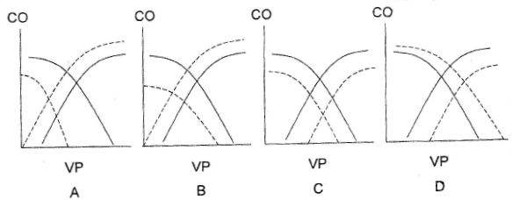
- Which of the above Guyton curves demonstrates a decrease in blood volume, in increase in total peripheral resistance and increase in contractility? The solid lines represent the control condition.
  - Curve A
  - Curve B
  - Curve C
  - Curve D
- Which of the following occurs during the baroreceptor reflex response to hemorrhage?
  - Constriction of the cerebral arterioles
  - Decreased heart rate
  - Constriction of the arterioles of the skin
  - Decreased contractility
- Why does the baroreceptor reflex not prevent chronic hypertension?
  - The baroreceptors adapt after approximately 3 days exposure to high blood pressure
  - The body cannot produce norepinephrine at a fast enough rate
  - The parasympathetic neurons which innervate the systemic arterioles become depleted
  - All of the above
- Why do most systemic capillaries filter water and electrolytes at their proximal end and absorb water and electrolytes at the distal end?
  - Capillary oncotic pressure is higher at the proximal end of the capillary than at the distal end
  - The diameter of the capillary is smaller than the diameter of the red blood cells
  - Capillaries have no smooth muscle in their walls
  - Capillary hydrostatic pressure is greater at their proximal end than at their distal end
- Which of the following is the reason that starving children have fluid accumulation in their abdomens? They have:
  - Higher than normal capillary hydrostatic pressures
  - Lower than normal capillary oncotic pressures
  - Higher than normal interstitial hydrostatic pressures
  - Lower than normal interstitial osmotic pressures
- Which is correct statement?
  - The total blood flow through the left coronary arteries is greater than the total flow through the right coronary arteries
  - Endocardial blood flow drops to zero during isovolumic contraction of the left ventricle
  - The average endocardial blood flow is greater than the average epicardial blood flow in the left ventricle
  - All of the above

- Which best describes the autoregulation of coronary blood flow?
  - Coronary blood flow is maintained by relatively constant despite large increases in cardiac work
  - Coronary blood flow is maintained relatively constant as mean blood pressure varies between approximately 60 and 160 mm Hg
  - Coronary blood flow is regulated only by changes in mean arterial blood pressure
  - The oxygen consumption of myocardium is maintained constant no matter what the coronary blood flow
- During the Cushing Response to an excessively elevated intracranial pressure
  - The heart rate is below normal
  - The mean arterial blood pressure is below normal
  - The cerebral vascular resistance is very low
  - All of the above
- Which substance, which dilates cerebral arterioles reached dangerously high levels during the Apollo 13 space flight?
  - O₂
  - CO₂
  - N₂
  - CO (carbon monoxide
- Which elite athlete would be expected to have the highest maximum oxygen consumption?
  - Swimmer
  - Weight lifter
  - Marathon runner
  - Cross country skier
- During aerobic exercise, which will have a value lower than it was at rest?
  - The arterial oxygen content
  - The mixed venous oxygen content
  - The arterial – venous oxygen difference (A-V)O₂
  - The mean blood pressure

