Temple University
Dental Physiology, D-277
Summer, 2009
Unit Examination 3
Dr. J. HECKMAN, Ph.D.
May 21, 2010
_________________________________________________________________________________

Name:_________________________
Directions: PRINT and KEY IN your name and your 9 digit student number on the blue answer sheet, in the spaces provided. This examination consists of 30 questions on 7 pages. You have 55 minutes to complete it. Blacken in the space on the answer sheet corresponding to your choice with a number 2 pencil, soft lead mechanical pencil or equivalent. Be aware that, in some questions, a group of choices (for example: “all of the above”) may correctly fulfill the question. If you must use an eraser on your blue answer sheet, do so NEATLY. When finished, turn in the blue answer sheet and keep the questions. A key will be posted shortly. All EXAMINATIONS are given under the conditions stipulated by the Honor Board.

Select the one best choice:

- Which of the following will increase if the crossectional area of the aortic valve orifice is decreased to 20 % of its original area while the cardiac output remains constant:
  - The velocity of blood flow through the aortic valve orifice
  - The left ventricular systolic pressure
  - The pressure difference across the aortic valve (Left ventricular pressure – aortic pressure)
  - **All of the above

- Which one of the following is true about capillaries
  - They constrict in response to norepinephrine released by the sympathetic neurons which innervate them
  - They are identical in structure no matter where they are located
  - **At any one time in a resting person, all have blood within their lumen but only about one-fourth of them have blood flowing through them
  - They typically absorb on their arterial or proximal end and filter on their venous or distal end

- Which of the following would be expected if some of the sodium-potassium ATPase pumps in the cardiac cells are blocked by a drug such as digitalis?
  - The sodium concentration gradient across the sarcolemma will increase
  - **The intracellular concentration of Ca⁺⁺ will increase
  - Contractility will decrease
  - The force of cardiac contraction will decrease

- During which phase of the cardiac cycle is the pulmonary valve open?
  - Isovolumic contraction
  - Isovolumic relaxation
  - Filling
  - **Ejection

- During what phase of the cardiac cycle is left ventricular pressure greater than is aortic pressure?
  - Isovolumic contraction
  - Isovolumic relaxation
  - Filling
  - **Ejection
- The administration of atropine, which blocks the muscarinic acetylcholine receptors in the SA node, will:
  - Increase the heart rate
  - Increase the slope of phase 4 of the SA node action potential
  - Make the most negative potential reached during phase 4 of the SA node action potential less negative
  - **All of the above
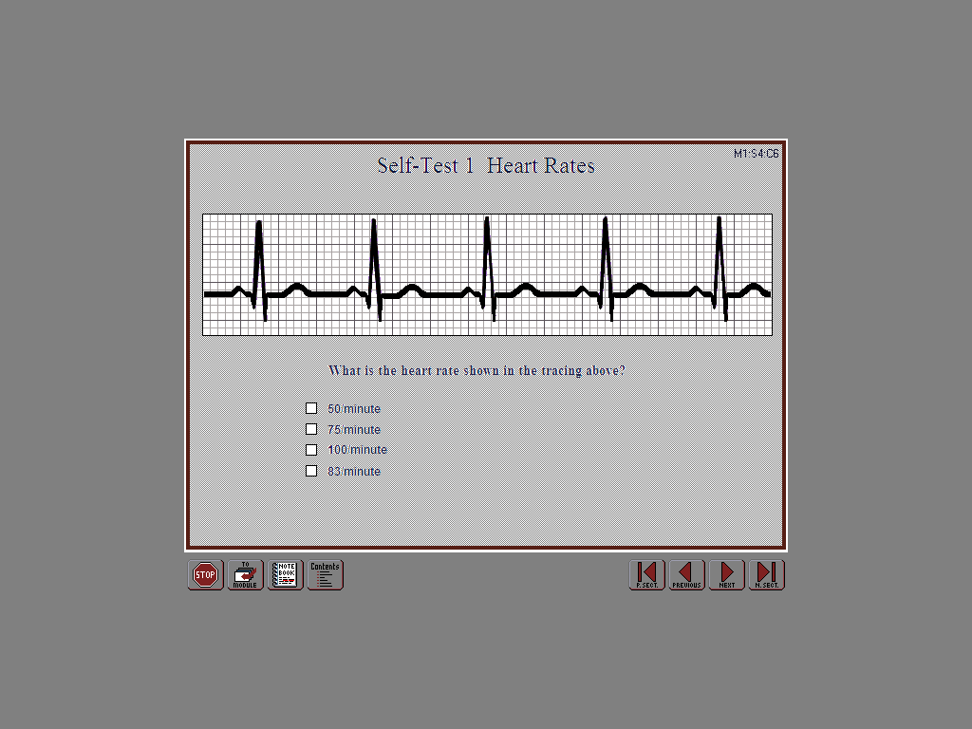
- What is the heart rate as determined from the above EKG?
  - 50 beats / minute
  - 75 beats / minute
  - 83 beats / minute
  - **100 beats / minute
- When a patient has atrial fibrillation:
  - **The atria are beating at about 400 beats per minute
  - The atria and ventricles are beating at the same rate
  - The atria are more effective in filling the ventricles than they are when a normal sinus rhythm is present
  - All action potentials which propagate through the atria also propagate through the AV node and the ventricles

- Which one of the following is most likely when the diastolic compliance of the left ventricle is greatly reduced?
  - An increase in the stroke volume
  - **An increase in the end-diastolic left ventricular pressure
  - An increase in the cardiac output
  - An increase in preload

- Why would placing a patient in heart failure in a fully reclined position (e.g. in a dental chair) not be advisable?
  - It would increase their heart rate
  - It would decrease their end-diastolic volume (preload) and thus decrease their blood pressure
  - **It would increase pulmonary capillary filtration and thus cause pulmonary edema
  - It would cause blood to pool in their lower limbs thus causing venous thrombosis

- Which one of the following will decrease systolic ventricular wall stress?
  - An increase in mean blood pressure
  - A decrease in the ejection fraction
  - **An increase the thickness of the walls of the left ventricle
  - An increase in the radius of the chamber of the left ventricle

- Which one of the following will be less than normal in a patient in heart failure
  - The left ventricular end-diastolic volume
  - The left ventricular end-diastolic pressure
  - Left ventricular preload
  - **Left ventricular contractility

- Which one of the following comparisons of the left and right ventricles is true?
  - **The average flow through the chamber of the right ventricle is equal to the average flow through the chamber of the left ventricle
  - The systolic right ventricular pressure is greater than the systolic left ventricular pressure
  - The number of times the left ventricle contracts each minute is greater than the number of times the right ventricle contracts each minute
  - The average left ventricular stroke volume is greater than the average right ventricular stroke volume

- If the compliance of the aorta were to decrease significantly:
  - The systolic pressure will decrease
  - The diastolic pressure will increase
  - **The pulse pressure will increase
  - The left ventricular afterload will not change

- Which of the following will increase swelling of the veins in the lower limbs?
  - Increasing the compliance of the lower limb veins
  - The presence of a blood clot which partially obstructs the venae cavae near the iliac veins
  - Standing for long periods
  - **All of the above
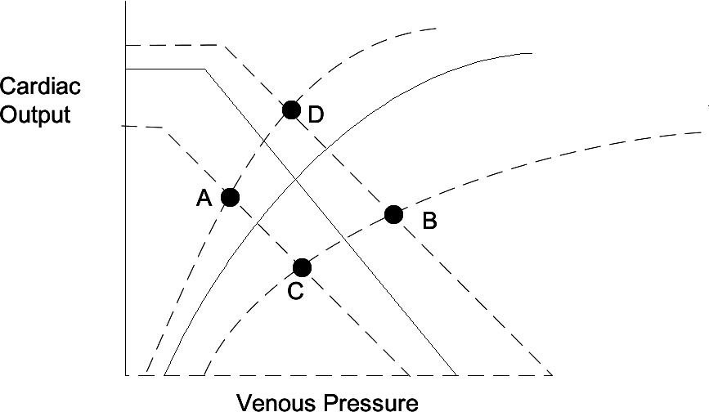
- At which point shown on the above Guyton Curves would a patient be operating during the reflex response to a mild hemorrhage? (The pre-hemorrhage curves are shown as solid lines).
  - **Point A
  - Point B
  - Point C
  - Point D

- Which one of the following would occur as a result of the baroreceptor reflex response to a patient, initially supine in the dental chair, standing suddenly upright?
  - A decrease in ventricular contractility
  - Pooling of blood in the lower limb veins
  - **An increase in heart rate
  - Constriction of the cerebral blood vessels

- During which one of the following would there be an increase in the activity (number of action potentials) of the inhibitory interneurons which connect the depressor center with the pressor center?
  - **External massage of the carotid sinus which stretches the receptors imbedded in its walls
  - Hemorrhage
  - Moving from a supine to a standing position
  - All of the above

- Why is total left coronary blood flow greater than total right coronary blood flow?
  - The pressure gradient (∆P) is greater across the left coronary vasculature than across the right coronary vasculature
  - Myocardial compression of the left coronary arteries is less than myocardial compression of the right coronary arteries.
  - The concentration of metabolites in the left ventricular myocardium is greater than the concentration of metabolites in the right ventricular myocardium
  - **The left ventricle has more capillaries in parallel with each other than does the right ventricle

- Which one of the following statements is true about the cerebral circulation?
  - The sympathetic nerves are the primary means by which cerebral blood flow is regulated; local regulation of cerebral flow is not physiologically significant
  - As arterial blood pressure falls, the cerebral arterioles constrict in order to maintain blood pressure
  - **Carbon dioxide is a potent vasodilator of cerebral blood vessels
  - Cerebral capillaries easily allow most substance dissolved in plasma to diffuse into the brain

- A decrease in which one of the following is part of the Cushing Response to an increase in intracranial pressure?
  - **Heart rate
  - Systemic vascular resistance
  - Blood pressure
  - Cerebral vascular resistance

- The total peripheral resistance decreases during aerobic exercise because:
  - The activity of the parasympathetic neurons which innervate the arterioles in the working skeletal muscle increases
  - **The concentration of metabolic vasodilators in the working muscles increases
  - The activity of the sympathetic neurons which innervate the arterioles in the working skeletal muscle decreases
  - All of the above

- The sounds heard during the determination of arterial blood pressure using the auscultatory technique normally:
  - Occur when the cuff is fully deflated
  - Occur when the cuff pressure is above the systolic pressure
  - **Occur when the cuff pressure is below the systolic pressure and above the diastolic pressure
  - Are the first and second heart sounds

- An abnormally high value for which one of the following is the reason for the pulmonary edema that occurs during heart failure?
  - **Pulmonary capillary hydrostatic pressure
  - Systemic capillary hydrostatic pressure
  - Plasma oncotic pressure
  - Tissue osmotic pressure

- Which one of the following is below normal
  - Resting oxygen consumption = 250 ml / min
  - Blood volume = 5 liters
  - **Ejection fraction = 30%
  - Pulse pressure = 80 mm Hg
- Which one of the following is a direct effect (without reflexes) of hemorrhage?
  - **Low stroke volume
  - High heart rate
  - Cold, clammy skin
  - High total peripheral resistance

- Three vessels in series with each other, each with a resistance of 2, and with no branches:
  - Will have a total resistance of 1.5
  - Cannot have the same flow through each
  - **Must have equal pressure differences between each of their proximal and distal ends
  - Will have a total resistance of 1/6

- The first heart sound:
  - **Occurs during systole
  - Occurs during isovolumic relaxation
  - Is caused by turbulent blood flow through the mitral valve
  - Is caused by turbulent blood flow through the aortic valve

- Which one of the following is the reason that the systolic blood pressure falls during spontaneous inspiration?
  - Heart rate increases during inspiration
  - **The interventricular septum moves to the left and decreases diastolic left ventricular compliance
  - Intrathoracic (intrapleural) pressure becomes more positive
  - The right ventricular end-diastolic volume decreases which decreases the right ventricular stroke volume

- Which one of the following is true about the AV node?
  - Decreasing the propagation velocity of the action potential through the AV node will decrease the heart rate
  - The AV node is only one of multiple pathways through which the action potential can propagate from the atria into the ventricles
  - If the action potential cannot propagate through the AV node and reach the ventricles, the ventricles will stop beating
  - **The relatively slow propagation velocity of the action potential through the AV node provides time for atrial contraction to assist in filling the ventricles

