Name: ___________________________

Final Examination - D-273 Introduction to Periodontology - spring 2009

Instructions: Select the single best answer for each question. Fill in answers, your name, and the last 4 digits of your student number on the computer sheet. Both this examination copy with your name on it and the computer answer sheet must be turned in. You have until 11:30 am to complete the examination. No questions during the examination to supervising proctors will be answered. Each question is worth 2 points.

1. Generalized moderate chronic periodontitis would show which of the following?

A. Less than 30% of the sites in the mouth are involved
➔B. Greater than 30% of the sites are involved
C. There is greater than 5 mm of attachment loss
D. There is 1-2 mm of attachment loss

2. Which of the following risks factors for chronic periodontitis is true?

A. females have more disease than males
B. Italians exhibit a higher prevalence as compared to other ethnic groups
➔C. smoking confers a 2-7 times greater risk as compared to non-smokers
D. The exact gene mechanism is known

3. Bacterial-mediated inflammatory reactions can indirectly induce tissue damage in chronic periodontitis
via all of the following mechanisms except which one?

A. Released neutrophil enzymes
B. Pro-inflammatory cytokines
C. Matrix-destroying metalloproteinases
➔D. LPS- endotoxin

4. Löe et al. in 1978 studied the natural history of periodontal disease in Sri Lankan tea laborers with no oral
hygiene and no dental care, and found 3 rates of disease progression, except which of the following?

A. 8 % had rapid periodontitis progression
B. 81% had moderately progressive periodontitis
C. 11% had minimal or no progression of destructive disease
➔D. 50% developed minimal bone loss over the time period of the study

5. Which of the following is true relative to infrabony pockets?

➔A. The bottom of the pocket is apical to the alveolar crest
B. Horizontal bone loss is seen radiographically
C. Transseptal fibers interproximally are arranged in a horizontal pattern
D. They are also called pseudo pockets

6. The root surface wall of periodontal pockets exhibits which of the following?

A. Decreased calcium, magnesium and phosphorous mineral content in cementum.
B. Increased biologic compatibility of endotoxin-coated cementum with adjacent gingival soft tissues.
➔C. Dental plaque biofilm growth.
D. all of the above

7. The “gold standard” for measuring the extent and severity of periodontitis is:

➔A. periodontal attachment loss
B. probing pocket depth
C. amount of gingival soft tissue recession
D. inflammatory bleeding on probing

8. The distance from the CEJ to the bottom of a periodontal pocket is called:

A. clinical periodontal probing depth
B. gingival recession
➔C. clinical periodontal attachment level or loss
D. none of the above

9. Which of the following types of dental implants is not placed into alveolar bone?

A. blade implant
B. cylindrical implant
➔C. subperiosteal implant
D. ramus frame implant

10. The term osseointegration refers to:

A. The direct contact of tooth to implant.
➔B. The direct contact of implant body to viable bone.
C. The direct contact of connective tissue to the implant body.
D. None of these answers are correct.

11. The bone associated with a dental implant which is more mature and mineralized is classified as woven bone.
A traumatic implant failure will demonstrate deep probing depths.

A. Both statements are true.
B. The first statement is true, but the second statement is false.
C. The first statement is false, but the second statement is true.
➔D. Both statements are false.

12. The anatomical landmark in the maxilla which may need to be superiorly lifted prior to implant placement in
order to avoid penetration is the:

A. greater palatine artery
➔B. schneideriann membrane
C. cribiform plate
D. nasal turbinates

13. The safe distance to place a dental implant from the mandibular canal is:

➔A. 2 mm coronal
B. 1 mm coronal
C. 0.5 mm coronal
D. all of the above

14. The minimal buccal–lingual bony width needed to place a 4 mm diameter root form dental implant would be:

A. 4 mm
B. 5 mm
➔C. 7 mm
D. 8 mm

15. Which type of alveolar bone has been classified as dense cortical bone and has a feeling of oak when drilled
into it?

➔A. Type 1
B. Type 2
C. Type 3
D. Type 4

16. Which of the following is not a contraindication for placement of dental implants?

A. Uncontrolled diabetes
➔B. Aspirin use
C. I.V. bisphosphonate medication use
D. titanium allergy

17. According to the assigned journal review article on vitamin C and periodontitis, the research study found:

➔A. persons with a plasma vitamin C deficiency had more clinical periodontal attachment loss as compared to
persons with normal vitamin C values.
B. persons with a excessive plasma vitamin C levels had more clinical periodontal attachment loss as compared
to persons with normal vitamin C values.
C. no statistically significant association between plasma vitamin C levels and clinical periodontal
attachment loss.
D. none of the above

18. Which of the following often presents as desquamative gingivitis?

➔A. squamous cell carcinoma
B. dental plaque overgrowth with Prevotella intermedia
C. Porphyromonas gingivalis infections
D. all of the above

19. Lichen planus:

➔A. Can be worsened by local trauma
B. Is treated with antibiotics
C. Is characterized by vesicles
D. both A and B of the above

20. Gingival hyperplasia:

A. Is resolved with systemic steroids
➔B. Can be reduced with effective oral hygiene
C. Will not recur if surgically removed
D. All of the above

21. Pyogenic granulomas:

A. Occur more frequently during pregnancy
B. Is the result of infection
C. Usually will not recur if removed
➔D. All of the above

22. You discover a 15 x 10 mm raised red lesion on the lower left gingiva - which of the following do you do?

A. You will avoid taking a radiograph of the site to avoid further damage.
B. You will inject the lesion with an antibiotic to see if a response occurs.
➔C. You will likely plan to biopsy the area if the lesion does not quickly resolve.
D. All of the above

23. Upon placing a rubber dam your patient suddenly develops erythema and edema of the lips and gingiva.
The likely cause is due to:

A. Mouth breathing
➔B. Allergic reaction
C. Chemical burn
D. ANUG

24. Malignant lesions of the gingiva:

A. May present as gingival enlargement
B. May result from chronic inflammation
C. Can result from ulcerative lichen planus
➔D. All of the above

25. Periodontal abscesses:

A. Should be treated with subgingival tetracycline fibers
➔B. Are due to the same organisms causing periodontal diseases
C. Do not have the potential to spread
D. Should not be treated with systemic antibiotics

26. The following are used to differentiate a periodontal abscess from an endodontic abscess:

A. Probing
B. Location of abscess
C. Radiograph
➔D. All of the above

27. Treatment of pericornitis:

A. Must include extraction of the tooth
B. Should include ultrasonics and systemic antibiotics
C. Can include surgical excision of covering tissue
➔D. both B and C of the above

28. ANUG is characterized by:

➔A. Painful, necrotic interdental tissue; mixed dental plaque microflora including spirochetes
B. Lowered host resistance resulting in necrosis of cheeks and lips
C. Zone 1 of the lesion consists of large numbers of neutrophils
D. All of the above

29. Phase 2 of dental plaque formation involves:

A. selective absorption of negatively-charged glycoproteins onto positively-charged phosphate groups
on hydroxyapatite tooth surfaces.
➔B. initial microbial colonization of teeth by gram-positive facultative bacteria.
C. selective absorption of positively-charged glycoproteins onto negatively-charged phosphate groups
on hydroxyapatite tooth surfaces.
D. co-aggregation of gram-negative anaerobic bacterial species onto the surfaces of initial gram-positive
microbial colonizers.

30. Which of the following participate in oxidative antimicrobial mechanisms in neutrophils?

A. elastase
➔B. myeloperoxidase
C. lysozyme
D. calprotectin

31. Chronic inflammation is characterized by:

1. presence of antibodies
2. fibroblast proliferation
3. influx of plasma cells
4. proliferative response
.

A. 1 and 3 only
B. 1, 3 and 4 only
C. 2 and 4 only
➔D. all of the above

32. Stippling of gingival tissues:

A. occurs with the onset of periodontal disease.
B. cannot be restored with periodontal therapy.
➔C. occurs on attached gingiva.
D. is best viewed by drying the lingual aspects of the gingiva.

33. The most coronal surface of the col is covered by:

A. keratinized stratified squamous epithelium
➔B. non-keratinized stratified squamous epithelium
C. cornified epithelial cells possessing densely packed tonofilaments
D. sulcular epithelium

34. According to the course textbook, microscopic studies demonstrate that deposits of subgingival calculus always
extend to the junctional epithelium of periodontal pockets in chronic periodontitis. Epithelial rests of Mallassez
are located close to tooth cementum surfaces throughout the periodontal ligament.

A. Both statements are true.
B. Both statements are false.
C. The first statement is true, with the second statement false.
➔D. The first statement is false, with the second statement true.

35. Which of the following pertain to subgingival dental calculus?

A. It is usually a black-brown color.
B. It is comprised in part of mineralized dental plaque.
C. It is more prominent in areas with gingival inflammation.
➔D. all of the above

36. According to the International Workshop for the Classification of the Periodontal Diseases, as described by
Armitage GC (Annals of Periodontology 4:1, 1999), a diagnosis of generalized chronic periodontitis is
present when:

A. less than 30% of periodontal sites in the oral cavity exhibit periodontal attachment loss.
➔B. greater than 30% of periodontal sites in the oral cavity exhibit periodontal attachment loss.
C. at least three periodontal sites on separate teeth in the oral cavity exhibit periodontal
attachment loss.
D. one to three periodontal sites in the oral cavity exhibit probing depths of 5 mm or greater.

37. Acellular cementum is located most commonly on what part of a tooth?

A. At the most apical one-third of the tooth root.
B. At the middle one-third of the tooth root.
➔C. At the cervical area of the tooth root.
D. none of the above

38. The most common relationship of enamel and cementum at the CEJ

➔A. is where the cementum overlaps the enamel.
B. is a butt joint between the cementum and enamel.
C. is where the enamel overlaps the cementum.
D. is where the enamel and cementum do not come together and meet.

39. The presence of numerous small Volkmann canals is associated with which of the following?

A. pericoronal abscess.
B. dehiscence.
➔C. cribiform plate.
D. fenestration.

40. The established gingivitis lesion:

A. will always convert to more progressive disease resulting in loss of periodontal attachment.
B. is dominated by T lymphocytes in connective tissue inflammatory infiltrates.
➔C. does not exhibit crestal alveolar bone loss.
D. appears within one week after the onset of initial gingival inflammation.

41. Where on the figure below is plaque-induced gingival redness first seen with the onset of gingivitis?

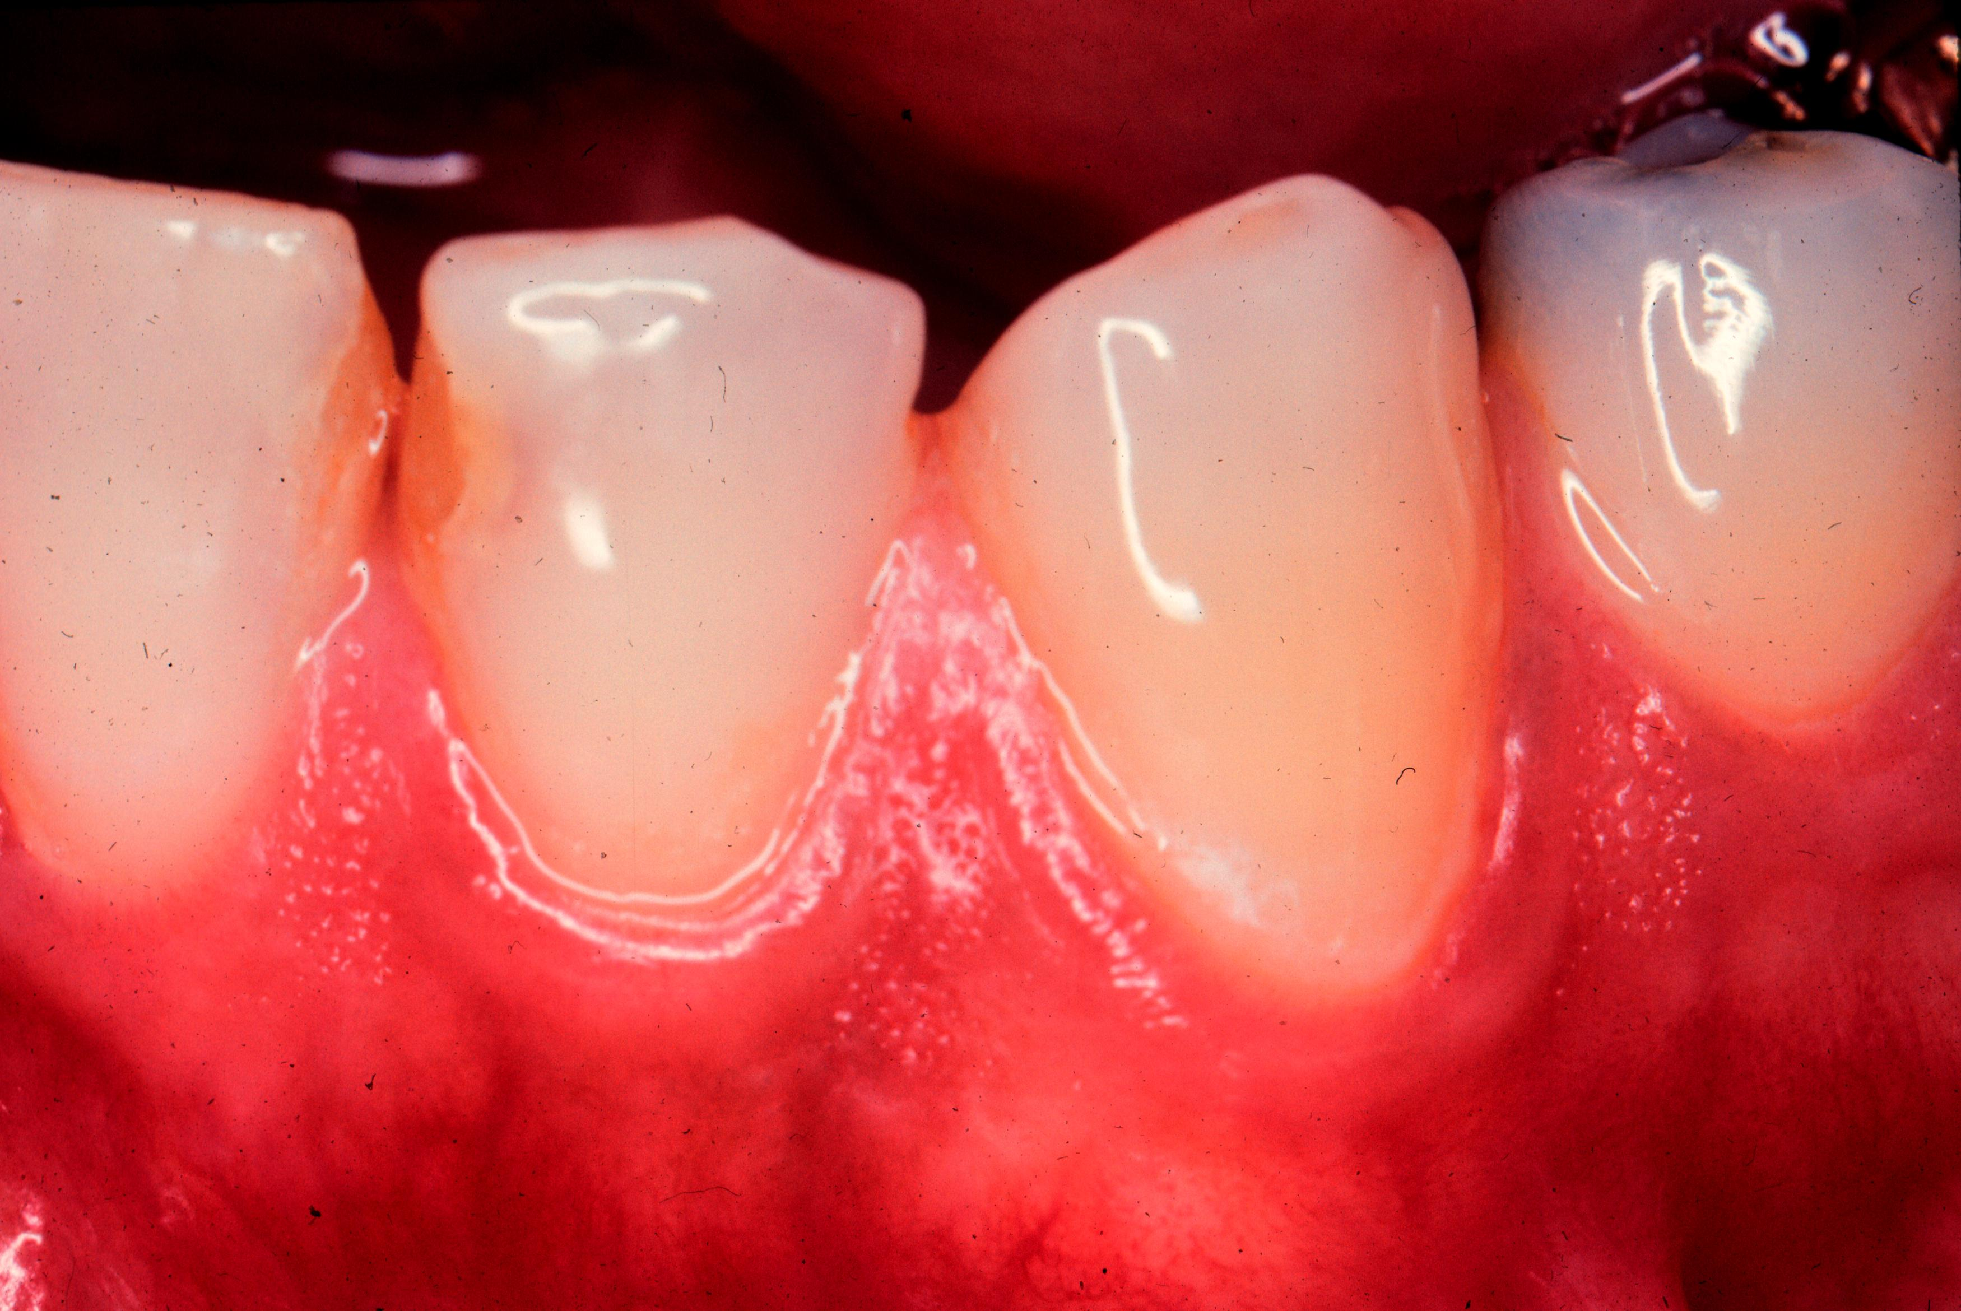

2

3

1A

4

A. Area #1 as indicated on the figure above.
➔B. Area #2 as indicated on the figure above.
C. Area #3 as indicated on the figure above.
D. Area #4 as indicated on the figure above.

42. Which of the following are responsible for red gingival tissue color seen in plaque-induced gingivitis?

1. decreased fibroblast activity
2. increased vascularization
3. decreased epithelial keratinization
4. increased stasis of venous blood in gingival tissues

A. all of the above
B. #1, 2 & 3 only
➔C. #2 & 3 only
D. #2 & 4 only

43. Gingival tissue redness is first seen clinically in the:

A. initial lesion
➔B. early lesion
C. established lesion
D. acute lesion

44. The histopathologic changes associated with the initial lesion of gingivitis are located:

A. at the gingival margin
B. at the tip of the interdental papillae
➔C. immediately apical to the junctional epithelium
D. subjacent to the basement membrane of the outer epithelium

45. After the cessation of toothbrushing and other forms of oral hygiene, approximately how long will it take for the
first signs of gingivitis to be clinically seen?

A. within 24 hours
➔B. 2-4 days
C. 7-10 days
D. 5-7 days

46. Which of the histologic zones associated with ANUG is closest to the alveolar bone adjacent to the lesion?

A. neutophil rich zone
B. bacterial zone
➔C. zone of spirochetal infiltration
D. necrotic zone

47. In which of the following do plasma cells dominate inflammatory cell infiltrates into gingival connective tissues?

A. prequel lesion
B. early lesion
C. initial lesion
➔D. established lesion

48. Which of the following are found with gingivitis?

1. slight to moderate alveolar bone loss
2. coronal swelling of inflamed gingival tissues
3. loss of periodontal attachment
4. increase size of subgingival compartment

A. all of the above
B. #2 only
C. #2, 3 & 4 only
➔D. #2 & 4 only

49. The junctional epithelium in periodontitis-affected lesions, as compared to periodontal health:

A. exhibits coronal migration.
➔B. is shortened in an apical-coronal direction.
C. is less infiltrated with PMNs.
D. is keratinized.

50. Which of the following exhibits alveolar bone loss?

A. inflammatory lesions
B. acute lesions
C. established lesions
➔D. advanced lesions

