RESTORATIVE DENTISTRY – QUESTION BANK
2005 EXAM 3
1. Which of the following is not synonymous with trabecular bone?
- Spongy
- Cancellous
- Cortical
2. Which of the following is characteristic of the primary maxillary canine?
- crown height < mesiodistal width
- indistinct central lobe on the facial surface
- the mesioincisal cusp ridge is shorter than the disotoincisal cusp ridge
- the mesioincisal cusp ridge is longer than the distoincisal cusp ridge
- one lingual fossa
3. Which of the following teeth typically has a cross-section at the CEJ as shown in the sketch below?
- mandibular second premolar
- maxillary first premolar
- maxillary first molar
- mandibular first molar
4. Which of the following permanent teeth that are normally single-rooted are most likely to have a bifurcated root?
- Maxillary central incisors
- maxillary lateral incisors
- mandibular canines
- mandibular first premolars
- mandibular second premolars
5. The thin, compact bony layer that lines the wall of the alveolus is known as the
- Lamina dura
- periodontal ligament
- cementum
- internal oblique line
- mylohyoid layer
6. Which of the following is not characteristic of primary posterior teeth?
- prominent mesial cervical ridge
- thin and slender roots, spread beyond the outlines of the crowns
- distinct root trunks
- narrow occlusal table
- shallow occlusal anatomy
7. Which of the following is a term used for an opening in the floor of the pulp chamber leading to a root canal?
- Apical foramen
- Pulp horn
- Accessory canal
- Anastomasis
- Orifice
8. Which of the following terms is used to describe a dark spot on a developing secondary tooth caused by an abscess from the infection of a primary tooth?
- Hutchinson's spot
- Turner’s Spot
- Amelogenesis imperfecta
- Focal hypomaturation
- Ankylosis
9. Which of the following in not a process of the maxilla?
- frontal
- zygomatic
- alveolar
- palantine
- ethmoidal
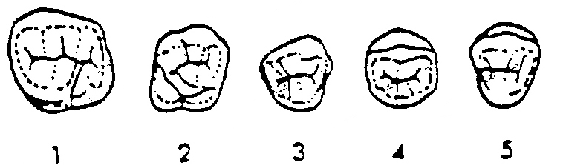
10. Which of the following sketches illustrates the occlusal view of a primary maxillary right first molar?
- 1
- 2
- 3
- 4
- 5

11. Which of the following numbers is the sum of the number of pulp horns plus the number of root canals of the typical permanent mandibular first molar?
- 5
- 6
- 7
- 8
- 9
12. Which of the following terms is used to describe the fusion or growing together of two adjacent teeth at the root through the cementum only?
- Hypercementosis
- Fusion
- Germination
- Dilacerations
- Concrescence

13. Which of the following teeth is most often associated with problems (i.e. infection or inflammation) in the maxillary sinus?
- 1
- 2
- 3
- 4
- 5
14. When you observe only three maxillary incisors but one crown is doubled in width and notched, what do you suspect?
- Fusion
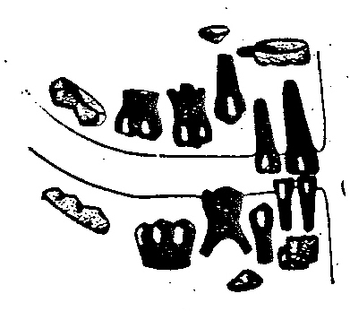
- Germination
- Concrescence
- Cementosis
15. Which of the following ages most closely corresponds to the dentition shown in the sketch below?
- 6 Months
- 1 year
- 18 Months
- 2 years
- 30 Months

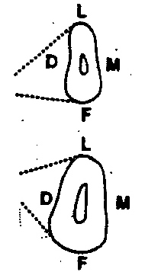
16. Which of the following teeth typically has a cross-section at the CEJ and at the midroot as shown in the sketch below? (viewed from the occlusal)
- 8
- 12
- 13
- 20
- 21

17. Which of the following permanent crown surfaces exhibit the greatest emergence profile?
- lingual surface of maxillary canine
- facial surface of mandibular premolars
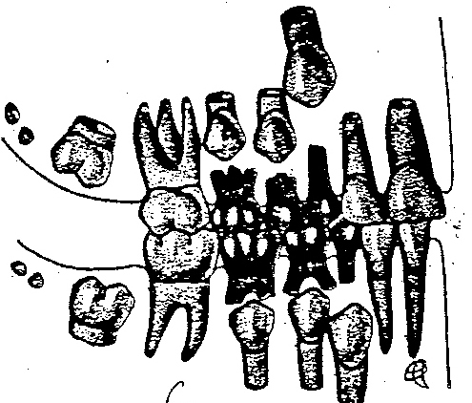
- facial surfaces of maxillary molars
- lingual surface of mandibular molars
- facial surface of mandibular molars
18. Which of the following ages most closely corresponds to the dentition shown in the sketch below?
- six years
- eight years
- ten years
- twelve years
19. The drawing below is a cross-section at the CEJ of what permanent tooth?
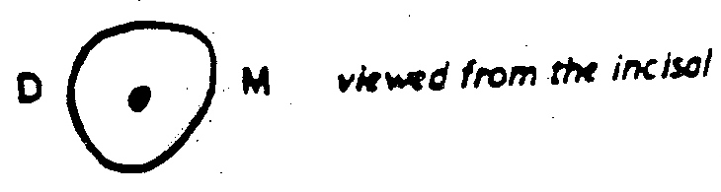
- 6
- 22
- 8
- 7
- 11

20. Which of the following primary molars is characterized as having a prominent transverse ridge, mesial marginal ridge and mesiobuccal cervical ridge
- A
- B
- S
- T

2005 EXAM 3
1 | C
2 | D
3 | C
4 | C
5 | A
6 | C
7 | E
8 | B
9 | E
10 | C
11 | D
12 | E
13 | C
14 | A
15 | B
16 | C
17 | D
18 | B
19 | C
20 | C

2004 EXAM 4
1. Which of the following is a not a process of the maxilla?
- pterygoid
- frontal
- zygomatic
- alveolar
- palatine
2. Which of the following teeth are the most commonly missing permanent teeth?
- maxillary lateral incisors
- maxillary first premolars
- maxillary third molars
- mandibular second premolars
- mandibular third molars
3. A small supernumerary tooth that forms between central incisors is termed a
- para-incisor
- peg lateral
- periodens
- mesiodens
4. Which of the following interferences is most likely to be incorporated into a restoration that is waxed-up on a small, hinge-type, nonadjustable articulator?
- laterotrusive
- mediotrusive
- centric
- protrusive
5. The furcations are likely to be farther a way from the cervical portion of the tooth in which one of the following teeth?
- mandibular first molar
- mandibular second molar
- mandibular third molar
- maxillary first molar
- maxillary second molar
6. Permanent maxillary first molars are most likely to have ___ roots and ___root canals?
- two. ... two
- two .... three
- two.. ..four
- three. ... three
- three.. ..four
7. The thin compact bony layer that lines the wall of each tooth socket is known as the
- periodontal ligament
- alveolar crest
- lamina dura
- trabecular bone
8. Unusual incisor and molar shapes that occur as a result of
- Turner's teeth
- talon teeth
- odontomas
- Hutchinson’s teeth
9. The root canal configuration in which one canal leaves the pulp chamber but divides in the apical third of the root into two separate canals with two separate apical foramina is known as
- Type I
- Type II
- Type III
- Type IV

10. Which of the the following is located in the floor of the mouth?
- Wharton’s Duct
- Stenson's duct
- Labial Frenum
- Philtrum
- Uvula
11. A disorder of the teeth in which the teeth have a light-blue or gray appearance, and the pulp is obliterated is known as
- amelogenesis imperfecta
- fluorosis
- focal hypomaturation
- dentinogenesis imperfecta
- prenatal syphilis
12. Maxillary anterior teeth are most likely to have how many root canals?
- one
- two
- three
- one or two
13. The permanent mandibular first molar usually has
- two root canals in the mesial root, one in the distal
- one root canal in the lingual root, one in the facial
- two root canals in both the mesial and distal roots
- one root canal in each root
14. Which of the following permanent anterior teeth exhibits the most deviation in tooth morphology?
- mandibular central incisor
- maxillary canine
- maxillary lateral incisor
- mandibular lateral incisor
15. Which of the following terms describes a crown that appears doubled in width and has two separate pulp canals?
- Gemination
- Fusion
16. The large flat mushroom shaped papillae forming a V shaped row on the dorsum near the posterior third of the tongue are known as
- filiform papillae
- foliate papillae
- fungiform papillae
- foremen secum
- plica fimbriata
17. The scalloped junction between the attached gingiva and the looser, redder alveolar mucosa is known as the
- gingival sulcus
- junctional epithelium
- vermilion zone
- mucogingival line
- wet line
16. Which of the following jaw relation records should be used for setting both the horizontal condylar guidance and the Bennett angle?
- intercuspation
- centric relation
- lateral interocclusal records
- protrusive interocclusal records
19. The emergence profile of the surfaces of most permanent teeth is 0.5 mm with the exception of
- the lingual surface of the maxillary canine.
- the buccal surface of the maxillary first molar.
- the lingual surface of the mandibular canine.
- the lingual surface of the mandibular molars.
- the labial surface of the mandibular canine.
20. The medio-lateral curvature of the occlusal plane of the permanent posterior teeth is known as the
- curve of Spee
- curve of Wilson.

21. The roots of all permanent mandibular posterior teeth have a buccal inclination with the exception of the
- mandibular first premolar
- mandibular second premolar
- mandibular first molar
- mandibular second molar
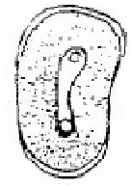
23. The picture is a occlusal view of the cervical section of tooth #
- 4
- 5
- 12
- 13
- 20

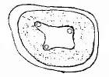
24. The picture is an apical view of the cervical section of tooth #
- 3
- 4
- 14
- 19
- 30
25. Which of the following pictures is an occlusal view of a mid-root section of the maxillary left second molar?
- A
- B
- C
- D
- None

26. The least likely of permanent teeth to have two root canals is
- the mesiobuccal root of a maxillary first molar
- the mesial root of the mandibular first molar,
- an upper premolar.
- mandibular canine.
27. The mental foramen is located where?
- on the external surface of the mandible
- on the internal surface of the mandible
- on the palatal surface of the maxilla
- on the external surface of the maxilla
- on the sphenoid bone
28. Tetracycline staining is a form of
- enamel dysplasia
- dentin dysplasia
29. An articulator in which the condylar paths simulating the glenoid fossae are attached to the lower member of the instrument is known as
- an arcon afliculator
- nonarcon articulator
30. The picture is a buccolingual section of tooth #
- 3
- 14
- 19
- 30

2004 EXAM 4
1 | A | 15 | B | 29 | B
2 | C | 16 | C | 30 | D
3 | D | 17 | D
4 | B | 18 | C
5 | C | 19 | D
6 | E | 20 | B
7 | C | 21 | A
8 | D | 22 | A
9 | D | 23 | C
10 | A | 24 | C
11 | D | 25 | E
12 | A | 26 | D
13 | A | 27 | A
14 | C | 28 | B
2004 EXAM 3
1. Which of the following mandibular posterior teeth of the adult dentition has a lingual tilt to its root axis line (in a frontal section as viewed from the anterior)?
- first premolar
- second premolar
- first molar
- second molar
- third molar
2. Which of the following permanent anterior teeth would be most likely to show a pulp cavity with three pulp horns visible in a mesiodistal longitudinal section?
- maxillary central incisor
- maxillary lateral incisor
- mandibular lateral incisor
- mandibular central incisor
- none of the above
3. Which of the following primary molars has a crown that is wider faciolingually than mesiodistally, has H-shaped occlusal grooves and somewhat resembles a permanent premolar?
- A
- B
- S
- T
4. Which of the following terms is used to describe the wearing away of tooth structure by mechanical means?
- Attrition
- bruxism
- abrasion
- erosion
- hypercementosis
5. Which of the following primary molars is characterized as having a prominent mesial marginal ridge and mesiobuccal cervical-ridge.
- A
- B
- S
- T
6. Which of the following is a term for the thin, compact bone that lines the wall of each tooth socket?
- periodontal ligament
- trabecular bone
- lamina dura
- alveolar eminence
- alveolar crest
7. Which of the following is a term used for an opening in the floor of the pulp chamber leading to a root canal?
- Apical foramen
- Pulp horn
- Acessory Canal
- Anastomosis
- Orifice
8. Which of the following terms is used to describe the fusion or growing together of two adjacent teeth at the root through the cementum only?
- hypercementosis
- fusion
- germination
- dilacerations
- concrescence
9. Which of the following teeth is most likely to be congenitaly missing in the adult dentition?
- 8
- 3
- 11
- 20
- 25
10. Which of the following is the best estimate of the age of two normal and unrelated children who are the exact same-age and have erupted permanent teeth as follows: one child has all permanent teeth except third molars, and the other child has permanent incisors, first molars, and the mandibular canine?
- 7
- 9
- 11
- 13
- 15

11. Which of the following measurements approximates the emergence profile of most crowns of the adult dentition?
- 0.5 mm
- 1.0 mm
- 1.5 mm
- 2.0 mm
- 2.5 mm

12. Which of the following terms is used to describe a dark spot on a developing secondary tooth caused by an absess from the infection of a primary tooth?
- Hutchinson's spot
- Turner's spot
- Amelogenesis imperfecta
- focal hypomaturation
- ankylosis

13. Which of the following is the correct sequence of eruption of the permanent maxillary teeth?
- central incisor, lateral incisor, canine, first premolar, second premolar, first molar, second molar.
- central incisor, lateral incisor, first molar, canine, first premolar, second premolar, second molar
- central incisor, lateral incisor, first molar, first premolar, second premolar, canine, second molar
- first molar, central incisor, lateral incisor, canine, first premolar, second premolar, second molar
- first molar, central incisor, lateral incisor, first premolar, second premolar, canine, second molar

14. Which of following permanent teeth most likely has three roots and four root canals?
- 3
- 5
- 18
- 30
- 32

15. Which of the following is not true of primary teeth?
- the cingulum of the incisor represents a single lobe
- the mandibular central incisor crown is smaller than the maxillary central incisor crown
- the maxillary canine is not as wide mesiodistally as the mandibular canine
- the mandibular lateral incisor has a longer root than the mandibular central incisor
- second molars closely resemble permanent first molars of the same arch

16. Which of the following terms is used to describe the medio-lateral curvature of the posterior teeth of the adult dentition?
- Curve of Spee
- Curve of Wilson

17. When the premolars have a single root canal, that root canal is narrower in which direction?
- Mesiodistal
- Faciolingual
- occlusocervical
18. Which of the following numbers is the sum of the number of pulp horns plus the number of root canals of the typical permanent mandibular first molar?
- 5
- 6
- 7
- 8
- 9
19. In which way are the primary mandibular first and second molars similar?
- number of cusps
- number of pulp horns
- occlusal surface
- number of roots
- number of identifiable lobes
20. How many teeth should be erupted in the mouth of a three year old?
- None
- 10
- 20
- 28
- 32

2004 EXAM 3
1 | A
2 | A
3 | B
4 | C
5 | C
6 | C
7 | E
8 | E
9 | D
10 | C
11 | A
12 | B
13 | E
14 | A
15 | C
16 | B
17 | A
18 | D
19 | D
20 | C

2002 EXAM 3
1. During a mandibular opening movement,
- the inferior head of the lateral pterygoid muscle is active, but the superior head is inactive.
- both the inferior head and the superior head of the lateral pterygoid muscle are active.
- the lateral pterygoid muscle is inactive.
2. A position of the mandible in which the condyles are in their uppermost, midmost positions in the mandibular fossae and related anteriorly to the distal slope of the articular eminence is known as
- Centric occlusion
- Centric relation
- Hinge axis position
- Retruded contact position
- Habitiual centric position
3. The temperomandibular ligament is found in the
- posterior part of the capsule.
- medial part of the capsule.
- anterior part of the capsule.
- lateral part of the capsule.
4. Which of the following muscles shows initial and sustained activity during mandibular opening movements?
- lateral pterygoid
- medial pterygoid
- masseter
- temporalis
5. Which of the Following muscles is capable of depressing and retruding the mandible?
- temporalis
- medial pterygoid
- lateral pterygoid
- masseter
- none of the above
6. Which of the following cusp ridges of tooth #5 would cause a protrusive interference?
- buccal cusp ridge of buccal cusp
- mesial cusp ridge of buccal cusp
- mesial cusp ridge of lingual cusp
- distal cusp ridge of buccal cusp
- distal cusp ridge of lingual cusp
7. What two structures articulate in the temperomandibular joint?
- the coronoid process of the mandible with the mandibular fossa of the temporal bone
- the condyloid process of ihe mandible with the mandibular fossa of the temporal bone
- the coronoid process of the mandible with the mandibular fossa of the sphenoid bone
- the condyloid process of the mandible with the mandibular fossa of the sphenoid bone
- the condyloid process of the mandible with the mandibular fossa of the maxillae
8. The ligament that limits the amount of movement of the mandible and attaches from the inferior surface of the neurocranium to the lingual of the mandible is the
- Lateral TMJ ligament
- Stylomandibular ligament
- Sphenomandibular ligament
- Sternocleidomastoid ligament
9. Where on the neurocranium does the mandible function?
- in the anterior third of the mandibular fossa called the articular fossa
- in the posterior third of the mandibular fossa called the articular fossa
- on the posterior inferior portion of the articular eminence
- on the anterior inferior portion of the articular eminence
10. The masseter muscle elevates the mandible. Which other muscles are involved in elevating the mandible?
- temporalis (anterior fibers) and lateral pterygoid muscles
- lateral pterygoid muscles and medial pterygoid muscles
- temporalis (posterior and anterior fibers) and medial pterygoid muscles
- medial pterygoid muscles and temporalis (anterior fibers)
- lateral pterygoid muscles and temporalis (posterior fibers)

11. Which of the following muscles would you palpate just medial to the angle of the mandible?
- masseter, the origin
- masseter, the insertion
- temporalis, the insertion
- medial pterygoid, the insertion
- lateral pterygoid, the insertion
12. In which direction do the fibers of the lateral pterygoid muscles travel from their origin to their insertion?
- medial and posterior
- medial and anterior
- lateral and anterior
- lateral and posterior
13. Protrusion of the mandible from the rest position is guided by
- contacts between the maxillary and mandibular teeth (anterior guidance)
- path of the condyle along the slope of the articular eminence (condylar guidance)
- (c) both a and b
- (d) neither a nor b
14. An immediate Bennett shift that is great requires that posterior cusp heights be
- relatively short
- relatively long
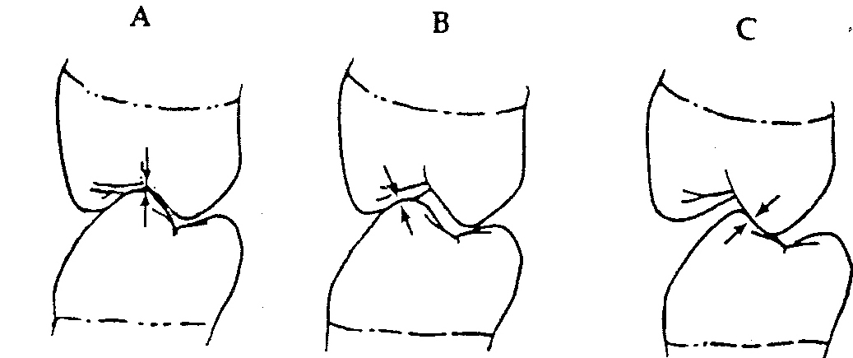
15. A dentist places a crown on a lower tooth on a patient who has canine guidance. The patient is guided into centric occlusion (A), and into right (B) and left (C) laterotrusive movements. Which of the following is observed?
- a centric interference
- a working interference
- a non-working interference
- B and C
- A, B and C

16. To correct the occlusal disharmony created by the crown in question #I5, the dentist should
- shorten the buccal cusp of the lower tooth and its lingual cusp ridge
- shorten the buccal cusp of the lower tooth and its buccal and lingual cusp ridges
- shorten the buccal cusp of the lower tooth
- shorten the lingual cusp ridge of the buccal cusp of the lower tooth
- shorten the buccal and lingual cusp ridges of the buccal cusp of the lower tooth
17. Which of the following bones is not a part of the neurocranium?
- sphenoid
- temporal
- frontal
- occipital
- none of the above
18. The curvature reflected in the lingual inclination of the crowns of the mandibular molars is known as the
- Curve of Spee
- Curve of Wilson
19: All of the roots of the mandibular posterior teeth incline toward the buccal except for the
- first premolar
- second premolar
- a and b
20. The articular disc of the TMJ is attached medially and laterally to the
- medial pterygoid muscle
- lateral pterygoid muscle
- poles of the condyle
- bilaminar zone
- none of the above
21. The interproximal space between the mandibular first and second premolars is ______________than the interproximal space between the mandibular canine and first premolar
- Larger
- Smaller
22. Anterior teeth have their contacts centered labiolingually, whereas posterior teeth have their contacts slightly buccal to the center buccolingually
- True
- False

23. All crowns converge more lingually than facially from contact areas, with the exception of the
- mandibular second molar
- mandibular second premolar
- maxillary first molar
- maxillary second premolar
- maxillary second molar
24. As viewed from the occlusal, the mesial marginal ridge groove of the maxillary first premolar
- lies lingual to the contact area between the first premolar and canine.
- lies facial to the contact area between the first premolar and canine.
- Lies at the contact area between the first premolar and canine.
25. As viewed from the occlusal, the mesial contact area of the mandibular ____________molar is located farther buccally than any of the other contact areas on mandibular posterior teeth.
- first
- second
- third
26. With the exception of the lingual surfaces of some posterior teeth, the normal curvature from the cementoenamel junction to the buccal or lingual crest of contour is
- 0.5 mm
- 1.0 mm
- 1.5 mm
- 2.0 mm
27. The curvature of the cervical line of most teeth will be identical distally and mesially.
- True
- False
28. The major portion of the canine fossa of the maxilla is directly above the
- philtrum
- roots of the maxillary incisors
- ala
- roots of the premolars
29. In the absence of pathologic conditions, the roots of the teeth and the floor of the maxillary sinus are separated by
- a layer of bone.
- a layer of sinus mucosa.
- A and B
30. Which of the following maxillary teeth would not be found in proximity to the floor of the maxillary sinus?
- first molar
- lateral incisor
- first premolar
- third molar
- They would all be close to the floor of the sinus.
31. The mental foramen is in the
- body of the maxilla
- ramus of the mandible
- alveolar process of the mandible
- alveolar process of the maxilla
- None of the above
32. The opening of the maxillary sinus into the nasal cavity is found
- in the floor of the sinus.
- in the roof of the sinus.
- two thirds of the way up the lateral wall of the sinus
- two thirds of the way up the medial wall of the sinus.
- none of the above, the maxillary sinus does not open into the nasal cavity.
33. The alveolar process of the mandib1e is more cancellous than the alveolar process of the maxilla.
- True
- False
34. The small round nodule of tissue in the center of the upper lip is known as the
- Philtrum
- Tubercle
- Vermillion border
- commissure

35. The pointed, flattened, smooth process of the ascending ramus of the mandible that serves as an attachment for part of temporalis muscle is the
- condylar process
- coronoid process
36. Which of the following bite registrations is needed to set both the Bennett angle and the condylar angle on the articulator?
- centric occlusion
- centric relation
- right and left lateral interocclusal
- protrusive
- retrusive
37. Your Hanau modular articulator is classified as
- non-arcon semiadjustable
- non-arcon fully adjustable
- arcon fully adjustable
- arcon semi-adjustable
- arcon fixed
38. Which of the following is a function of the incisal/occlusal embrasure form?
- to serve as a spillway for the escape of food during mastication
- to protect the liplcheek from trauma due to biting
- a and b
- neither a nor b
39. The incisal embrasure on the mesial side of the maxillary central incisor is _____________than the incisal embrasure on the distal side of the maxillary central incisor.
- larger
- smaller
40. As viewed from the labial, a line bisecting the contacting areas distal to the maxillary central and mesial to the maxillary lateral incisor is
- in the incisal third of the crown.
- at the junction of the incisal and middle third of each crown.
- in the middle third of each crown
2002 EXAM 3
1 | A | 29 | C
2 | B | 30 | B
3 | D | 31 | E
4 | A | 32 | D
5 | E | 33 | B
6 | E | 34 | B
7 | B | 35 | B
8 | C | 36 | C
9 | C | 37 | D
10 | D | 38 | A
11 | D | 39 | B
12 | D | 40 | B
13 | B
14 | A
15 | E
16 | B
17 | E
18 | B
19 | A
20 | C
21 | B
22 | A
23 | C
24 | A
25 | A
26 | A
27 | B
28 | D

