Name ____________________________

DENTAL BIOCHEMISTRY AND NUTRITION
(D-100 )
EXAM I
OCTOBER 6, 2010
INSTRUCTIONS

1. Count the pages to make sure you have them all, 1 - 22.

2. Put your name on this page. On the front of the bubble sheet, write your name and bubble it in. Sign the back of the bubble sheet.

3. This page contains data that may help you in answering some of the questions.

4. If you need more space to work or answer problems, please use the back of the exam.

5. The point values of the questions are given for each section. There are 50 questions plus 2 extra credit questions. The total number of points is 100 plus 2 extra credit points.

6. Hand your completed exam to one of the Dental Biochemistry faculty members when you have finished. All exams will be collected at 12:00 noon.

CONSTANTS AND EQUATIONS

[Products]_{equilibrium}
ΔG^{0'} (Kcal/mole) = – 1.4 log log 0.01 = -2
[Substrates]_{equilibruim} log 0.1 = -1
log 1 = 0
V_{max} [S] log 10 = 1
v = log 100 = 2
K_{m} + [S] [A]
pH = pK + log
[HA]

A codon table is on the back of this page.

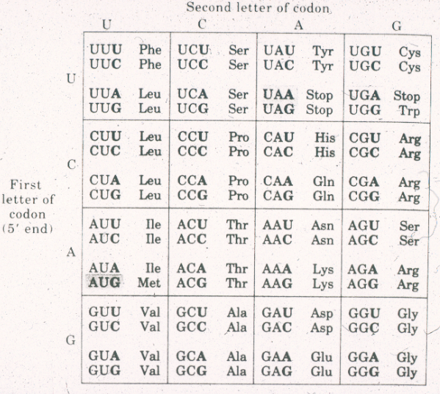

1. Of the following, the amino acid MOST LIKELY to have its side chain buried in the interior of a protein is

A. arginine.

*B. alanine.

C. asparagine.

D. aspartic acid.

E. lysine.

2. When the pH in the oral cavity rises from 6.5 to 7.5, the hydrogen ion concentration [H⁺] in the oral cavity

A. increases by a factor of 10.

B. increases by a factor of 100.

C. decreases by a factor of 2.

*D. decreases by a factor of 10.

E. decreases by a factor of 100.

3. A student dissolves 5 millimoles of ascorbic acid (HAs, pK_{a} = 4.5) and 500 millimoles of sodium ascorbate (Na⁺ As–) in a small volume of water. The pH of the resulting solution will be approximately

A. 2.5

B. 3.5

C. 4.5

D. 5.5

*E. 6.5

8 9 10
G H J

1 2
A
B
3 4 5 6 7
C D E F

4. The branched pathway shown above produces two essential metabolites: compound 7 and compound 10. In this pathway, enzyme A is MOST LIKELY to be regulated by

A. substrate activation by compound 1.

*B. product inhibition by compound 2.

C. allosteric inhibition by compound 7.

D. allosteric inhibition by compound 10.

E. allosteric activation by both compound 7 and compound 10.

5. In the liver, aldehyde dehydrogenase II has a K_{M} for acetaldehyde of 0.6 μM, and a V_{max} of 1.2 μmoles/min/mg of tissue. When the acetaldehyde concentration in the liver is 0.2 μM, this enzyme will convert acetaldehyde to acetate at a rate of

A. 0.2 μmoles/min/mg of tissue.

*B. 0.3 μmoles/min/mg of tissue.

C. 0.4 μmoles/min/mg of tissue.

D. 0.6 μmoles/min/mg of tissue.

E. 0.9 μmoles/min/mg of tissue.

o

o

o
x
1/V o x
x
o x
x
x

x = no compound E

o = 1 mM compound E

1/S

6. In the above graph, the x’s and o’s show the results of actual measurements of the rate of product formation by an enzyme at various substrate concentrations, in the absence and presence of compound E. Of the following choices, the best conclusion from these data is that compound E

*A. increases K_{M} but does not change V_{max}.

B. increases V_{max} but does not change K_{M}.

C. decreases K_{M} but does not change V_{max}.

D. decreases V_{max} but does not change K_{M}.

E. decreases both V_{max} and K_{M}.

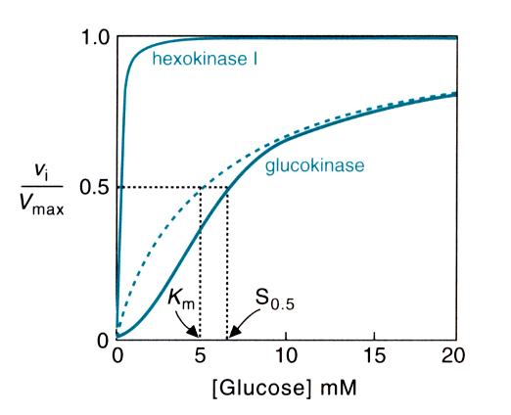

7. Hexokinase and glucokinase are isozymes that both catalyze the first step in the metabolism of glucose. The level of glucose in the blood normally varies between 4 and 20 mM. From these facts and the above graph, we would be MOST LIKELY to conclude that

A. hexokinase will be found in cells that store excess glucose.

B. glucokinase will be found in cells that depend on glucose for their energy.

C. glucokinase binds glucose more tightly than hexokinase.

D. hexokinase has quaternary structure.

*E. glucokinase can exist in two different conformations, only one of which can bind glucose.

8. All of the following are true about enzymes EXCEPT:

A. The active sites of enzymes are usually altered by substrate binding.

B. During catalysis, covalent bonds sometimes form between enzymes and their substrates.

C. The initial enzyme-substrate complex is held together by non-covalent bonds only.

*D. Once an enzyme-substrate complex forms, it always proceeds to product formation.

E. The product of an enzymatic reaction is usually a competitive inhibitor of the reaction.

H

pK = 4 HOOC – C – (CH₂)₄ – NH₄⁺ pK = 10

NH₄⁺

pK = 8.5

9. The amino acid lysine has the pK values indicated above. At pH 7.4, the net charge on the lysine molecule is closest to

A. -2

B. -1

C. 0

*D. +1

E. +2

10. Aspirin (acetyl salicylic acid), a suicide substrate for the enzyme cyclooxygenase,

A. acts as a competitive inhibitor of the enzyme.

*B. forms a product that remains covalently bound to the active site of the enzyme.

C. forms a product that acts as a competitive inhibitor of the enzyme.

D. cannot bind to the enzyme.

E. binds to the active site of the enzyme but cannot react.

11. The ANTICODON for tryptophan tRNA is

A. 5' UGG 3'

B. 5' GGU 3'

C. 5' ACC 3'

*D. 5' CCA 3'

E. None of the above

12. The crossed stranded structure formed between two DNA molecules during homologous recombination is called a

A. recombinase.

B. D- loop.

C. signal sequence.

*D. Holliday junction.

E. nucleosome.

13. The autoradiogram below shows the result of dideoxy (chain termination) sequencing of a primed DNA template. The TEMPLATE that was sequenced is

A. 5' AATCCGATGTA 3'

*B. 5' TACATCGGATT 3'

C. 5' ATGTAGCCTAA 3'

D. 5' TTAGGCTACAT 3'

14. An enzyme that normally uses UTP as a substrate is

A. DNA polymerase.

B. reverse transcriptase.

*C. primase.

D. RNAseH.

E. topoismerase.

15. The figure below shows an advancing DNA replication fork with some of the ends marked. Which of these ends are 5' ?

A. B, C, E

B. B, C, F

C. A, D, E

*D. A, D, F

E. Can’t be determined from this figure.

16. When bacteria are grown in the presence of lactose and the absence of
glucose, the CAP protein will

A. bind to the lac repressor protein and prevent transcription of the lac operon.

B. bind to the lac repressor protein and induce transcription of the lac operon.

C. bind to the regulatory region of lac operon and prevent transcription.

*D. bind to the regulatory region of the lac operon and induce transcription.

E. bind cAMP and lose its DNA binding site.

17. Cyclin dependent protein kinases

A. add methyl groups to histones.

B. join the large and small subunits of the ribosome.

C. add phosphates to nucleosides.

*D. help regulate the eukaryotic cell cycle.

E. remove damaged bases from DNA.

18. In which phase of the cell cycle would an anti-cancer drug that targets DNA replication be most effective?

A. G_{o}

B. G₁

*C. S

D. G₂

E. M

19. In prokaryotes, the sigma factor helps

*A. guide RNA polymerase to the proper promoter.

B. initiate protein synthesis.

C. peptide bond formation during the elongation step of protein synthesis.

D. locate the origin of DNA replication.

E. identify proteins destined to be secreted from the cell.

20. Transcription is regulated by addition or removal of modifying chemical groups on the amino terminal tails of

A. proteasomes.

B. signal sequences.

*C. nucleosomes.

D. chaperones.

E. transposons.

21. The peptide encoded by the mRNA with the sequence
5' CAAUGGUUAAUAGGUAAG 3' is

A. Glu-Trp-Ile-Ile Gly- Asn.

B. Gln-Trp-Leu-Ile-Gly-Lys.

C. Met-Asp-Asn-Trp.

*D. Met-Val-Asn-Arg.

E. none of the above.

22. The antibiotic tetracycline binds to

A. DNA polymerase.

B. the catalytic subunit of RNA polymerase.

*C. the small subunit of the ribosome.

D. helicase.

E. the cell wall.

23. Benzo(a)pyrene causes bulky lesions in DNA that are most likely to be repaired by

*A. nucleotide excision repair.

B. base excision repair.

C. mismatch repair.

D. DNA polymerase’s edit function.

24. Both DNA polymerase and RNA polymerase

A. require a primer.

*B . require a template.

C. synthesize in the 3' to 5' direction.

D. have associated exonucleases.

E. have associated endonucleases.

25. During replication of a retroviral genome,

*A. reverse transcriptase extends a tRNA primer by synthesizing new DNA.

B. reverse transcriptase extends a tRNA primer by synthesizing new RNA.

C. Okazaki fragments form on the lagging strand of the DNA replication fork.

D. Okazaki fragments form on the leading strand of the DNA replication fork.

E. Rnase H digests any RNA that is not base paired.

26. During the synthesis of proteins destined to be secreted from the cell,

A. ubiquitin is attached to the amino terminal residues.

B. ubiquitin is attached to the carboxy terminal residue.

*C. a signal sequence is synthesized on the amino terminal end of the protein.

D. a signal sequence is synthesized on the carboxy terminal of the protein.

27. Proto-oncogenes typically

A. block DNA repair pathways.

B. trigger apoptosis.

C. cause improper folding of newly synthesized proteins.

*D. help regulate the cell cycle in normal healthy cells.

E. are activated only in cancerous cells.

28. In eukaryotes, a major role of small nuclear RNAs (snurps) is

A. priming Okazaki fragments.

B. priming RNA polymerase II.

*C. helping to remove introns from the primary RNA transcript.

D. helping the ribosome catalyze peptide bonds.

E. transporting amino acids to the ribosome.

29. During apoptosis a eukaryotic cell

A. becomes locked in G_{o}.

B. divides rapidly without regard for normal regulatory signals.

C. repairs damage in its DNA.

*D. undergoes programmed cell death.

E. transcribes only essential genes.

30. When performing polymerase chain reaction (PCR), it is important that the DNA polymerase

A. is capable of de novo synthesis (i.e. can begin synthesis without a primer).

*B. is resistant to high temperatures.

C. has an efficient 5' - 3' exonuclease activity.

D. lacks a 3' - 5' exonuclease activity.

E. is taken from a eukaryotic source.

31. Which of the following enzymes is NOT active at a eukaryotic DNA replication fork?

A. Helicase

B. Primase

*C. Reverse transcriptase

D. RnaseH

E. Ligase

32. Which of the following are believed to be risk factors or carcinogens that play a role in the etiology of oral cancer (squamous cell carcinoma)?

A. Smoking cigarettes

B. Drinking alcohol

C. Human papillomavirus

*D. All of the above

33. Oral cancer (squamous cell carcinoma) can be detected

A. only with special handheld devices.

B. only with DNA analysis.

*C. with the unaided eye.

D. only after it has metastasized.

34. HPV is responsible for a subset of oral cancer (squamous cell carcinoma) predominately found

*A. in the oropharynx and base of tongue.

B. on the gingiva.

C. in the floor of the mouth.

D. on the lateral tongue.

35. NAD is synthesized from which of the following vitamins?

A. Biotin

B. Thiamine

C. Riboflavin

*D. Niacin

E. Pantothenate

36. Which of the following is NOT a function of the TCA Cycle?

A. Produce FADH₂.

*B. Produce H₂O.

C. Produce GTP.

D. Produce NADH.

E. Oxidize acetyl CoA.

37. The oxidation of acetyl CoA by the TCA Cycle will be DECREASED under which of the following conditions?

A. High ADP levels

B. Low NADH/NAD+ ratio

*C. High ATP levels

D. Low GTP/GDP ratio

38. The process of oxidative phosphorylation

A. provides energy for the red blood cell.

B. is an example of substrate level phosphorylation.

C. results in the production of ATP and O₂.

*D. occurs in the mitochondria of most cells.

39. Which of the following cytochromes of the mitochondrial electron transport chain requires copper?

*A. Cytochrome a

B. Cytochrome b

C. Cytochrome c

D. Cytochrome P450

40. Addition of an uncoupler to mitochondria

A. decreases electron [flow] and ATP synthesis.

B. inhibits electron flow past complex IV.

*C. increases electron flow and decreases ATP synthesis.

D. increases electron flow and ATP synthesis.

41. Electrons derived from many substrates use the mitochondrial electron transport chain because

*A. the substrates are oxidized by enzymes linked to NAD and FAD.

B. each substrate is oxidized in the mitochondria.

C. electron from each substrate are transferred to ATP.

D. protons from each substrate are used to form H₂O.

42. Which of the following would be classified as an anaplerotic reaction?

*A. formation of oxaloacetate from pyruvate and CO₂

B. formation of citrate from oxaloacetate and acetyl CoA

C. formation of succinate from succinyl CoA

D. formation α-ketoglutarate from isocitrate

43. A decrease in the activity of pyruvate dehydrogenase would cause an increase in all of the following EXCEPT

A. lactate.

*B. acetyl CoA.

C. pyruvate.

D. alanine.

44. Which enzyme can produce pyruvate?

A. Hexokinase

B. Glyceraldehyde 3-phosphate dehydrogenase

C. Phosphofructokinase-1

D. Aldolase

*E. Lactate dehydrogenase

45. Which compound consumed during the production of pyruvate from glucose must be regenerated for the glycolysis pathway to continue uninterrupted?

A. ADP

B. Acetyl CoA

C. CoA

*D. NAD+

E. NADH

46. Anaerobic glycolysis by oral bacteria produces which of the following compounds that directly contributes to the formation of dental caries?

A. Pyruvate

B. NADH

C. Glucose

*D. Lactic acid

E. ATP

47. Ketone bodies

A. are utilized by the liver as major energy fuels in the starvation state.

B. are utilized as energy fuels only in the brain.

C. are intracellular organelles.

D. cannot be synthesized in the body.

*E. can cause ketoacidosis if they are over-produced.

48. The rate of glycolysis in skeletal muscle increases during exercise due principally to stimulation by

A. ADP.

*B. AMP.

C. ATP.

D. NAD+.

E. NADH.

49. β-oxidation of fatty acids in liver mitochondria produces

A. fatty acyl carnitine.

B. malonyl CoA.

C. hydrogen peroxide.

D. glucose.

*E. acetyl CoA.

50. Glucagon

*A. activates fatty acid release from adipose tissue.

B. is made of glucose.

C. is the only regulator of fuel metabolism.

D. inhibits gluconeogenesis during fasting.

E. is a short-chain fatty acid.

Extra Credit Questions on the following page

Extra Credit: ANY Answer to each of the following questions will receive 1 point extra credit. For each question, please choose the 1 answer that best describes your opinion. (Multiple answers to any question will receive 0 credit!)

51. In this course, paper handouts should be supplied in addition to posting lectures on Blackboard.

A. Agree strongly

B. Agree somewhat

C. No opinion

D. Disagree somewhat

E. Disagree strongly

52. In this course, paper handouts are

A. more useful than Blackboard during lectures.

B. more useful than Blackboard for study and review.

C, Both A and B.

D. less useful than Blackboard during lectures and for study/review.

