Name ____________________________

DENTAL BIOCHEMISTRY AND NUTRITION
(D-100 )
EXAM I
OCTOBER 7, 2009
INSTRUCTIONS

1. Count the pages to make sure you have them all, 1 - 22.

2. Put your name on this page. On the front of the bubble sheet, write your name and bubble it in. Sign the back of the bubble sheet.

3. This page contains data that may help you in answering some of the questions.

4. If you need more space to work or answer problems, please use the back of the exam.

5. The point values of the questions are given for each section. There are 52 questions plus 2 extra credit questions. The total number of points is 100 plus 2 extra credit points.

6. Hand your completed exam to one of the Dental Biochemistry faculty members when you have finished. All exams will be collected at 12:00 noon.

CONSTANTS AND EQUATIONS

[Products]_{equilibrium}
ΔG^{0'} (Kcal/mole) = – 1.4 log log 0.01 = -2
[Substrates]_{equilibruim} log 0.1 = -1
log 1 = 0
V_{max} [S] log 10 = 1
v = log 100 = 2
K_{m} + [S] [A]
pH = pK + log
[HA]

A codon table is on the back of this page.

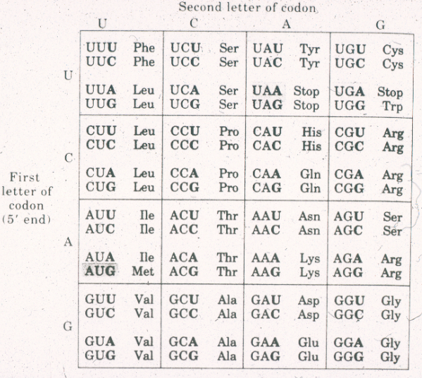

True/False. Bubble in A if the statement is True, B if it is False. (1 point each)

1. In the reaction: lactate + NAD⁺ pyruvate + NADH + H⁺, T
lactate is oxidized to pyruvate.

2. Covalent modification (phosphorylation/dephosphorylation) changes enzyme F
activity faster that allosteric regulation.

3. Myoglobin has secondary structure but NOT tertiary structure. F

4. Hyperventilation causes an increase in the pH of the blood. T

Single Best Answer. (2 points each)

5. When the pH in the oral cavity drops from 6.5 to 4.5, the hydrogen ion concentration [H⁺] in the oral cavity

A. increases by a factor of 10.

B.* increases by a factor of 100.

C. decreases by a factor of 2.

D. decreases by a factor of 10.

- decreases by a factor of 100.

H
I
pK_{a} = 2 HOOC – C – CH₂ – CH₂ – COOH pK_{a} = 4
I
NH₂
pK_{a} = 9

6. At physiological pH (7.4), the amino acid shown above will have a time-averaged net charge of

A. +2

B. +1

C. 0

D.* –1

E. –2

7. A student dissolves 100 millimoles of ascorbic acid (HAs, pK_{a} = 4.5) and 10 millimoles of sodium ascorbate (Na⁺ As–) in a small volume of water. The pH of the resulting solution will be approximately

A. 2.5

B.* 3.5

C. 4.5

D. 5.5

E. 6.5

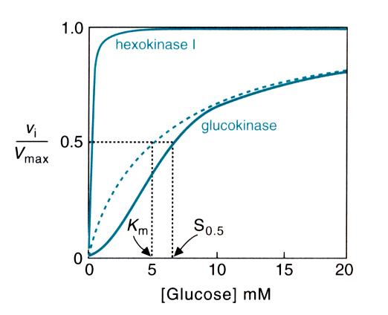

8. From the graph above, we can conclude all of the following EXCEPT:

A. Glucokinase displays cooperativity in substrate binding.

B. Glucokinase has quaternary structure.

C. Hexokinase binds glucose more tightly than glucokinase.

D.* Glucokinase obeys the Michaelis-Menten equation.

E. Glucokinase can exist in two different conformations, only one of which can bind glucose.

9. An enzymatic reaction is found to have a V_{max} of 10 μg/min/mg of tissue, and
a K_{M} of 80 μM. At a substrate concentration of 20 μM, the rate of product formation will be (in μg/min/mg of tissue)

A. 1.

B.* 2.

C. 3.

D. 5.

E. 10.

2

1
1
V

Curve 1: no E
Curve 2: 1 mM E

1
S

10. The above graph represents measurements of the activity of an enzyme at different substrate concentrations, in the presence and absence of compound E. The graph reveals that compound E

A.* changes K_{M} but not V_{max}.

B. changes V_{max} but not K_{M}.

C. changes both V_{max} and K_{M}.

D. changes neither V_{max} nor K_{M}.

11. All of the following are true about enzymes EXCEPT:

A. The active sites of enzymes are usually altered by substrate binding.

B. During catalysis, covalent bonds sometimes form between enzymes and their substrates.

C. The initial enzyme-substrate complex is held together by non-covalent bonds only.

D.* Enzymes catalyze reactions by altering equilibrium constants.

E. The product of an enzymatic reaction is usually a competitive inhibitor of the reaction.

8 9 10

1 2
A
B
3 4 5 6 7
C D E

12. In the above branched pathway, we might expect compound 7 to be an
allosteric inhibitor of the enzyme that catalyzes reaction

A. A.

B. B.

C. C.

D.* D.

E. E.

13. A suicide substrate

A. cannot bind to its target enzyme.

B. binds to the active site but cannot react.

C. acts as a competitive inhibitor of its target enzyme.

D. forms a product that acts as a competitive inhibitor of its target enzyme.

E.* forms a product that remains covalently bound to the active site of the target enzyme.

14. In humans the base excision repair pathway of DNA repair begins with an
enzyme called

A. AP endonuclease.

B.* glycosylase.

C. excinuclease.

D. XP endonuclease.

E. DNA polymerase.

15. Signal sequences are

A. located on the amino terminal ends of histones.

B. located on the carboxyl terminal ends of histones.

C. DNA sequences that regulate transcription of certain genes.

D. RNA sequences that help to position the ribosome for correct translational start.

E.* amino acid sequences that guide polypeptides to their proper location.

16. The autoradiogram shown resulted from dideoxy sequencing of a primed DNA template. The sequence of the TEMPLATE was

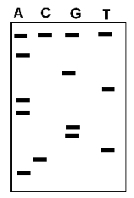

A. 5' ACTGGAATGA 3'

B 5' AGTAAGGTCA 3'

C.* 5' TCATTCCAGT 3'

D. 5' TGACCTTACT 3'

17. A malignant growth in a patient's mouth is most likely initiated by

A. a single mutation in one cell.

B. single mutations in several nearby cells.

C. apoptosis of a damaged cell.

D.* accumulation of several mutations in a given cell.

E. inability of a cell to replicate its DNA.

18. A tRNA molecule with the anticodon 5' GCA 3' will be charged with

A. Ala.

B. Thr.

C.* Cys.

- Arg.

19. Improper folding of newly synthesized proteins is reduced by

A. proteasomes.

B. edit functions.

C. nucleosomes.

D.* chaperones.

E. enhancers.

20. The phase of the cell cycle when the cell prepares for cell division is

A. G_{0.}

B. G_{1.}

C.* G₂.

D. S.

E. M.

21. Mutagenic inactivation of which of the following enzyme activities is most likely to cause reduced fidelity of DNA synthesis?

A. Ligase

B. Primase

C. Reverse transcriptase

D.* 3' - 5' exonuclease of DNA polymerase

E. RNAseH

22. DNA polymerases

A.* can use either RNA or DNA as a primer.

B. will synthesize DNA without a primer on the lagging strand of a DNA replication fork.

C. can not incorporate a nucleotide into a growing DNA chain unless that nucleotide has a 3'-OH .

D. always have an associated RNaseH.

E. are required for nucleotide excision repair, but not for base excision repair.

23. During homologous recombination the recombinase (i.e. RecA or Rad51)

A. resolves Holliday junctions.

B. puts a double strand break in one homologue.

C.* first binds single stranded DNA and then binds double stranded DNA.

D. forms a gap in one of the participating DNA molecules.

E. joins a 3'-OH to a 5'-phosphate to complete a Holliday junction.

24. RNA polymerase

A. incorporates NTPs into a growing RNA chain.

B. requires either an RNA or DNA primer.

C.* lacks an editing function.

D. requires an associated helicase to produce a single stranded DNA template.

E. always transcribes the leading strand of a double stranded DNA molecule.

25. Restriction fragment length polymorphisms

A. occur only in individuals with genetic diseases.

B. always create a new site of sensitivity to a given restriction
endonuclease.

C. are not found in procaryotes.

D. occur only in introns.

E.* are caused by mutations that alter sensitivity to restriction endonucleases.

26. Replication of retroviral genomes

A. does not require a primer.

B.* depends upon repeated sequences at the ends of the genome.

C. requires primase.

D. proceeds with unusually high fidelity.

E. depends upon telomerase to complete the ends of the genome.

27. The amino acid composition of a protein produced by the transcript shown below is

5' - AGAUGCUUGUGGUAC… - 3'

A. His - Gly - Val - Arg - Arg…

B. Met - Val - Phe - Val…

C. Arg - Cys - Leu - Trp - Tyr…

D.* Met - Leu - Val - Val…

28. When bacteria are grown in the presence of glucose the CAP protein will

A. bind to the lac repressor and prevent transcription of the lac operon.

B. bind to the lac repressor and induce transcription of the lac operon.

C. bind to the regulatory region of lac operon and prevent transcription.

D. bind to the regulatory region of the lac operon and induce transcription.

E.* not bind to either the lac operon DNA nor the lac repressor.

29. The antibiotic streptomycin binds to

A. bacterial DNA polymerase and blocks DNA replication.

B. bacterial RNA polymerase and blocks transcription.

C.* the small subunit of the bacterial ribosome and inhibits initiation of protein synthesis.

D. the bacterial cell wall and promotes cell lysis.

E. bacterial DNA and causes it to be degraded.

30. Modifications to histone proteins, such as the addition of acetyl or methyl groups,

A. take place primarily on the carboxyl terminal ends of the histones.

B. influence the number of times the DNA wraps around the nucleosome.

C. change the distribution of various histone proteins within the nucleosome.

D.* are one determinant of whether the genes in that region of chromatin will be transcribed.

E. block removal of introns from the primary transcript.

31. Cyclin dependent protein kinases

A. are present at high levels throughout the cell cycle.

B. determine whether a given protein will be degraded.

C. help newly synthesized protein to fold properly.

D. determine the degree to which chromatin is compacted.

E.* phosphorylate proteins that regulate the cell cycle.

32. In eukaryotes, primary RNA transcripts synthesized by
RNA polymerase II are modified by

A. addition of a poly A tail to the 3' end.

B. addition of a 7 methyl G cap to the 5' end.

C. removal of introns by splicing exons together.

D.* All of the above.

33. In eukaryotes, the basal transcription factors

A. by themselves determine the level of expression of a given gene.

B. help destabilize heterochromatin to make DNA more accessible to RNA polymerase.

C.* recognize the promoter and help position RNA polymerase in the proper orientation for transcription.

D. bind directly to enhancer sequences in the DNA.

E. cause transcription to terminate at the proper site.

34. When performing PCR, it is important that

A. the DNA polymerase does not have an associated 3' - 5' exonuclease.

B. the DNA polymerase is readily denatured by high temperatures.

C. only RNA primers are used.

D.* a vast excess of primers are provided.

E. each of the reactions contains one of the four dideoxyribonucleoside triphosphates.

35. In human chromatin,

A. nucleosome cores are made up of a single polypeptide chain

B.* DNA is wrapped around nucleosome cores.

C. DNA is completely enclosed within nucleosomes.

D. nucleosomes repel one another to stretch out the chromatin.

E. DNA in the linker region is single stranded.

36. A feature of transcription that is common to prokaryotes and eukaryotes is that both

A. use the same RNA polymerase to synthesize tRNA, rRNA and mRNA.

B.* regulate gene expression via a promoter located 5' to the coding region.

C. often transcribe a block of related genes, called an operon, into a single continuous RNA molecule.

D. use DNA sequences called "enhancers" to increase the level of transcription.

E. routinely splice introns out of the primary transcript.

37. In a eukaryotic cell, a protein with ubiquitin attached to it is most likely to end up in a

A.* proteasome.

B. nucleosome.

C. chaperone.

D. replisome.

E. ribosome.

38. Which of the following mitochondrial electron carriers uses molecular oxygen as an electron acceptor?

A. NADH dehydrogenase

B. Coenzyme Q (CoQ)

C. Complex b-c₁

D. Cytochrome c

E.* Cytochrome oxidase

39. All of the following enzymes are located in mitochondria EXCEPT

A.* phosphofructokinase.

B. pyruvate dehydrogenase.

C. α-ketoglutarate dehydrogenase.

D. succinate dehydrogenase.

E. acyl CoA dehydrogenase.

40. All of the following complexes of the mitochondrial electron transport chain are capable of pumping protons across the inner mitochondrial membrane EXCEPT

A. Complex I.

B.* Complex II.

C. Complex III.

D. Complex IV.

41. Which of the following is a correct statement concerning electron carriers involved in oxidation-reduction reactions:

A. NAD⁺ is found only in the cytosol.

B.* NAD⁺ accepts two electrons in the form of a hydride (H⁻) ion.

C. FAD is synthesized from the vitamin pantothenate.

D. FAD is released from enzymes once it has been reduced to FADH₂.

42. Which of the following pathways can produce high energy phosphate bonds via substrate level phosphorylation?

A. Glycolysis only.

B. TCA cycle only.

C. β-oxidation of fatty acids only.

D.* Glycolysis and TCA cycle.

E. Glycolysis, TCA cycle and β-oxidation of fatty acids.

43. Which of the following can produce energy in the absence of O₂?

A.* Glycolysis only.

B. TCA cycle only.

C. β-oxidation of fatty acids only.

D. Glycolysis and TCA cycle.

E. Glycolysis, TCA cycle and β-oxidation of fatty acids.

44. If a person consumed a chemical that irreversibly inhibited cytochrome C in the electron transport chain,

A. proton pumping would be unaffected.

B. the rate of malate oxidation would increase.

C.* ATP levels in the cell would fall.

D. NADH levels in the cell would fall.

45. Which of the following conditions would cause a decrease in TCA Cycle activity?

A. Decrease in the ATP/ADP ratio.

B. Increase in oxaloacetate levels.

C.* Decrease in the NAD⁺/NADH ratio.

D. Uncoupling of oxidative phosphorylation.

46. A deficiency of the enzyme pyruvate dehydrogenase would result in increased levels of all of the following except?

A. lactate

B. pyruvate

C.* acetyl CoA

D. alanine

47. The end products of aerobic glycolysis include

A. ADP and lactate.

B. ADP and pyruvate.

C. ATP and lactate.

D.* ATP and pyruvate.

E. lactate and pyruvate.

48. The rate-limiting step in glycolysis in skeletal muscle and most tissues is conversion of

A. glucose to glucose 6-phosphate.

B. glucose 6-phosphate to fructose 6-phosphate.

C.* fructose 6-phosphate to fructose 1,6-bisphosphate.

D. 2-phosphoglycerate to phosphoenolpyruvate.

E. phosphoenolpyruvate to pyruvate.

49. Which of the following CANNOT be converted to lactic acid when plaque bacteria are present in the oral cavity?
A. Ingested sucrose.
B. Ingested starch.
C. Plaque glucans.
D. Bacterial glycogen.
E.* All of the above can be converted to lactic acid.

50. During starvation, which of the following compounds increases in concentration in the blood with increasing time?

A. Acetyl CoA

B. Glucose

C.* Acetoacetate

- Palmitoyl CoA

51. Hypoglycin is a toxin which inhibits acyl CoA dehydrogenase, leading to Jamaican vomiting sickness. Ingestion of hypoglycin reduces the level of

A. fatty acids in mitochondria.

B. fatty acids in the blood.

C.* acetyl CoA in mitochondria.

D. FAD in mitochondria.

52. Genetic deficiencies in carnitine palmitoyltransferase I (CPT1) result in a decrease in

A.* beta-oxidation of long chain fatty acids.

B. synthesis of malonyl CoA.

C. transport of fatty acids from adipocytes into the blood.

D. transport of fatty acids from the mitochondria into the cytosol.

Extra Credit: ANY Answer to each of the following questions will receive 1 point extra credit. For each question, please choose the 1 answer that best describes your opinion. (Multiple answers to any question will receive 0 credit!)

53. In this course, paper handouts should be supplied in addition to posting lectures on Blackboard.

A. Agree strongly

B. Agree somewhat

C. No opinion

D. Disagree somewhat

E. Disagree strongly

54. In this course, paper handouts are

A. more useful than Blackboard during lectures

B. more useful than Blackboard for study and review.

C, Both A and B.

D. less useful than Blackboard during lectures and for study/review.

