Name ____________________________

DENTAL BIOCHEMISTRY AND NUTRITION
(D-100 )
EXAM I
OCTOBER 5, 2011
INSTRUCTIONS

1. Count the pages to make sure you have them all, 1 - 21.

2. Put your name on this page. On the front of the bubble sheet, write your name and bubble it in. Sign the back of the bubble sheet.

3. This page contains data that may help you in answering some of the questions.

4. If you need more space to work or answer problems, please use the back of the exam.

5. The point values of the questions are given for each section. There are 50 questions plus 2 extra credit questions. The total number of points is 100 plus 2 extra credit points.

6. Hand your completed exam to one of the Dental Biochemistry faculty members when you have finished. All exams will be collected at 11:30.

CONSTANTS AND EQUATIONS

[Products]_{equilibrium}
ΔG^{0'} (Kcal/mole) = – 1.4 log log 0.01 = -2
[Substrates]_{equilibruim} log 0.1 = -1
log 1 = 0
V_{max} [S] log 10 = 1
v = log 100 = 2
K_{m} + [S] [A]
pH = pK + log
[HA]

A codon table is on the back of this page.

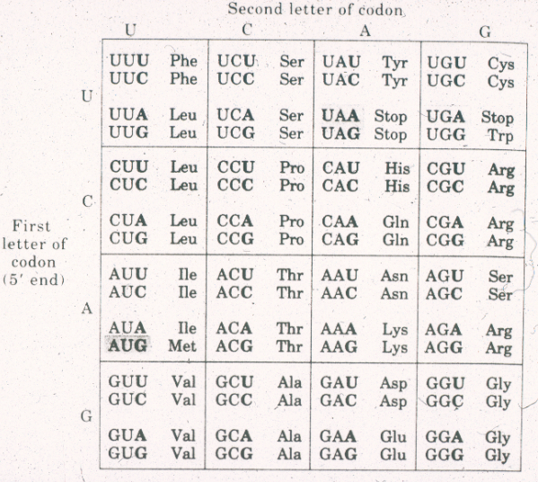

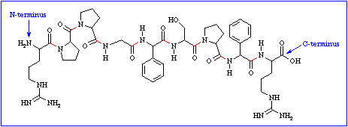
bradykinin
I
II
III
IV

pK_{a} I = 8.5 pK_{a} II = 12.8 pK_{a} III = 13.5 pK_{a} IV = 2.0

Refer to the structure and information above to answer questions 1 and 2.
- At pH 7.4, the peptide hormone bradykinin (shown above) has a time-averaged net charge closest to
A. -1.
B. 0.
C. +1.
*D. +2.
E. +3.

2. The amino acid side chain (R group) circled in the figure above is best
described as

A. basic.

B. acidic.

C. hydrophobic.

D. aromatic.

*E. polar.

3. When the pH in the oral cavity drops from 6.0 to 3.0, the hydrogen ion
concentration [H⁺] in the oral cavity

A. decreases by a factor of 1000.

B. decreases by a factor of 100.

C. decreases by a factor of 2.

D. increases by a factor of 2.

*E. increases by a factor of 1000.

4. You are a chemist working for a pharmaceutical company. You make a vitamin C tablet that contains 1 millimole of ascorbic acid (HAs, pK_{a} = 4.5) and 10 millimoles of sodium ascorbate (Na⁺ As–). When this tablet dissolves in someone’s mouth, the pH will in the oral cavity will be approximately

A. 2.5

B. 3.5

C. 4.5

*D. 5.5

E. 6.5

5. The MINIMUM size of an enzyme is around

A. 10 amino acids.

B. 30 amino acids.

*C. 120 amino acids.

D. 360 amino acids.

E. 1000 amino acids.

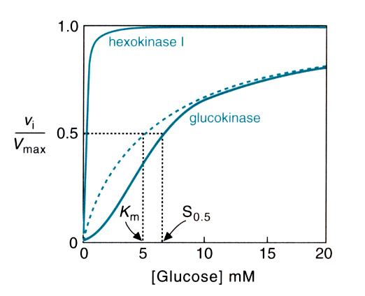

6. Hexokinase and glucokinase are isozymes that both catalyze the first step in the metabolism of glucose. The level of glucose in the blood normally varies between 4 and 20 mM. From these facts and the above graph, we would be MOST LIKELY to conclude that

A. glucokinase has disulfide bonds.

*B. glucokinase has quaternary structure.

C. glucokinase binds obey Michaelis-Menten kinetics.

D. the main function of glucokinase is to provide the cell with a constant, steady supply of its product, glucose 6-phosphate.

E. glucokinase binds glucose more tightly than hexokinase.

- Of the following, the amino acid most likely to have its side chain (R group)
exposed on the surface of a protein is

A. arginine.

B. alanine.

C. phenylalanine.

D. leucine.

E. valine.

8. In the liver, aldehyde dehydrogenase II has a K_{M} for acetaldehyde of 0.6 μM, and a V_{max} of 1.2 μmoles/min/mg of tissue. When the acetaldehyde concentration in the liver is 0.6 μM, this enzyme will convert acetaldehyde to acetate at a rate of

A. 0.2 μmoles/min/mg of tissue.

B. 0.3 μmoles/min/mg of tissue.

C. 0.4 μmoles/min/mg of tissue.

*D. 0.6 μmoles/min/mg of tissue.

E. 1.2 μmoles/min/mg of tissue.

9. All of the following are true about enzymes EXCEPT:

*A. Once an enzyme-substrate complex forms, it always proceeds to product formation.

B. The initial enzyme-substrate complex is held together by non-covalent bonds only.

C. The active sites of enzymes are usually altered by substrate binding.

D. During catalysis, covalent bonds sometimes form between enzymes and their substrates.

E. The product of an enzymatic reaction is usually a competitive inhibitor of the reaction.

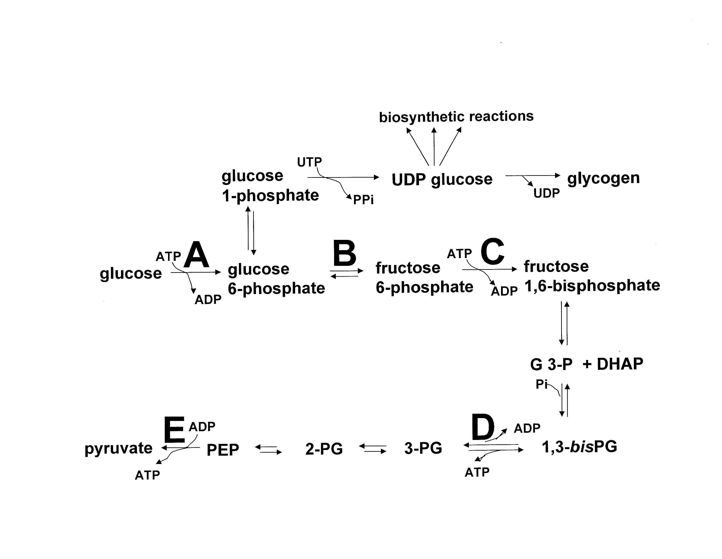
10. The figure above shows several fates of glucose in the liver. Based on
general principles of pathway regulation, the MOST LIKELY step for
regulation of glycolysis (conversion of glucose to pyruvate) is

A. A.

B. B.

*C. C.

D. D.

E. E.

11. During RNA transcription, sites of bulky DNA damage

A. are by-passed by error-prone DNA polymerases.

B. are repaired by base excision repair.

C. are repaired by mismatch repair.

*D. cause RNA polymerase to stall and recruit the nucleotide excision repair pathway.

12. DNA double-strand breaks are usually repaired by

A. base excision repair.

B. direct repair.

C. glycosylases.

*D. recombinational repair.

E. nucleotide excision repair.

13. When bacteria are grown in the presence of glucose and the absence of
lactose,

A. glucose inactivates the lac Repressor protein.

B. cAMP inactivates the lac Repressor protein.

*C. the lac Repressor protein blocks transcription of the lac operon.

D. CAP protein blocks transcription of the lac operon.

E. CAP protein induces transcription or the lac operon.

14. Gene transcription is silenced when

A. DNA is packaged in the form of euchromatin.

B. the TATA binding protein binds to DNA at the promoter region.

*C. DNA at the promoter region is methylated.

D. cytosines in the promoter region are deaminated.

15. In prokaryotes, termination of transcription

A. is signaled by the polyadenylation sequence AAUAAA.

*B. requires formation of a hairpin loop or binding of rho protein.

C. occurs when sigma factor detaches from RNA polymerase.

D. is followed by RNA splicing.

E. occurs when RNA polymerase encounters a stop codon.

16. In eukaryotes,

A. all RNA is synthesized by a single RNA polymerase.

*B. alternative splicing of a single pre-mRNA can produce different proteins.

C. introns are present in nearly all mRNA molecules.

D. recognition of the start codon is facilitated by the Shine-Dalgano sequence.

E. most mRNAs have a very short half life of only a few minutes.

17. The ANTICODON for methionyl-tRNA (met-tRNA) is

A. 5' UGG 3'

B. 5' GGU 3'

C. 5' ACC 3'

*D. 5' CAU 3'

E. None of the above

18. The “template” strand of a segment of DNA has the sequence: 5’…TCCAGGCTTACT…3” This segment of DNA could code for the amino acid sequence

A. Arg-Ser-Glu

*B. Ser-Lys-Pro-Gly

C. Ser-Arg-Leu-Thr

D. Met-Glu-Gly-Val

E. None of the above

19. All of the following statements about protein synthesis are true, EXCEPT

A. mRNA is read in the 5’ to 3’ direction.

*B. Polypeptide chains are synthesized starting at the carboxy terminus.

C. Ribosomes catalyze the formation of peptide bonds.

D. Translation ceases when ribosomes encounter a stop codon.

E. An amino acid is attached to the 3’ end of each tRNA molecule.

20. Streptomycin and chloramphenicol inhibit

A. DNA polymerase.

B. RNA polymerase.

C. ligase.

D. helicase.

*E. ribosomes.

21. Chaperone proteins

*A. assist in the proper folding of proteins.

B. help mRNA bind to ribosomes.

C. guide secretory proteins to the endoplasmic reticulum.

D. guide RNA polymerase to the promoter.

E. attach ubiquitin to proteins targeted for degradation.

22. Which of the following enzymes is used for DNA repair, but NOT for DNA replication?

A. DNA polymerase

B. Ligase

C. Primase

D. RNase H

*E. Glycosylase

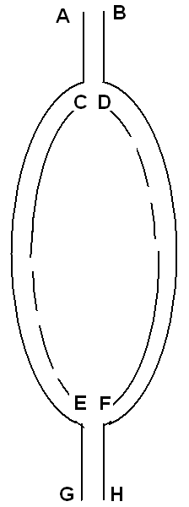23. The figure below is meant to depict a pair of DNA replication forks advancing from an origin of replication. Which of the ends are 5'?

*A. A, D, E, H

B. A, C, F, H

C. B, C, F, G

D. B, D, E, G

E. The polarity can not be determined
from this information.

24. The RNA on the end of an Okazaki fragment is removed by

A. 3' - 5' exonuclease.

*B. RNase H.

C. reverse transcriptase.

D. helicase.

E. ligase.

25. During homologous recombination, the enzyme called “resolvase”

A. initiates formation of D loops.

B. causes migration of Holliday junctions.

*C. separates the DNA strands that were joined in a Holliday junction.

D. removes mismatches from crossed DNA strands.

E. fills in gaps in the recombining DNA.

26. An enzyme that does NOT synthesize DNA is

A. telomerase.

B. reverse transcriptase.

*C. primase.

D. DNA polymerase.

27. A newly identified virus is found to have a genome with 23% A, 27% C,
31% G, and 19 % T. From this you would conclude that its genome is

A. single stranded RNA.

B. double stranded RNA.

*C. single stranded DNA.

D. double stranded DNA.

E. a DNA/ RNA hybrid.

28. In a double stranded DNA molecule,

A. hydrogen bonds link the 3' and 5' carbons of adjacent
deoxyribonucleoside monophosphates.

B. a series of linked deoxynucleoside triphosphates makes up each of the strands.

C. the number of adenines must exceed the number of cytosines.

D. a left handed helix is formed.

*E. the number of pyrimidines must equal the number of purines.

29. In human chromatin,

A. nucleosome cores consist of a single polypeptide chain.

*B. DNA is wrapped around the outside of the nucleosome core.

C. DNA is completely enclosed within the nucleosomes.

D. nucleosomes repel one another to stretch out the chromatin.

E. DNA in the linker region is single stranded.

30. The technique of Southern blotting

A. is used to visualize the products of DNA sequencing reactions.

B. Is essential for good PCR amplification.

*C. uses a DNA probe to identify DNA fragments after electrophoresis.

D. uses a DNA probe to identify RNA fragments after electrophoresis.

E. sometimes happens to careless opossums on Georgia highways.

31. Dideoxyribonucleotides terminate DNA synthesis because they

A. can not be incorporated into newly synthesized DNA.

B. do not form Watson-Crick base pairs with normal deoxyribonucleotides.

C. are removed by the DNA polymerase edit function.

*D. lack a 3’ OH group.

32. Most restriction enzymes will NOT cut

A. linear double stranded DNA.

B. closed circular double stranded DNA.

*C. single stranded DNA.

D. DNA within the coding region of a gene.

E. DNA that is part of an intron.

33. For polymerase chain reaction (PCR) to be successful it is important that

*A. the number of primer molecules greatly exceeds the number of template DNA molecules that are to be amplified.

B. the primers base pair with each other.

C. reverse transcriptase is included in the reactions.

D. dideoxyribonucleotides are included in the reactions.

E. a DNA polymerase without a proofreading function is used.

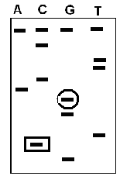34. The autoradiogram depicted below was obtained after performing dideoxy sequencing of a primed DNA template with ³²P label on the 5' end of the primer. The band in the "G" lane enclosed by a circle was produced by a DNA fragment that

*A. has a dideoxy GMP on its 3' end.

B. has a dideoxy GTP on its 3' end.

C. has a dGMP on its 3' end.

D. has a dCMP on its 3' end.

E. is shorter than the DNA fragment in lane "C" enclosed by a square.

35. FAD is synthesized from the vitamin

A. biotin.

B. thiamine.

*C. riboflavin.

D. niacin.

E. pantothenate.

36. In the electron transport chain, how many complexes pump protons across the inner mitochondrial membrane?

A. 1

B. 2

*C. 3

D. 4

37. The oxidation of acetyl CoA by the TCA cycle will be INCREASED by

*A. high ADP levels.

B. a high NADH/NAD+ ratio.

C. high ATP levels.

D. a high GTP/GDP ratio.

38. Electron transport by the electron transport chain

A. takes place in the outer mitochondrial membrane.

B. is an example of substrate level phosphorylation.

*C. leads to the production of ATP and H₂O.

D. occurs under anaerobic conditions.

39. Copper is an essential component of

A. NADH dehydrogenase.

B. flavin linked dehydrogenase.

*C. cytochrome oxidase.

D. iron sulfur proteins.

E. coenzyme Q.

40. Uncoupling of oxidative phosphorylation in mitochondria

A. decreases both electron transport and ATP synthesis.

B. inhibits electron flow past complex IV.

*C. increases electron flow and decreases ATP synthesis.

- increases both electron flow and ATP synthesis.

E. increases NADH levels.

41. Which of the following would be classified as an anaplerotic reaction?

*A. Formation of oxaloacetate from pyruvate and CO₂.

B. Formation of citrate from oxaloacetate and acetyl CoA.

C. Formation of succinate from succinyl CoA.

D. Formation α-ketoglutarate from isocitrate.

E. formation of malate from oxaloacetate.

42. Pyruvate dehydrogenase is inhibited by

A. lactate.

*B. acetyl CoA.

C. pyruvate.

D. alanine.

E. calcium.

43. Anoxia (O₂ deprivation) will result in

*A. lower levels of ATP.

B. lower levels of intracellular calcium.

C. lower levels of intracellular sodium.

- increased electron transport chain activity.

E. a higher rate of NADH synthesis.

44. An individual with a disease caused by a defect in mitochondrial DNA might be expected to have which of the following?

A. Increased activity of complex IV.

B. Deletion of the X chromosome.

C. A high ratio of ATP/ADP.

*D. An increased ratio of NADH/NAD+.

45. Anaerobic bacteria in the mouth produce lactate from pyruvate using which enzyme?

A. Hexokinase

B. Pyruvate kinase

C. Enolase

*D. Lactate dehydrogenase

E. Pyruvate dehydrogenase

46. The rate of ATP production by glycolysis increases in muscle during
exercise vs. rest due to stimulation of which enzyme by AMP?

A. Hexokinase

B. Glyceraldehyde 3-phosphate dehydrogenase

*C. Phosphofructokinase-1

D. Pyruvate kinase

E. Pyruvate dehydrogenase

47. Which compound is produced in liver and then released into the blood using lactate produced by the red blood cell?

A. O₂

B. Fructose

*C. Glucose

D. NAD

E. NADH

48. Long-chain fatty acids (12-20 carbons in length)

A. are rare in the body.

B. produce FAD and NAD⁺ through the steps of β-oxidation in mitochondria.

C. can enter the mitochondrial matrix as free fatty acids, independent of carnitine.

D. cause the Jamaican vomiting sickness.

*E. can be transported via the blood from the adipocytes to other tissues with the help of albumin.

49. Ketone bodies

A. are utilized by the liver as major energy fuels in the starvation state.

B. are utilized as energy fuels only in the brain.

C. are intracellular organelles.

D. cannot be synthesized in the liver.

*E. can cause ketoacidosis if they are over-produced.



50. β-oxidation of fatty acids in liver mitochondria produces

A. fatty acyl carnitine.

B. malonyl CoA.

C. hydrogen peroxide.

D. glucose.

*E. acetyl CoA.

Extra Credit: ANY Answer to each of the following questions will receive 1 point extra credit. For each question, please choose the 1 answer that best describes your opinion. (Multiple answers to any question will receive 0 credit!)

51. In this course, paper handouts should be supplied in addition to posting lectures on Blackboard.

A. Agree strongly

B. Agree somewhat

C. No opinion

D. Disagree somewhat

E. Disagree strongly

52. In this course, paper handouts are

A. more useful than Blackboard during lectures.

B. more useful than Blackboard for study and review.

C. Both A and B.

D. less useful than Blackboard during lectures and for study/review.

