Study-guide for Biochem Quiz 4

- Major dietary carbs: amylase & amylopectin (starches), sucrose, lactose, indigestible fiber
Major digestion products: glucose, galactose, fructose
- sucrose ά-1,2 → fructose + glucose (via sucrase)
- lactose β-1,4 → galactose + glucose (via lactase)
- starch → maltose + isomaltose + ά-Dextrin + trisaccharides
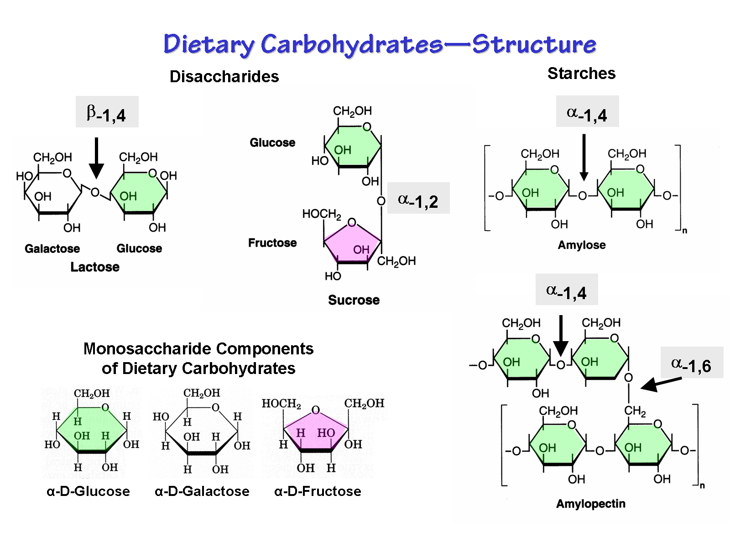
(via salivary & pancreatic ά-amylase, only for ά-1,4 glycosidic bonds) → glucose (via intestinal maltase & isomaltase)

- Indigestible carbs: fiber (polysaccharides) – human enzymes unable to cleave β-1,4 bonds of cellulose

- Glucose transport:
  - Facilitative transport into all cells (by facilitative transport carriers, down the conc. gradient)
  - 2º active transport in absorptive epithelial cells of intestine & kidney (requires active transport of Na⁺)

- Major structural carb of oral plaque: dextran
Dietary precursor: sucrose
Enzyme of synthesis: dextran-sucrase

