Name ____________________________

DENTAL BIOCHEMISTRY AND NUTRITION
(D-100)
EXAM II
NOVEMBER 09, 2009
INSTRUCTIONS

1. Count the pages to make sure you have them all, 1 - 17.

2. Put your name on this page. On the front of the bubble sheet, write your name and bubble it in. Sign the back of the bubble sheet.

3. This page contains data that may help you in answering some of the questions.

4. If you need more space to work or answer problems, please use the back of the exam.

5. The point values of the questions are given for each section. There are 58 questions. The total number of points is 100.

6. Hand your completed exam to one of the Dental Biochemistry faculty members when you have finished.

CONSTANTS AND EQUATIONS

Alcohol 7 Cal/g
Cal = kcal Fat 9 Cal/g
1 lb = 454 g; 1 kg = 2.2 lbs Carbohydrate 4 Cal/g
Protein 4 Cal/g

BMR = 24 kcal/kg/day Protein RDA = 0.8 g/kg/day
Calories required for activity: 3500 kcal deficit to lose 1 lb.
Sedentary ≈ 30% of BMR 4000 kcal excess to gain 1 lb.
Moderate (at least 1 hr. jogging/day) ≈ 60% of BMR
Heavy = 100% or more of BMR

wt. (lbs) X 703
Body mass index (BMI) =
height (in.)²

Section I. True/False (1 point each). Choose A if the statement is TRUE and B if the statement is FALSE. Questions 1-16.

1. Serotonin and epinephrine each contain an atom derived from methionine. F

2. Nitric oxide is produced from arginine. T

3. In humans, a major fate for serine is to produce glycine. T

4. An inherited disorder of branched chain amino acid catabolism can produce serious mental development problems. T

5. Reduction of glucose produces sorbitol. T

6. The first step in the assimilation of dietary galactose is the formation of galactose-6-phosphate by galactokinase. F

7. Humans are unable to synthesize galactose from glucose. T (free galactose)
(Dr. de Riel wrote this question, it is ambiguous as written. 1 point Extra Credit)
8. In the fasted state, the oxidative reactions of the pentose phosphate pathway are required to produce ribose phosphate for nucleotide biosynthesis. F

9. Synthesis of fatty acids from acetyl CoA requires NADPH but not ATP. F

10. In human cells, fatty acid desaturases can only insert double bonds between C10 (counting from the carboxyl carbon) and the terminal (ω) carbon. F

11. After a 12 hour fast, liver cells derive most of their energy from metabolism of glucose as fuel. F

12. Proteases that remove the N-terminal and C-terminal peptides from tropocollagen are normally found in the endoplasmic reticulum. F

13. Lysine and proline hydroxylases are normally found in the extracellular matrix. F

14. Integrins provide structural links between the extracellular matrix and the cytoskeleton inside cells. T

15. Integrins affect gene expression. T

16. Some matrix metalloproteases are attached to the cytoplasmic membrane. T

Section II. Choose the single best answer or completion (2 points each). Questions 17 - 58.

17. In a person who has not eaten for 3 days, glucose is synthesized from

A. acetoacetate.

B. palmitate.

C. glycogen.

D. UDP-glucose.

*E. glycerol.

18. All of the following proteins in liver are phosphorylated in response to high glucagon EXCEPT

*A. glucagon receptor.

B. phosphorylase kinase.

C. glycogen phosphorylase.

D. glycogen synthase (synthetase).

E. pyruvate kinase.

19. One hour after starting to eat a high carbohydrate meal, compared to 8 hours after the meal, the blood concentration of

A. glucose is high and insulin is low.

B. glucose is high and glucagon is high.

C. glucose is high and insulin and glucagon are low.

D. glucose is low and insulin is low.

*E. glucose is high and glucagon is low.
20. During glycogen breakdown, most glucose units are removed from glycogen in the form of

A. glucose-6-phosphate.

*B. glucose-1-phosphate.

C. glucose.

D. UDP-glucose.

E. sucrose.

21. Which enzyme of carbohydrate digestion is located on the surface of the absorptive cells of the intestine?

A. α-Amylase.

*B. Lactase.

C. Dextran-sucrase.

D. None of the above.

E. All of the above.

22. The enzyme glucose 6-phosphatase is the last step in which two pathways?

A. Glycolysis and β-oxidation of fatty acids.

B. Glycogenolysis and glycolysis.

*C. Glycogenolysis and gluconeogenesis.

D. Glycogenolysis and glycogen synthesis.

E. Gluconeogenesis and glycogen synthesis.

23. Which of the following compounds stimulates phosphofructokinase-1 in liver and is produced in response to insulin?

A. ATP.

B. ADP.

C. NADH.

*D. Fructose-2,6-bisphosphate.

E. Acetyl CoA.

24. All of the following are important for proper tooth development EXCEPT

A. phosphate.

B. vitamin A.

C. vitamin C.

D. vitamin D.

*E. All of the above are important.

25. Facilitative glucose transporters are expressed on the surface of which cells in the fed state but not in the fasting state?

A. Brain.

*B. Muscle.

C. Intestine.

D. Kidney.

E. Liver.

26. Protein kinase A phosphorylates and inhibits which enzyme in liver?

*A. Glycogen synthase.

B. Glycogen phosphorylase.

C. Phosphoenolpyruvate carboxykinase.

D. Phosphofructokinase-1.

E. Glucokinase.

27. Degradation of glycogen in MUSCLE requires which one of the following enzymes?

*A. Debrancher enzyme.

B. Protein phosphatase.

C. Glucose 6-phosphatase.

D. Glucokinase.

E. Aldolase B.

28. In the liver, which pair of pathways is more active 8 hours after a meal, compared to 1 hour after a meal?

A. Glycolysis and gluconeogenesis.

B. Glycolysis and glycogenolysis.

*C. Glycogenolysis and β-oxidation of fatty acids.

D. Gluconeogenesis and glycogen synthesis.

E. Gluconeogenesis and fatty acid synthesis.

29. Which of the following enzymes of the Pentose Phosphate Pathway requires thiamine as a cofactor?

A. Glucose-6-phosphate dehydrogenase

*B. Transketolase

C. Transaldolase

D. Epimerase

E. Phosphogluconate dehydrogenase

30. Malonyl CoA

A. is an essential fatty acid.

B. is synthesized from acetyl CoA in the mitochondria.

*C. provides two-carbon units for fatty acyl chain elongation on the fatty acid synthase complex.

D. serves as a carrier of activated CO₂ in carboxylation reactions.

31. The rate-limiting step for the synthesis of palmitate from acetyl CoA is the

A. formation of citrate from acetyl CoA in mitochondria.

B. transfer of citrate from mitochondria to the cytosol.

C. conversion of citrate to acetyl CoA in the cyotosol.

*D. conversion of acetyl CoA to malonyl CoA.

E. elongation of fatty acyl chains on the fatty acid synthase complex.

32. Palmitate

A. is the longest fatty acid that can be synthesized from acetyl CoA in the body.

*B. can be synthesized from dietary carbohydrates.

C. is mainly synthesized in the fasted state.

C. is synthesized from acetyl CoA in the mitochondrial matrix.

D. stimulates the activity of acetyl CoA carboxylase.

33. Which of the following dietary lipids is the most effective in lowering the incidence of heart attacks?

A. Cholesterol

B. Trans fatty acids

*C. Omega-3 polyunsaturated fatty acids

D. Monounsaturated fatty acids

E. Saturated fatty acids

34. A patient is treated with cholestyramine, a resin that binds some of the bile salts in the intestine, causing them to be excreted in the feces rather than being recycled to the liver. This treatment will

*A. stimulate the synthesis of additional LDL receptors.

B. increase free cholesterol in liver cells.

C. inhibit HMG-CoA reductase.

D. inhibit lipoprotein lipase.

E. increase the formation of oxidized LDL.

35. Which of the following pathways becomes more active during fasting than in the fed state?

A. Fatty acid synthesis

B. Cholesterol synthesis

C. Triacylglycerol synthesis

*D. Fatty acid beta-oxidation in the mitochondria

36. Bile acid is synthesized from cholesterol in the

*A. liver.

B. brain.

C. kidney.

D. muscle.

37. Cholesterol

A. is required in our diet.

B. can be synthesized only in the liver.

C. can be generated from cholesterol esters by ACAT in liver cells.

D. is more polar than cholic acid.

E. is mostly synthesized from carbon atoms derived from dietary fatty acids.
[Because of a mistake in wording, there is no correct answer. Any answer will receive credit.]

38. Which of the following compounds is a better emulsifying agent in the small intestine for triacyloglycerol digestion? (see the figure shown below)

A. Glycine

B. Cholate

*C. Glycocholate

D. None of the above is an emulsifying agent for triacylglycerol digestion in the small intestine.

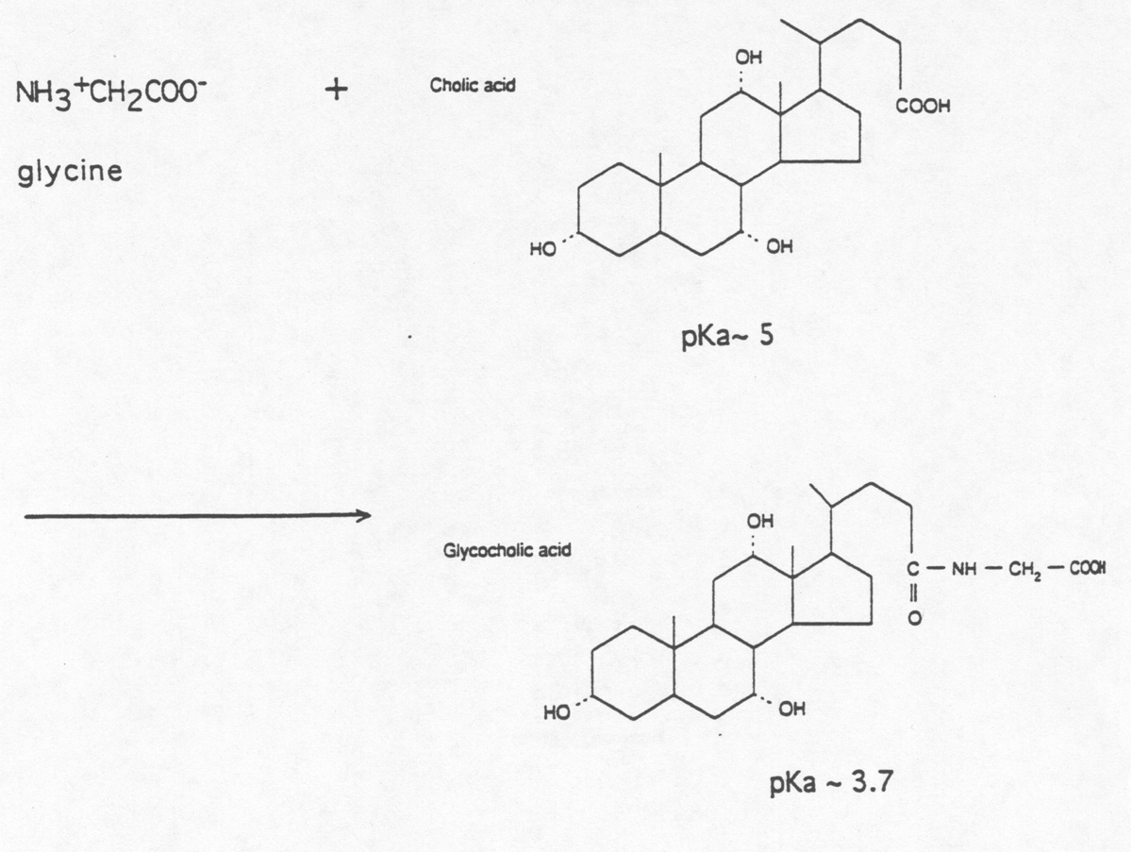

39. In an untreated diabetic patient, two lipoproteins usually accumulate in the blood. They are

*A. chylomicrons and VLDL.

B. VLDL and LDL.

C. LDL and HDL.

D. HDL and chylomicrons.

E. IDL and LDL.

40. LDL receptor

A. binds LDL only.

*B. binds LDL via apo-protein B100.

C. is the site for the action of LCAT.

D. does not exhibit any mutations.

41. Which of the following amino acids is BOTH solely ketogenic in its metabolic fate AND essential in the diet?

A. Tyrosine

*B. Leucine

C. Methionine

D. Valine

E. Phenylalanine

42. The cofactor used in the alanine aminotransferase reaction is derived from the essential nutrient

A. niacin.

B. vitamin B12.

C. folic acid.

*D. vitamin B6.

E. thiamin

43. The major allosteric stimulator for the enzyme carbamoyl phosphate synthetase II (CPSII, CPS-glutamine) is derived directly from

*A. ribose 5-phosphate.

B. UMP.

C. glutamate.

D. ornithine.

E. aspartate.

44. During fasting of at least 12 hours, blood glucose is supported by the metabolism of amino acids derived from muscle breakdown, with a consequent increase in the excretion of

*A. urea.

B. leucine.

C. arginine.

D. creatinine.

E. uric acid.

45. In humans, proline is mainly synthesized from the amino acid

A. tyrosine.

*B. glutamate.

C. methionine.

D. phenylalanine.

E. cysteine.

46. Which of the following amino acids DOES NOT provide atoms toward the biosynthesis of the high energy compound creatine?

A. Arginine

*B. Aspartate

C. Methionine

D. Glycine

47. A person with inadequate levels of vitamin B12 will probably have elevated levels of

*A. homocysteine.

B. methionine.

C. cysteine.

D. tryptophan.

E. serine.

48. A patient with very pale gums announces he is feeling very tired lately. Since his nutrition appears to be based largely based on consumption of cheesesteaks, you propose that he should consume more green vegetables and orange juice, or a vitamin pill, to increase his intake of

A. niacin.

B. biotin.

C. pyridoxine (B6).

*D. folic acid.

E. vitamin B12.

49. An amino acid that does NOT contributes atoms for the synthesis of IMP is

A. aspartate.

B. glycine.

C. glutamine.

*D. threonine.

E. serine.

50. The protease most likely to make the first cut in an ingested protein is

*A. Pepsin.

B. Trypsin.

C. Chymotrypsin.

D. Elastase.

E. Carboxypeptidase.
51. Elastins

A. are a distinct class of collagen protein.

B. lack the strength of fibrous collagen due to the absence of covalent cross-links between amino acid residues.

C. contain unusually high glycine and proline content that appears as a repeating Gly-X-Y tripeptide.

*D. contain stretchable hydrophobic regions separated by regions rich in alanine and lysine where intermolecular crosslinks form.

E. Both C and D

52. Proteoglycans are distinct from other types of glycoproteins in that they

A. contain both N-linked and O-linked glycosaminoglycans.

*B. contain long, unbranched, polyanionic, repeating disaccharide chains.

C. always exhibit more protein than carbohydrate content.

D. are postively charged because they contain amino sugars.

E. are only found embedded in cell membranes.

53. Structurally, mucins typically

A. have many short sugar chains that all have an identical sequence.

B. have only N-linked oligosaccharides.

*C. include repeated amino acid sequences rich in serine or threonine.

D. are made up of short polypeptide chains (less than 100 amino acids).

E. are good lubricants because they are predominantly hydrophobic.
54. Which of the following hormones level rises immediately prior to eating a meal?

A. Insulin

*B. Ghrelin

C. Leptin

D. Thyroid hormone

E. Epinephrine

55. The RDA value of a nutrient is the amount that is sufficient for what percentage of the specified demographic group?

A. 50%

B. 75%

C. 90%

*D. 98%

E. 100%

56. Donald Straitner is a 6’3” tall 220 lb dental student who wants to be an orthodontist. He has to get all A’s so he spends all his free time studying. His daily energy expenditure is likely to be closest to

A. 2400 kcal.

B. 2700 kcal.

C. 2900 kcal.

*D. 3100 kcal.

E. 3800 kcal.

57. Donald’s diet gives him an average daily intake of 250 grams of carbohydrate, 150 grams of fat, and 200 grams of protein. Donald’s daily caloric intake is closest to

A. 2400 kcal.

B. 2700 kcal.

C. 2900 kcal.

*D. 3100 kcal.

E. 3800 kcal.

58. Using the above information, we can conclude that Donald is

A. likely to lose weight.

*B. eating too much fat.

C. likely to be in positive nitrogen balance.

D. None of the above.

